**A SUPPORT PORTAL FOR ONLINE STUDENTS AT USFSP**

FINAL REPORT

CASEY FRECHETTE, PH.D.  
Assistant Professor, Journalism and Digital Communication

BERRIE WATSON, MCP, MCSE Core

Head, Library Systems and Digital Technology

SHARON AUSTIN, MA, MSIT

Programmer/Analyst



TABLE OF CONTENTS

|  |  |
| --- | --- |
| I TABLE OF CONTENTS  II INTRODUCTION  III BACKGROUND  IV HOW THE PORTAL WAS BUILT  V OVERVIEW OF CRITICAL CONCERNS  VI OVERVIEW OF PORTAL FEATURES  VII ADDRESSING THE CRITICAL CONCERNS  1. Students find it confusing and difficult to obtain information.  2. It’s a challenge to balance student privacy with the transparency needed to promote student safety.  3. Some students are unprepared for online learning.  4. Some students are unprepared for college.  5. Failure to provide timely, comprehensive support to a growing online student body may interfere with our alignment with SACS requirements.  6. Existing support systems serve students to varying degrees, depending on the device from which they are accessed and the student’s needs.  7. Seeking support presents a variety of personal concerns, especially when students receive specific, personalized feedback.  8. Students sometimes struggle to connect with professors and advisors to address online learning support needs.  9. Accessibility for students with disabilities is still a challenge.  10. Students need easy access to information we are legally obliged to supply.  VIII MORE INFORMATION ON THE PORTAL FEATURES Overall - Content should be available and accessible regardless of device.  1. Dashboard - A personal hub by which notifications and important messages are centralized 2. Search - A customized search that brings forward USFSP-specific assets. 3. Talk/Chat 4. Knowledgebase/FAQ   IX NEXT STEPS  X CONCLUSION  XI NOTES  XII REFERENCES | 1  3  4  8  10  14  16  26  28  40  56  59  62  66  69  77  79  80  87  91  95  98  99  100  101 |

INTRODUCTION

“Student success is at the heart of all we do.”

*Regional Chancellor Sophia Wisniewska*

The USFSP Online Student Support Portal team, consisting of Dr. Casey Frechette, Mr. Berrie Watson, and Ms. Sharon Austin, was tasked with designing a robust web presence that would help USFSP’s online students to accomplish tasks to advance their academic careers without coming to campus. Needs related to orientation, registration, advising, research and study, and other were considered. The portal was intended to cover all aspects of the online student’s college experience outside of the virtual classroom..

Accounting for all campus departments and units relevant to these tasks resulted in a massive amount of information and diverse set of stakeholder needs.

A traditional approach to such a task might involve compiling a comprehensive set of links, and the first design efforts reflected this strategy.

Initial testing revealed limitations with this approach. Merely aggregating existing resources meant students would need to understand the organizational hierarchy, decode jargon and recognize inconsistencies in how information was conveyed — some small and some large. To address this, we developed custom platform to address student questions both synchronously and asynchronously, and archive answers. The platform used interactions between students and support staff to improve an artificial intelligence system developed to provide instantaneous response and generate targeted FAQs that could be browsed or searched.

Developing a mobile-friendly, accessible platform for our students with disabilities was another integral goal.

The technological component was only half of the equation that went into the development of the Online Student Support Portal. The other half was the commitment to the student support network, to include friends, family, and community. The portal takes into account those who support our students, but who may not be part of the “formal” USFSP network, such as family and friends. So, the technology was built to accommodate this informal network of support for the students.

The functionality of the platform developed to addresses these challenges is in place. Launching the portal, however, requires coordination with administrators and significant user testing. We are convinced that the platform we have developed is unique among institutions of higher education. All features interact with one another, and therein lies the platform’s power. It was built from the ground up, right here at USFSP, with a focus on student success.

BACKGROUND

Last year, the support portal team reached out to key stakeholders to better understand how to design a system that serves students in all aspects of their online studies. The results may be found here: <http://dspace.nelson.usf.edu/xmlui/handle/10806/14940>. Ultimately, however, the most important stakeholders are the students themselves.

Students have many academic and non-academic needs when attending college. If not addressed, these needs can become barriers that prevent students from completing school. Support is available; the problem for students is finding that support, and finding it in a timely manner. The sheer volume of the information is a potential source of confusion for new students, or for students who need help quickly. In the case of students with disabilities, the volume of material can be an insurmountable burden. Additional hardship cases, such as our soldiers serving overseas trying to register for an online classes, or a local student without the financial resources to afford a desktop computer, presented additional concerns. Additionally, we felt it was important to be able to include, where possible, the offline support system of family and friends for students and potential students.

This custom platform developed for USFSP addresses these issues. It captures questions from students, potential students, friends and family, then automatically archives them for review and ensures that they are sent on to authoritative help. Should an authority not be available to answer immediately, the system provides an automated response to the student saying that help is on the way. The platform was designed to allow anonymous questions to be asked. This permits easy access without the need to log in to an account. It also provides anonymity for students who desire it. The platform uses social media features in a way that connects students with the information they most need and, in some cases, allows them to do so anonymously. In a study exploring the value of anonymity during reference service via instant messaging (IM), the authors found that the ability to be anonymous may attract users to the IM reference service who may otherwise be uncomfortable with face-to-face references (Roper, Sobel, 2012).

According to Kayhan and Davis, “Privacy is fundamental to individuality, enabling us to express ourselves selectively” (Kayhan et al, 2016). Privacy was not only enabled by “where” the content was accessed, but also “how” the content was accessed. The technology of SMS messaging is built into the portal for many reasons, but in terms of the *perception of privacy*, it should be noted a “text” SMS message is far less likely to be overheard than a voice conversation (Hord, n.d.) and may contribute to the appeal of this medium. We also recognized students’ need to consult family and friends as a support mechanism.

The platform is not meant to replace personal, one-on-one interactions between students and support staff or faculty. It simply offers a safety net to catch the students who are otherwise unable to come to campus, or are unable to avail themselves of staff during the hours that staff are available, or find themselves waiting excessive periods of time when staff is too busy to help. Research shows that, “brief computer-delivered remote interventions have several advantages over in-person interventions, including reduced cost and participant burden, greater reach, and potentially higher appeal to potential college student participants” (Rodriguez et al, 2015).

The platform was built very specifically to allow students — or parent, or friend, or potential student — to ask questions anonymously and privately, yet still gain access to assistance. A login is not required. In addition to promoting privacy, we found that this feature also has value to students with certain disabilities. The very process of logging in is problematic to those who rely on certain kinds of assistive technology to function. The ability to get a question answered without having to log in may seem minor to those with full motor skills, but presents a real hardship to those who do not have full use of their hands.

The platform employs the same technical engines that power social media, but without the algorithms that commercial social media platforms use. The platform should feel familiar and easy to use because it uses technology familiar to students. Students use social media for support (Seo et al, 2016). We had considered simply integrating off-the-shelf social media platforms into the portal, but were concerned with the problems attendant to these platforms.

The problem with using the common social media platforms such as Facebook and Twitter is that such companies use algorithms that aren’t designed to ferret out individual problems and get authoritative help. In fact, at one point, Facebook floated a technology devised to tinker with users’ emotions in a news feed experiment, manipulating the news feed of half a million users to change the number of “positive” and “negative” posts they saw (Goel, 2014). The bottom line: if a student needed help and reached out for it, the consequences could truly be serious if the platform’s software algorithms prevented the post from surfacing. To that end, a chat/notification system was developed in-house that reflects social media communication tools but connects students with authoritative resources. Ultimately, this system allows students to keep the support of family, friends, and in some cases, caregivers, in the loop. For more background on this, see the article, “College campus crisis: mental health services,” in the Jan. 29, 2017 Tampa Bay Times. According to the article, “Friends, family, and all things familiar are stripped away as students enter the major leagues of academic and social stress” (McNeil, 2017).

Additionally, and critically, the technology is context-sensitive. Authors Kaya Van Beynen and Camielle Swenson (now, Camielle Crampsie), when studying peer-to-peer and library interaction on the USFSP Facebook Page, “USFSP The Know It All's Guide To Knowing It All!,” noted “The types of reference questions between those submitted to the Know It All Guide were very different from those fielded by the NPML service desks” (Van Beynen & Swenson, 2016).

One facet of context is the ability to ask both general and specific questions, a capability built into the Online Student Support Portal. A general search box on the homepage connects students with answers on myriad topics. A specific search box on the “Courses” page provides results from OASIS, our online course schedule, along with special filters to customize how results are returned. Unlike the official course search page, our customized tool provides a streamlined interface that mimics the Google search experience. In other words, students can search in a way that makes intuitive sense, without needing to understand codes, catalog numbers, hierarchies, abbreviations, and other conventions internal to our systems and processes.

The platform was designed to be fully integrated, rather than have functionality bolted-on from third-party sources. As is true for components in the physical world, it is also true for the virtual world, where dis-similar components join, there is weakness at the joint. Relying on third-party vendors adds maintenance requirements for complicated systems; if a change is made in the vendor’s product, then everything else may be affected. Both the quality of the technology and its attendant service is uneven, and sometimes, unpredictable, with third party sources.

Consequently, to keep maintenance down, the platform was built as a self-integrated unit able to stand on its own. That said, this platform was designed to integrate with the extant, or upcoming, important assets already in place at USFSP. It was extremely important to us to keep these assets in place and to connect to them — not to replace them. Student retention, a problem for all universities and colleges, was on our minds as we worked. Because the platform was developed in-house, the expertise of the platform builders aligns with students and their needs. We’re here, we live, teach, and work with the students — here, at USFSP. The platform has USFSP built into its DNA.

It’s important to understand that although we were tasked with providing ready access to information that “supported” online learning, we were to stop at the line that actually included online instruction. In effect, the portal would serve as a gateway to student services online. As we worked, we kept in mind the definition of “accessible” as defined by the Office of Civil Rights and the U.S. Department of Education regarding inaccessible IT — that a student with disabilities must be able to access the same information ‘’... *with substantially equivalent ease of use.’’* (Note 1). Any websites and/or applications we developed had to provide information with “*substantially equivalent ease of use*” was a significant task. In other words, it was not enough to provide a comprehensive “website” linking to the online courses, it had to be “substantially” as easy for a person with disabilities to use as for a person without disabilities. We could not fall back on the fact that services were offered on-campus for those with disabilities. Consider the recent case of Gil v. Winn Dixie; Winn Dixie argued that only physical locations are subject to Title III of the ADA — and lost the case. The lesson as it applies to us is that, simply because student resources are available on campus, the institution still has the responsibility to make resources accessible online.

The challenge was magnified by the sheer volume and diversity of the content we needed to connect: orientation, registration, advising, research and study, are examples of content and contact points we were to specifically address. Data was in silos, and we had to find a way to “flatten” it. In one trial run, we found one student with disabilities took close to thirty minutes just to access the link on OASIS simply to access the courses for his major within the upcoming semester. We felt we could do better than that for our students with disabilities. When we showed the solution to the student with disabilities, his comment was, “This is not only going to be great for students with disabilities, this is going to be great for ALL students.”

The reason this works for all students, and not just those with disabilities, is the fact that we do not expect students to be experts on organizational hierarchy to find the information they need. We don’t make them find the information, we bring the information to them. This is the critical, one-of-a-kind, development that we have made for our students here at USFSP.

The portal was designed to align interaction with student expectations; the portal embraces a “Google” sensibility to the searches, because that is what students are comfortable using. It also embraces voice input, again, because so many students use their smartphones for performing tasks.

First and last, however, the portal interface was designed to help students ask questions, and with every design stroke, to enforce the idea that we were here to listen. This is critical. Students seek help by asking questions, so the portal enables students to ask questions very easily, and at all points within it. There’s not a special “help” page. The whole portal IS a help platform. Research supports this. “The fact that explicit questions are associated with direct support seeking suggests that most of the time when people asked for direct help, they framed it in form of a question, which is not surprising.” (Andalibi et al, 2016). So, the portal interface makes it very clear that we want students — or their support network of friends and family — to feel free to ask questions. And, it starts with the landing page. Anyone can just ask.

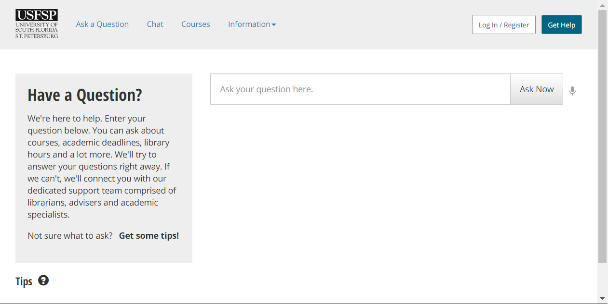

[ III - I ] Figure 1. A screenshot of the landing page.

The very first thing a student sees when signing on to the portal is a large, “Google-Like” search box, in which he can ask anything. In this prototype version, the artificial intelligence, developed in-house here at USFSP, understands that this is a “general” question due to the context (location) of the page. There are very few tasks for the user on this page. Very few decisions have to be made at this point, and, therefore, there is very little confusion as to what is expected of the user. Modern smartphone users will be familiar with the mode of just, “asking” for what they want. However, there’s a bit of a safety net here that’s not present on most phones. If, for some reason, the student does not want to “ask” a question, “traditional” methods are available to him. The navigation bar above allows him to start a chat, or look for information on courses in particular, or generally through an information menu. The platform takes advantage of the best of both worlds, the modern convenience of mobile technology, combined with the comprehensive nature typically associated with desktop operations, and combines them into one platform.

In the above scenario, an automatic answer is provided by artificial intelligence (AI), coded in-house by USFSP’s Dr. Frechette. The code was developed so that the “answers” are informed by the stakeholders themselves. If a stakeholder changes the hours of operation for the department, the information immediately becomes available to the AI.

HOW THE PORTAL WAS BUILT

The architecture of the Online Student Support Portal was designed and developed by Dr. Casey Frechette. He created the code libraries and blueprints by which to construct the custom Content Management System (CMS). This meant, specifically, that he designed the custom, responsive Graphical User Interfaces (GUIs) as well as the custom database structure to provide customized data output. Mr. Berrie Watson designed and established the network architecture by which the portal was able to be developed in a manner that ensured stability, and also, safety for the network. Without this solid foundation of the database maintenance and perimeter fence of network security, none of us would have been able to work. Ms. Sharon Austin “built” the CMS according to the code blueprints and libraries designed and developed by Dr. Casey Frechette. Because of the team’s commitment to accessibility, a USFSP student with multiple disabilities, Mr. Robert Beasey, was present while the CMS was built, to provide input on at least a weekly basis.

Development of the portal was iterative, with multiple files being updated simultaneously and replicated using SourceTree and GIT. Protection of the work and access for varying levels of network visibility required for the project. The control of data into and out of secure networks at the USFSP Nelson Poynter Memorial Library involved use of VPN, Cisco firewall, and local controls to establish access for onsite users only during the development period. Virtual networks allowed the machine exposure to either a live, unrestricted network, or an internal/VPN network when necessary. The architecture of the server used was virtual, based on VMWare products. Two instances were employed, for testing and pre-production. Testing and development were done using a combination of local MAMP environments and a testing instance on a stand-alone machine using VMWare Workstation. A production level instance was copied from the testing virtual machine and located on a VMWare ESX host and storage array. Backups and systems components were managed in a flexible manner virtually, which allowed ‘snapshots’ of machine state and data at critical times. This allowed rollbacks to prior server and data states, protecting programming milestones and lessening the risks of testing. Virtual backups were stored off-array using Dell’s vRanger Pro application to compress and manage backups of the full server.

While the paragraph above describes the technical aspects of the construction of the portal, it does not address the commitment to a ‘student-first’ vision. The team recognized that technology alone could not solve the problems stakeholders identified in the interviews. The technology had to connect students with the support they needed in a meaningful way, and for the process to be meaningful, all parties had to be able to participate. A barrier to participation is the fact that information and expertise is in silos. Another barrier to participation is the fact that often, a student must have a login and/or NetID to get help. This precludes family, friends, and community members that could help the student from participating easily in assisting the student. “Bureaucratic and hierarchical organizations show formal and administrative procedures that prevent the sharing of knowledge and new ideas” (Khosrow-Pour, 2008). In examining the organizational charts, we found that it was almost inevitable that information the student needed would fall into silos. Single or few authoritative experts held the keys to the knowledge kingdom. Yet, we all understand, instinctively, that it does indeed take a village to raise a child. “A community of individuals is more likely to practice wisdom than a single individual.” (Gunawardena et al, 2004).

Consequently, the “vision” of how to solve the technical problem on how breakthrough information silos, and connect a community of support to the student in need, was based on over a decade’s worth of thought and consideration. The vision of how to use technology to solve a human problem was built upon a FOCAL model. “The mission of the FOCAL model is to provide support for an online community through human-human interaction. Learning is a participatory process where members share their feeling of belonging, experiences, ritual, culture, and knowledge in a collaborative practice in support of the community's common goals and missions.” (Gunawardena et al, 2004). The vision of using a FOCAL model to use technology to solve the problems identified by stakeholders dovetailed with the Regional Chancellor’s Bold Goals of Strategic Partnerships. The portal is designed to allow communications with, and share resources with, USFSP Partners that provide civic engagement and off-campus mentoring. Control is granular on the platform. There’s an ability for organizational units to use the platform as an internal communication system to communicate information about student questions.

The technology of the portal was designed and developed to cross silos, and to surface diverse expertise to the student, rather than have the student look for the expertise. This meant that the portal had to be able to put everything from all the various departments into just one bucket, and then sort it out again when the student asked for it. to make sure that this could happen, functionality testing was done frequently, and iteratively.

OVERVIEW OF CRITICAL CONCERNS

#### 1. Students find it confusing and difficult to obtain information.

##### Information about online learning appears in different places and formats. Students aren’t sure where to look or how to interpret the information they receive.

##### This concern really encompasses two distinct components; confusion, and difficulty. How this was addressed in the Online Student Support Portal:

##### To address difficulty: The portal was designed to bring information to the student, rather than have the student search for information. This was accomplished via custom code, developed in-house, and unique to USFSP.

##### To address confusion: The portal structure was developed to work around centralized repositories, customized to USFSP and populated by authoritative USFSP stakeholders. This content is dynamically generated, meaning, as soon as a stakeholder updates the information, the information is immediately available to students. No middle-man is required.

To address confusion: The portal was designed to bridge the “two kinds” of content silos: Technological, and Organizational. The portal provides a technological path to cross silos, but the technology alone is not enough. Organizational expertise is made available via keywords so that student concerns may be forwarded to an appropriate organizational unit by consulting a keyword list. This enables a bridge across silos not only from a technical standpoint, but an informational one also. It enables a way to find the expertise of other departments. The keywords are maintained by the stakeholders themselves.

#### 2. It’s a challenge to balance student privacy with the transparency needed to promote student safety.

##### Finding the right balance between protecting and disseminating information is critical.

##### How this was addressed in the Online Student Support Portal:

##### A “Help” drop-down menu available on every public-facing page, with the special note that if there is an emergency, to call 9-1-1.

##### Develop a chat platform that allowed anonymous and private conversation for students, strengthened by a keyword feature, unique to USFSP, that supported staff in the routing of the chat to an appropriate authority. This includes the ability to list and publicize special USF system after-hours support for USFSP students, and the ability to list off-campus support institutions, such as area hospitals. On the recommendation of one of our students with disabilities, geolocation features were incorporated for mobile devices. To address privacy concerns, permission must be enabled before geolocation is enabled.

#### 3. Some students are unprepared for online learning.

##### Many students approach online learning with misconceptions about the rigor required of the experience.

How this was addressed in the Online Student Support Portal:

To address connecting students with the people who can help them learn how to handle rigorous requirements: Connect students to librarians, appropriate support staff, and university professors in a more robust and targeted manner, technologically speaking.

To address the problem that students may not be as proficient with digital technology as we may assume: Address the myth of the Digital Native. The myth of the Digital Native assumes that students are able to find help easily on digital platforms, because they have been using them most of their lives. While it is true that students are familiar with these platforms, they are not necessarily familiar with how to search for help using them. Students rely heavily on Google, but they are not very good at customizing searches to get targeted results. The portal takes advantage of an interface that is Google-like in function, to make the student feel comfortable. Under the hood, however, the database is built to deliver targeted resources for students to get to the help they need. This is done first, through a Google-like search, then via chat, or email. From there, authoritative resources can connect with the student, directing him to the appropriate resources, for example, the Student Success Center or the Student Technology Center.

#### 4. Some students are unprepared for college.

##### The transition from high school to college challenges many incoming students.

##### How this was addressed in the Online Student Support Portal:

In many ways, the features for connecting students to appropriate help in item 3 also had direct applications to addressing the concerns in item 4. There’s a nuance of difference between the concerns in item 3 and in item 4, however, in that item 3, as worded, tends to align with academic concerns, whereas the concerns in item 4 tend to align with concerns young people face when encountering a college environment for the first time.

To address connecting students with the people who can help them fit in with college culture: Connect students to appropriate support staff and community assets in a more robust and targeted manner, technologically speaking. In terms of addressing a young person’s outreach for help, the portal was designed to be able to address questions asked anonymously.

To help young students embrace the college culture outside the walls of the classroom: Incorporate community connections, technologically speaking.

#### 5. Failure to provide timely, comprehensive support to a growing online student body may interfere with our alignment with SACS requirements.

##### As the portion of instruction delivered online increases, so does the importance of providing adequate support services.

##### How this was addressed in the Online Student Support Portal:

##### Create special interfaces to allow stakeholders to tag reports necessary to SACS, and create a special, public-facing page, dynamically populated by the stakeholders themselves. This dynamically-populated page allows auditors to search for reports relevant to SACS and other important institutions.

#### 6. Existing support systems serve students to varying degrees, depending on the device from which they are accessed and the student’s needs.

##### Some information is difficult to access on mobile devices or without the use of downloadable plugins. Some students require access to specialized software, depending on their major.

##### How this was addressed in the Online Student Support Portal:

##### To address the difficulty of accessing the content on mobile devices, the platform was developed as a mobile-first one. If a web site is available on mobile platforms, it will be available anywhere.

To address the issue of downloadable software/plugins: An Accessibility Initiative baked into the portal was designed by Dr. Casey Frechette in concert with USFSP student Robert Beasey. This special feature, unique to USFSP, allows students with certain disabilities to access easy-to-see features and enter voice commands without the purchase of expensive software such as Zoom Text, or Dragon Naturally Speaking.

To ensure the support system was able to serve the students in as many ways as possible, multi-modal functionality was built into the system.

#### 7. Seeking support presents a variety of privacy concerns, especially when students receive specific, personalized feedback.

##### Legal protections apply to certain information students might seek or share.

##### How this was addressed in the Online Student Support Portal: Structure chat so that important conversations may be directed to appropriate, authorized help, and also, archive important anonymous conversations.

#### 

#### 8. Students sometimes struggle to connect with professors and advisors to address online learning support needs.

##### Difficulty in receiving one-on-one assistance may impact the quality of support students receive.

##### How this was addressed in the Online Student Support Portal:

##### The initiatives that addressed the concerns described in items 1, 3, and 4 addressed many of the concerns connecting students to help. The specialized components of this item, item 8, offer a convenient, centralized location for the professor to receive notifications, questions from the students, or signal that he is available for conversation.

#### 9. Accessibility for students with disabilities is still a challenge.

##### Various systems and software packages provide a wide range of support and access to students with disabilities.

##### How this was addressed in the Online Student Support Portal:

##### A student with multiple disabilities was part and parcel to the process of designing and building the portal, and his input was integral in designing the User Interface. Standard accessibility practices were employed, but also, because the student was alongside at all points of the design process, new, one-of-a-kind accessibility initiatives were created — one of which is absolutely unique to USFSP.

##### Additionally, because the search function plays an extremely large role to those with disabilities, a specialized search function was developed to work specifically with USFSP databases, enabling a very targeted, context-sensitive search result. It is a simple but powerful initiative that allows students with disabilities to find information on a timely basis on par with those who do not have disabilities. This allowed us to substantially meet the definition of “accessible” as defined by the Office of Civil Rights and the U.S. Department of Education regarding inaccessible IT.

#### 10.Students need easy access to information we are legally obliged to supply, including Title IX and CLERY documentation.

##### We must supply easy, direct access to basic information about the University and its support for students.

##### How this was addressed in the Online Student Support Portal: A public-facing page that is searchable by report type.

We also reviewed the design of the Online Student Support Portal in terms of our responsibility to provide resources online where they were otherwise available by coming to campus. We did take especial note one of the recent cases, for the United States District Court for the Southern District of Florida Juan Carlos Gil, Plaintiff v. Winn Dixie Stores, Inc., Defendant Civil Action No. 16-23020-Civ-Scola, Judge Scola noted that “Winn-Dixie’s website is heavily integrated with, and in many ways operates as a gateway to, Winn-Dixie’s physical store locations.”

OVERVIEW OF PORTAL FEATURES

#### 1. Overall.

##### Content should be available and accessible regardless of device.

##### How this was addressed in the Online Student Support Portal: Develop the platform with a mobile-first platform, ensuring USFSP branding is in place, bringing forward USFSP-specific assets when search is used, and using accessibility as a strategy, not a tactic.

#### 2. Dashboard.

##### A personal hub by which notifications and important messages are centralized.

##### How this was addressed in the Online Student Support Portal: Developed a personal dashboard/profile page for users in which alerts, notifications are received, and by authorized users may control availability notification through widgets customized to fit on department pages.

#### 3. Search.

##### A customized search that brings forward USFSP-specific assets.

##### How this was addressed in the Online Student Support Portal: A search utility was developed in-house to specifically interact with a custom, USFSP-specific database, largely populated by USFSP stakeholders, that is able to provide responses very specific to USFSP. In the particular case of course search, the course search integrates with current, official BANNER data.

#### 4. Talk/Chat.

##### A customized chat feature developed in-house that integrated diverse service components.

##### How this was addressed in the Online Student Support Portal: A chat system developed in-house provides real-time communications with designated support staff when they are available, and when they are not, provides a way to review the question for forwarding to an available staff member so that the question is not dropped. The in-house chat system was developed to be able to cross departmental silos and send multiple notifications when student questions required the response of more than one department.

What makes this chat different from off-the-shelf chat technology: integration with keywords, to enable the ability of a staff member to connect a student’s question to a proper and authoritative source. The keywords are established by the stakeholder themselves, and do not require a webmaster. The key point to remember is that more than simply departmental information is in silos, the “who” is responsible for “what” is also in information silos. The chat platform allows staff to search for keywords relevant to a student question, and route the chat accordingly.

This process directly aligns with the Vision 20/20 Strategic Plan Goals, Strategy no. 5.7: Design and enhance internal and external communication systems to support mission and goals

5. Knowledgebase/FAQs.

##### A feature developed in-house that integrated authentic student questions into archived data.

##### How this was addressed in the Online Student Support Portal: Provide answers to questions submitted by real students. These questions will come from directly from the input from the students, but sanitized of personal information to protect privacy.

##### 

##### 

##### 

##### ADDRESSING THE CRITICAL CONCERNS

1. Students find it confusing and difficult to obtain information.

##### *To address difficulty: The portal was designed to bring information to the student, rather than have the student search for information. This was accomplished via custom code, developed in-house, and unique to USFSP.*

##### *To address confusion: First of two initiatives to address confusion — The portal structure was developed to work around centralized repositories, customized to USFSP and populated by authoritative USFSP stakeholders. This content is dynamically generated, meaning, as soon as a stakeholder updates the information, the information is immediately available to students. No middle-man is required.*

*To address confusion: Second of two initiatives to address confusion — The portal was designed to bridge the “two kinds” of content silos: Technological, and Organizational. The portal provides a technological path to cross silos, but the technology alone is not enough. Organizational expertise is made available via keywords so that student concerns may be forwarded to an appropriate organizational unit by consulting a keyword list. This enables a bridge across silos not only from a technical standpoint, but an informational one also. It enables a way to find the expertise of other departments. The keywords are maintained by the stakeholders themselves.*

More information on portal initiatives to address this item:

Students find it difficult to obtain information, so to address this difficulty, the portal was designed to bring information to the student, rather than have the student look for the information. The information that is delivered via this interface is designed to be specifically relevant to USFSP, delivering a better and more targeted result than an student would be able to retrieve via a Google search.

The problem is, of course, how to “categorize” information, both in terms of how questions are phrased, and where to get the answers to the question. In other words, the right answer has to be given to the right question, and sometimes, even the author of the question themselves to not know how to word a question. Librarians are extraordinarily trained in this subject matter — or, perhaps it would be better to say, subject matters. The first subject matter is, what question is really being asked? The second subject matter is, where is the appropriate information to answer the question? Early research by USFSP’s very own Tina Neville and Deb Henry noted the following: ‘Online resources and new technologies have altered the types of questions received at library reference desks, leading some institutions to reconsider the classification systems used to document reference service.”(Neville et al, 2009).

None of us can be expert at all subject matters, and few of us may afford the training that librarians receive to classify information. No software can compete. But with the platform, we CAN cut a path to the librarians and their expertise, or, for that matter, the expertise of any other expert on campus — and the platform can provide a roadmap to make this happen. The roadmap is provided by the stakeholders themselves, in the form of keywords. Also, the portal is set up so that staff from different departments may both be alerted to help the student with a question. In other words, the platform crosses institutional silos. As we were interviewing stakeholders, one of the example questions posed to us was, “What if a student asks to do research on a business problem? Does the question go to the Research Department, or to the Business School?” Our answer is, “both.” On our platform, a question on business research goes to both the Reference Librarians and to the Business School. This is the “technical” bridge. The “cognitive bridge” across silos is addressed by the keyword list as mentioned before, but also, by context. If a student is on the “Courses” page, the words used in a student question would take on a different meaning than they would if he were on a chat page. And, for that reason, would search a different (unique-to-USFSP) set of data.

Even though students may be able to come to campus and obtain help to do this, there are times they prefer not to, and instead, choose to use automated systems — *even when they are on campus*. In a report on the assessment of the use of Self-Checkout Machines at Nelson Poynter Memorial Library, the authors found that some of the reasons patrons did not ask for help were that they were too embarrassed to ask for assistance (15%) or that the library staff had been too busy or unable to help (15%) (van Beynen et al, 2013). It’s probably safe to say that all departments have experienced times in which staff were so busy, that they were unable to attend to students immediately. It is for this reason that online resources are so valuable, even for students who are able to come to campus. For those who are totally unable to come to campus, such as our soldier-students serving overseas, the feature is priceless.

This portal was built in-house to deliver content relevant to USFSP, rather than all of the USF system. Because it was built in-house, by USFSP employees, the portal has the knowledge of USFSP resources built into its DNA. This feature helps all USFSP students, but it has particular application to our students with disabilities, in that it greatly facilitates a disabled student’s abilities to find information with a substantially equivalent ease of use as a student without disabilities. This is important; there is legislation that addresses accessibility as it applies to the ease of use obtaining information. ( “Accessible” as defined by the Office of Civil Rights and the U.S. Department of Education regarding inaccessible IT — that a student with disabilities must be able to access the same information ‘’... *with substantially equivalent ease of use.’’* (Note 1). Any websites and/or applications we developed had to provide information with “*substantially equivalent ease of use*”) .

The portal is designed to make it as easy as possible to, “Just Ask.” By both visual design, and by functionality, the portal positions itself to *listen*. The student is encouraged to ask, rather than told to go find an appropriate link for more information.

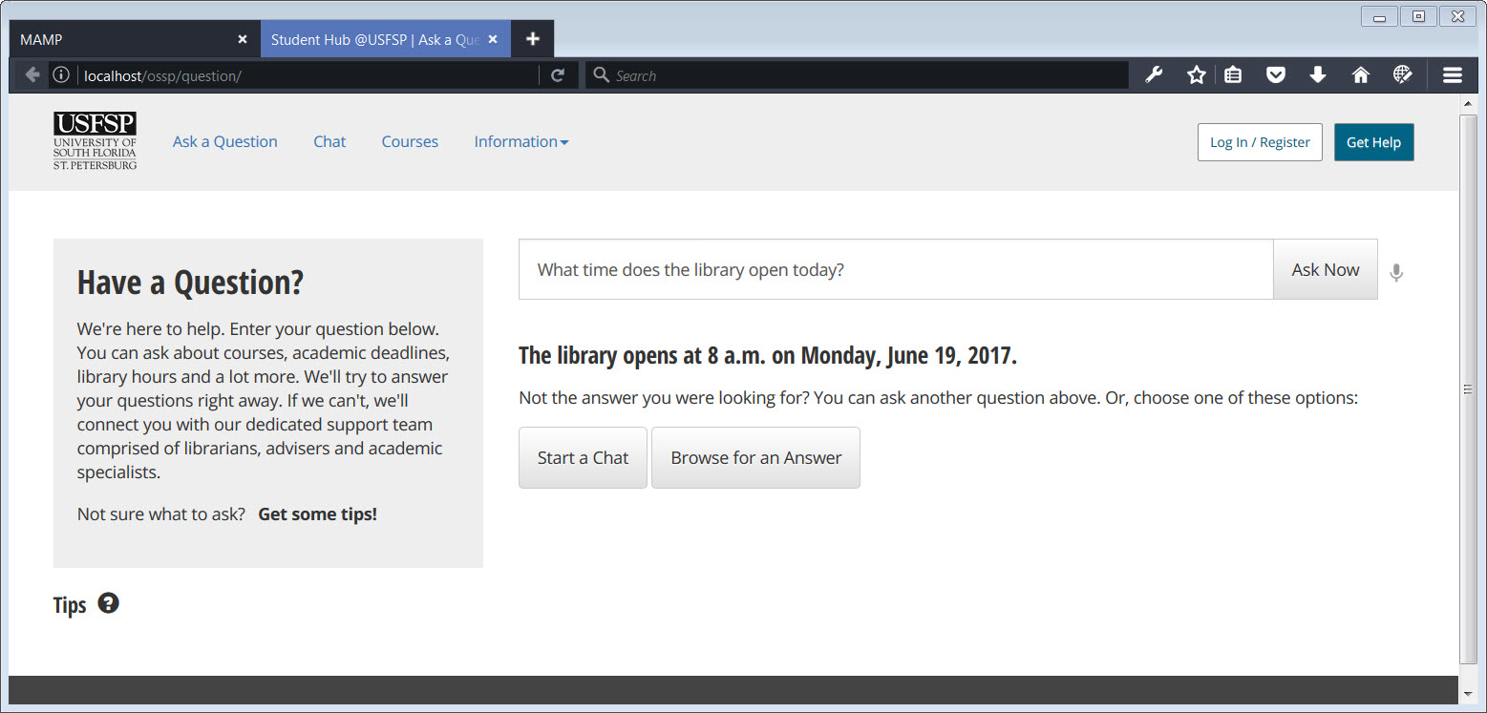

##### [ Section VI - I ] Default: Figure 1.

##### A student only has to ask a question to get an answer. He does not have to take additional steps to find the library’s web page, or a page with USFSP hours on it.

This platform makes information “findable” — not by providing an overwhelming list of links for a student to pursue, *but by bringing the information to the student as the student asks for it.* According to Crews, “Indeed, research has singled out findability as not only the most significant predictor of both self-efficacy and motivation among students in online courses, but the *only* significant variable that predicts these two key factors.” (Crews et al, 2017). The process of bringing information to students rather than have students go after the information also “modernizes” the information delivery tool, dovetailing the process with the modern expectations students have about “how” they get their information; students have long expected that digital communication paths will be used to communicate with them (Kvavik, 2005).

Mental effort varies across task stages (Gwizdka, J. 2010). Links and buttons on a website may seem to be simple choices to those familiar with organizational hierarchy, but present multiple cognitive task stages to those unfamiliar with the organization. For example, a new student, when presented with choices on a web page, would first need to decipher the meaning of the jargon on a link or button, and then make a decision as to whether or not the button or link will actually lead him to the information he seeks. Typically, a solution is to provide helpful resources, such as FAQ pages or videos which, in essence, “train” the user to understand the hierarchy or jargon used. This is extremely time-consuming, and in the case of those students who only have low-bandwidth available to them, or who have disabilities, these time-consuming self-help resources can actually serve as a kind of barrier to getting the information. What we tried to do with this platform is to find a way to “train” the platform to the student, rather than train a student to the platform.

To avoid expecting a student to know organizational hierarchy, or understand specific jargon associated with departments, programs, or specific services, an interaction built on custom data tables, populated by stakeholders, was paired with custom code that captured the individual student question, analyzed it, and provide an answer, or alternative ways to get the answer.

This may be broken down into two components, each from different sources. The first component is the data the student seeks. It must be authoritative, and current. The second component is the manner in which the student asks for the data. He may or may not use the correct term for the information he seeks. He may or may not ask for it in a format that mirrors common speech patterns. The issue becomes even more complicated when search queries use voice as the format for input. The software must “understand” speech through a what may prove to be imperfect formation of the words. Brice notes that speech perception, “..must interpret the sound and identify the sound (speech perception). Speech perception is more than just hearing sounds” (Brice, 2014).

In the case of students with disabilities, they may use a specialized form of search that is meant to cast a wide net of options that he may then narrow down to a reasonable “guess” of the appropriate jargon or terminology, and proceed from that narrowed-down list. But, it is an extremely slow process when one has poor motor skills, poor mobility, poor vision, or all of the above. It is because of the fact that a student with multiple disabilities was included at all stages of the design of the portal that it was designed with the intent to bring content to the student, rather than the other way around. In that regard, we do feel that the portal platform addresses accessibility as a strategy, rather than a tactic.

That said, simply because the appropriate information becomes available to the student, does not mean the student may necessarily receive the right help in a timely manner. This is because information is in silos. The content is in silos, and also, the knowledge of who owns the content is in silos.

To address this problem, a keyword index was created as an integral part of the portal. It dynamically generates the index on keywords created by, and maintained by, the stakeholders. In this manner, if a staff member, or other support person, does not know where to route a question for authoritative help, he/she is able to consult the keyword index.

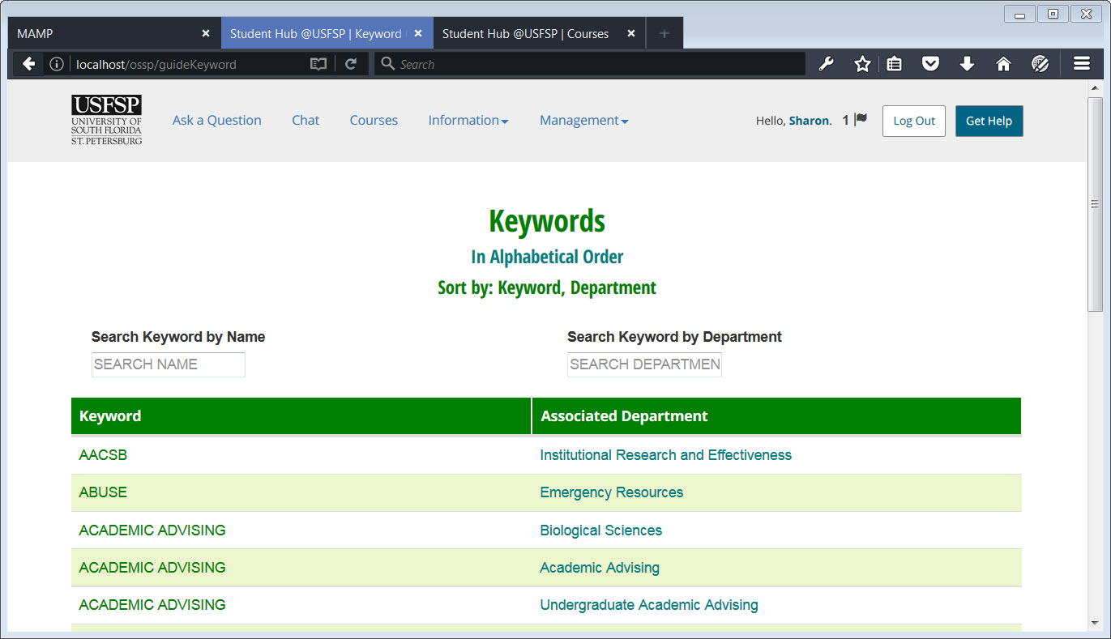

##### [ VII - I ] Keywords: Figure 1.

This is the landing page that those who are tasked to route questions will see.

One must be authorized to see the page. Different authorizations are required to add or subtract keywords from the page.

If a student question comes in, for example, with the term, AACSB, and the router is unfamiliar with the term, he may conduct a cross-reference to the term, and see that it is “owned” by Institutional Research and Effectiveness. He may then forward the question on AACSB to the Department of Institutional Research and Effectiveness.

Departments may have similar terms. If two or more departments share a term, the router is able to route the question to both departments, or as many departments as is needed.

Keywords are determined by stakeholders. When the stakeholder logs into his personal account, the platform will recognize the Department to which he is assigned. When the stakeholder enters the keyword, the department to which he is assigned will automatically be paired with the keyword. The “Associated Department” is not something that is routinely able to be edited by a stakeholder, without special, higher authority.

The terms for the “Associated Department” would be ones that align with official department titles. The ones for the initial version of the platform were derived from organizational charts.

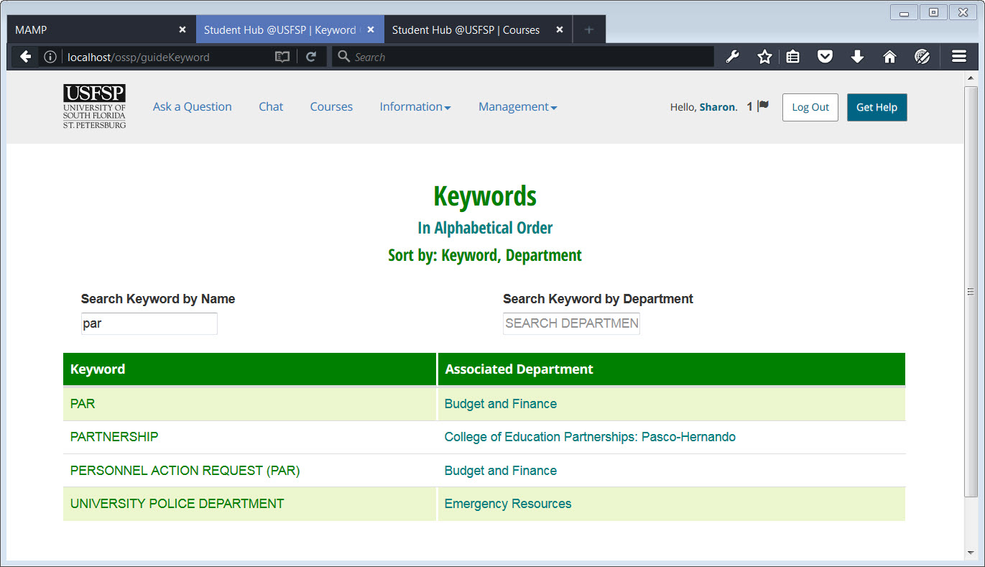

##### [ VII - I ] Keywords: Figure 2.

##### The above image is a screenshot of a user searching the Keyword Page by the Keyword itself. Here, you can see that three letters are entered, “PAR.” The search is not case-sensitive, thus relieving those who have challenges with motor skills of the requirement to use the shift key. This is an example of accessibility as a strategy, rather than a tactic, used throughout the portal.

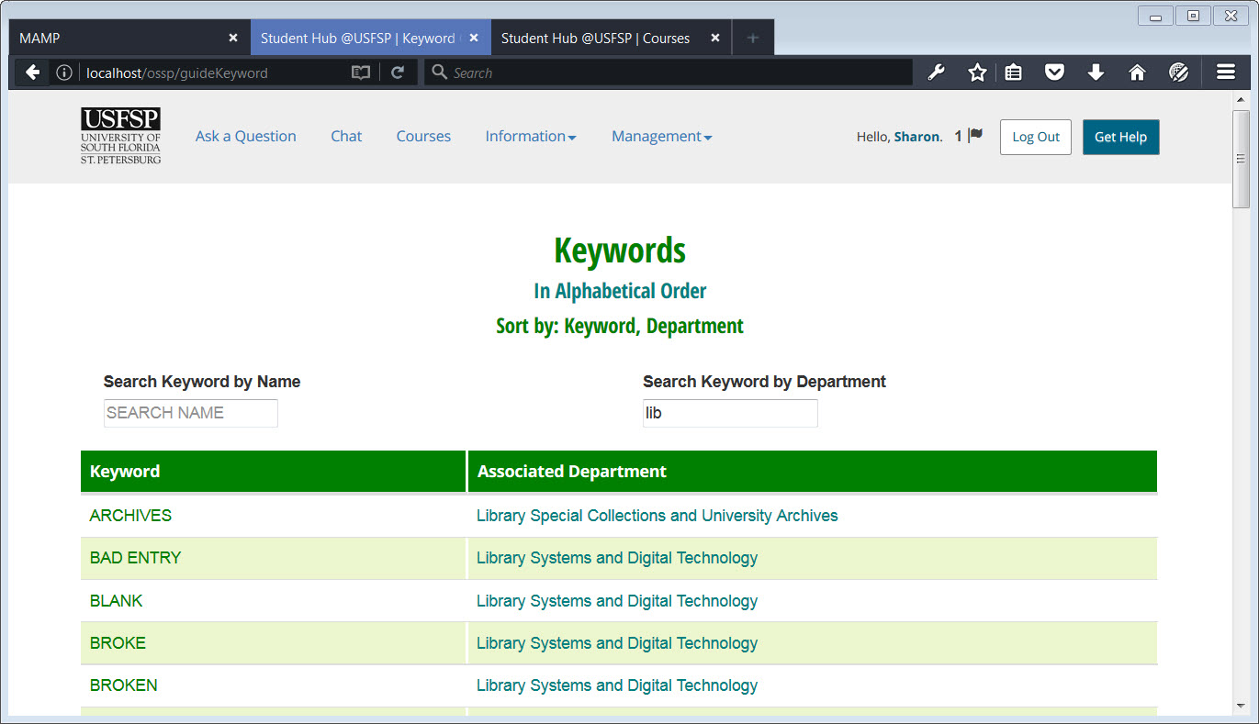

##### [ Section VII - I ] Keywords: Figure 3.

##### 

##### The screenshot above shows a user searching the Keyword Page for the Department “owner” or “owners” of the keyword. This provides a roadmap for routers; support personnel who are unfamiliar with the mission of other departments will be able to route a student question to the proper authority based on keywords used in the student question, or based on the subject matter of the student question.

On Forms:

Forms are particularly problematic; they serve as a kind of unofficial gatekeeper to the start of many official administrative processes processes. Muilenburg and Berge noted eight student barriers to online learning, among them, administrative issues. (Muilenburg, Berge 2007). Forms are central to the administrative process; locating forms is troublesome, even for staff. It is even more difficult for students, who are unfamiliar with jargon or organizational hierarchy. In the interviews, one stakeholder recommended that “...the development of a single repository for forms could be extremely valuable campus wide.” (See page 62 of the report: Support Services for Online Learners at USFSP for full context)

Consequently, such a repository was created, to be dynamically generated by content entered by the stakeholders themselves. It is sortable and searchable.

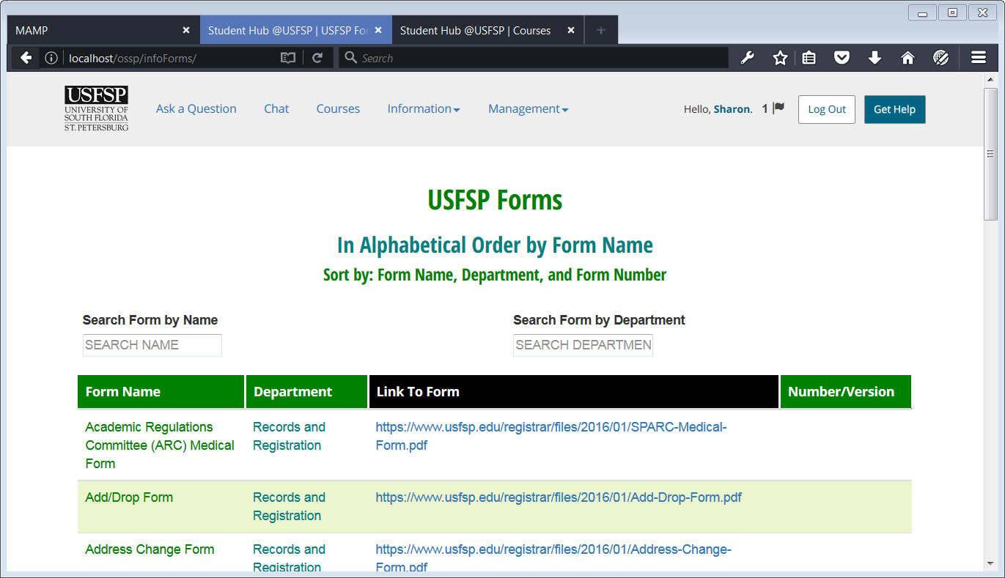

##### [ VII - I ] Forms: Figure 1.

##### During our interviews with stakeholders, a centralized form repository was requested. The screenshot above is of the consolidated forms page. Below, one searches for a form by name.

##### SearchByFormName.jpg

##### [ VII - I ] Forms: Figure 2.

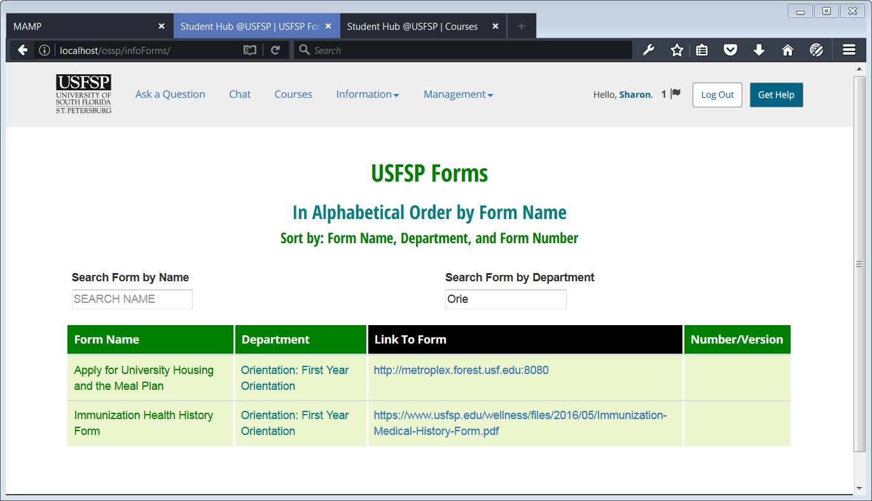

##### [ VII - I ] Forms: Figure 3.

##### The screenshot above illustrates searching the Forms Page by the department — searching by “who” owns the form. It may be seen by the example above that typing in a few letters, “Orie,” brings up relevant departments such as “Orientation.” The ability to use just a few letters rather than requiring that a department be spelled out in full addresses student difficulties in finding information, such as when spelling skills are poor, or when disabilities are present, so this was an accessibility initiative, but it has turned out to be a convenient method to search.

#### 

#### 

#### 

#### 2. It’s a challenge to balance student privacy with the transparency needed to promote student safety.

##### *A “Help” drop-down menu available on every public-facing page, with the special note that if there is an emergency, to call 9-1-1.*

##### *Develop a chat platform that allowed anonymous and private conversation for students, strengthened by a keyword feature, unique to USFSP, that supported staff in the routing of the chat to an appropriate authority. This includes the ability to list and publicize special USF system after-hours support for USFSP students, and the ability to list off-campus support institutions, such as area hospitals.*

##### *On the recommendation of one of our students with disabilities, geolocation features were incorporated for mobile devices. To address privacy concerns, permission must be enabled before geolocation is enabled.*

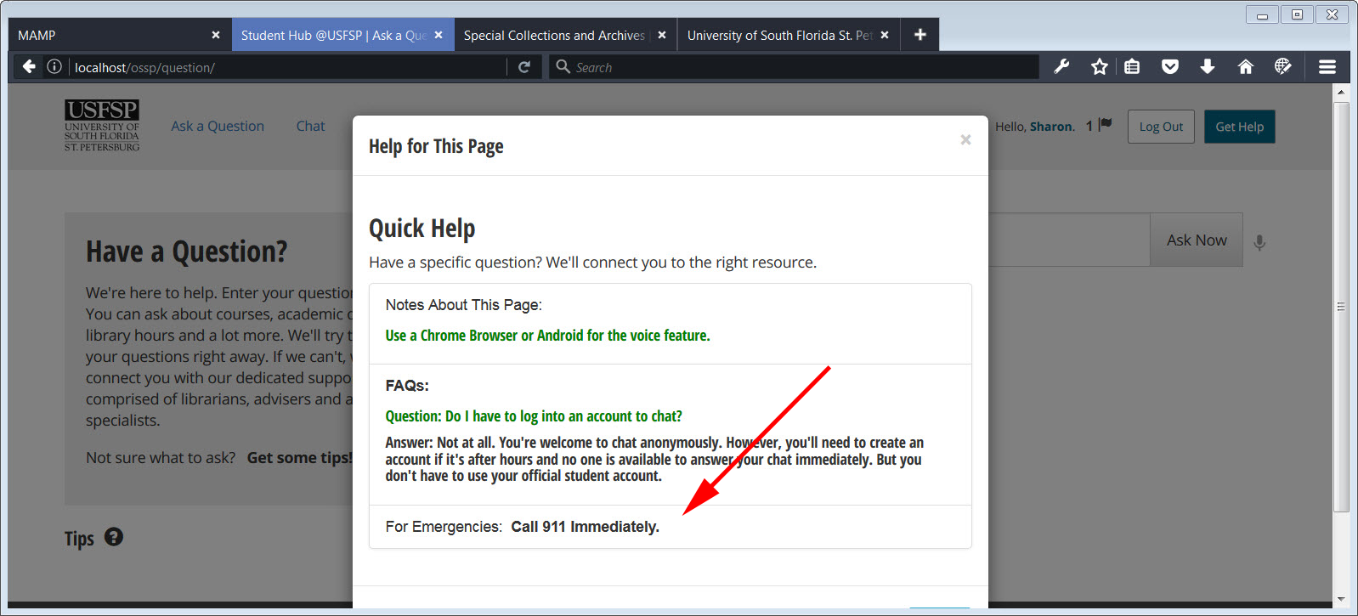

[ Section VII - 2 ] Help Menu: Figure 1.

More information on portal initiatives to address this item:

There were multiple approaches to address student privacy and student safety within the portal. On every public-facing page, there is a “Help” drop-down menu. While the content of the help menu changes depending upon the context of the page location, all help menus have a notice to call 9-1-1 on them, as recommended by Chief David Hendry.

The very definition of privacy is a challenging one (Kayhan et al, 2016). At a minimum, one level of privacy is enabled by simply providing a method by which a student — or parent, or friend — may ask a question without a requirement to provide personal information. The question could be routed to an appropriate authority. The question itself, however, would be captured for evaluation and subsequent filtering for possible referral, and/or to inform the FAQ resource.

The “technology” used in social media was used to develop this component of the platform. Although this platform is a technological “cousin” to such social platforms as Facebook and Twitter, it has a distinct, important difference — there is no algorithm in place that would keep important questions from surfacing, as in the case of Facebook. All questions are seen, and all are reviewed; none get buried. Where they cannot be answered right away, notifications are sent to appropriate, authoritative parties or offices. This matters. According to Beetham, students want more guidance on academically credible sources and academically legitimate uses of online content (Beetham White, et al, 2013). The question is retained, and a status assigned, so that stakeholders may review the status of the questions to prioritize those which have not been addressed yet.

While it may be counter-intuitive, one of the portal features meant to address student safety is the anonymous feature of chat. “ In an examination of Reddit posts about experiences of sexual abuse, Andalibi, Haimson, De Choudhury, and Forte (2016) found that posts that described a need to self-disclose, in addition to posts that explicitly included reasons for disclosing or not disclosing, were more likely to be posted from a “throwaway” account, or a temporary account created to dissociate content from a user’s primary Reddit identity” (Andalibi et al, 2016)

A special feature for student safety was implemented based on the recommendation of one our students with disabilities. During one of the feedback sessions we had with him, he recommended a geolocation feature be incorporated into the portal so that, in an emergency, if he were unable to call for assistance, then his phone could be used for geolocation by first responders. A screenshot of the incorporation of the technology may be seen below.

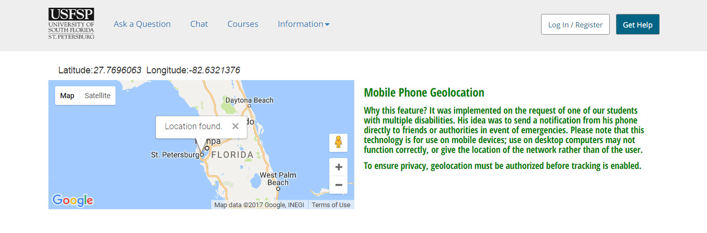

#### [Section VII - 2] Geolocation: Figure 1.

The image above is a screenshot of a geolocation request made from the portal platform. World wide, there is impetus to adopt geolocation apps for safety purposes. This is done for nuts and bolts reasons of incorporating technology that may help students, of course, but also, for the way the students *feel* safer on campus because of it. As mentioned, this was done on the behest of one of our students with disabilities, but we believe it could have broader applications. According to an article on Education Drive, “Campus police are praising some of the apps for creating a new trove of incident alerts and detailed tips, complete with GPS coordinates, detailed physical descriptions, and photos of potential lawbreakers or license plates. And, they say, the new apps seem to be catching on partly because students feel more comfortable with texting or communicating through the apps instead of calling, which may be an intimidating task.” (Button, 2014). The problem, of course, is getting students to download an app. The portal technology above does not require the download of an app; it is built on the latest web technology. Although this technology can work with certain browsers on a desktop, as shown above, it is meant for mobile devices.

#### 

#### 

#### 

#### 3. Some students are unprepared for online learning.

##### Many students approach online learning with misconceptions about the rigor required of the experience.

How this was addressed in the Online Student Support Portal:

*To address connecting students with the people who can help them learn how to handle rigorous requirements: Connect students to librarians, appropriate support staff, and university professors in a more robust and targeted manner, technologically speaking.*

*To address the problem that students may not be as proficient with digital technology as we may assume: The myth of the Digital Native assumes that students are able to find help easily on digital platforms, because they have been using them most of their lives. While it is true that students are familiar with these platforms, they are not necessarily familiar with how to search for help using them. Students rely heavily on Google, but they are not very good at customizing searches to get targeted results. The portal takes advantage of an interface that is Google-like in function, to make the student feel comfortable. Under the hood, however, the database is built to deliver targeted resources for students to get to the help they need. This is done first, through a Google-like search, then via chat, or email. From there, authoritative resources can connect with the student, directing him to the appropriate resources, for example, the Student Success Center or the Student Technology Center.*

More information on portal initiatives to address this item:

*Connect students to help in a more robust manner and targeted manner, technologically.*

##### As mentioned earlier, many students approach online learning with misconceptions about the rigor required of the experience. It has been noted that connecting students with their professors earlier rather than later was helpful in assisting students acclimate to online learning (Lytle, 2013). The Online Student Support Portal interface addressed this very point, ensuring that the ability to connect with professors, or other authorized help, was available on any public-facing page, and through multiple paths. One could start a chat at any time even without a login. Even more refined communication paths are available upon login. Support personnel are notified that a chat has come their way.

##### 6June2017OnlineChallenges_1.jpg

##### [ VII - 3 ] Connecting: Figure 1.

##### A student asks a very general question by starting a chat. There is no information other than the very generic question of, “Do I have to check in every day for my online class?.” Note that no login is required. One certainly assumes that more details are needed.

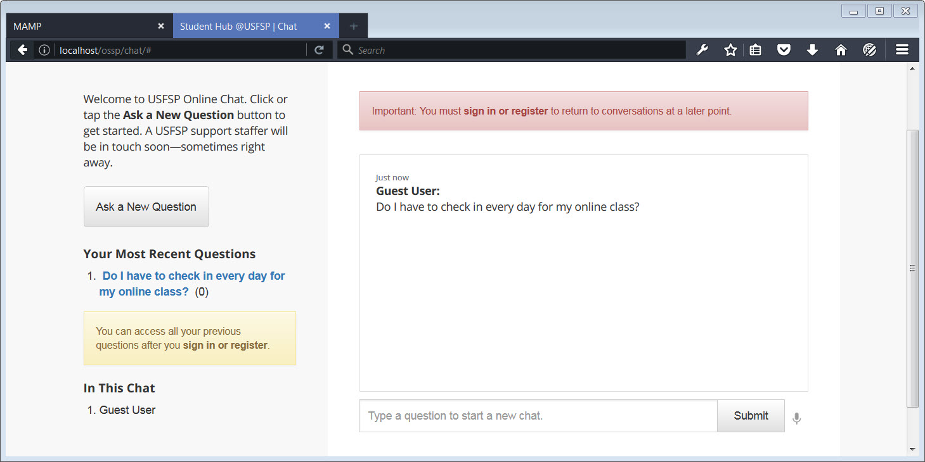

[VII - 3 ] Connecting: Figure 2.

A warning is displayed to the anonymous user that a login is required if no one is available to answer the question immediately, and that there is a need to return to the conversation at a later point.

.

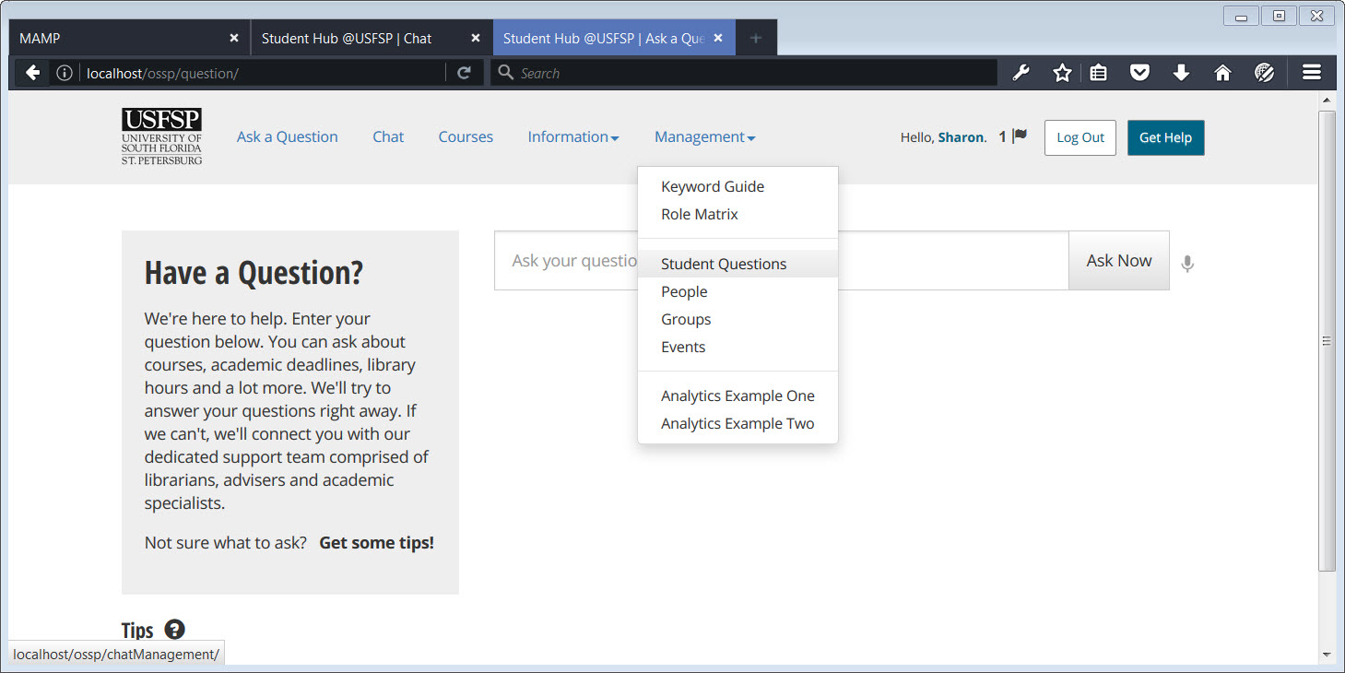

##### [ VII -3 ] Connecting: Figure 3.

##### Simultaneously, on the other end of the conversation, a router has set himself/herself up to monitor student questions as they come in. In this figure, user “Sharon,” who has administrative privileges, is setting up to review the chat questions that have come in.

##### 

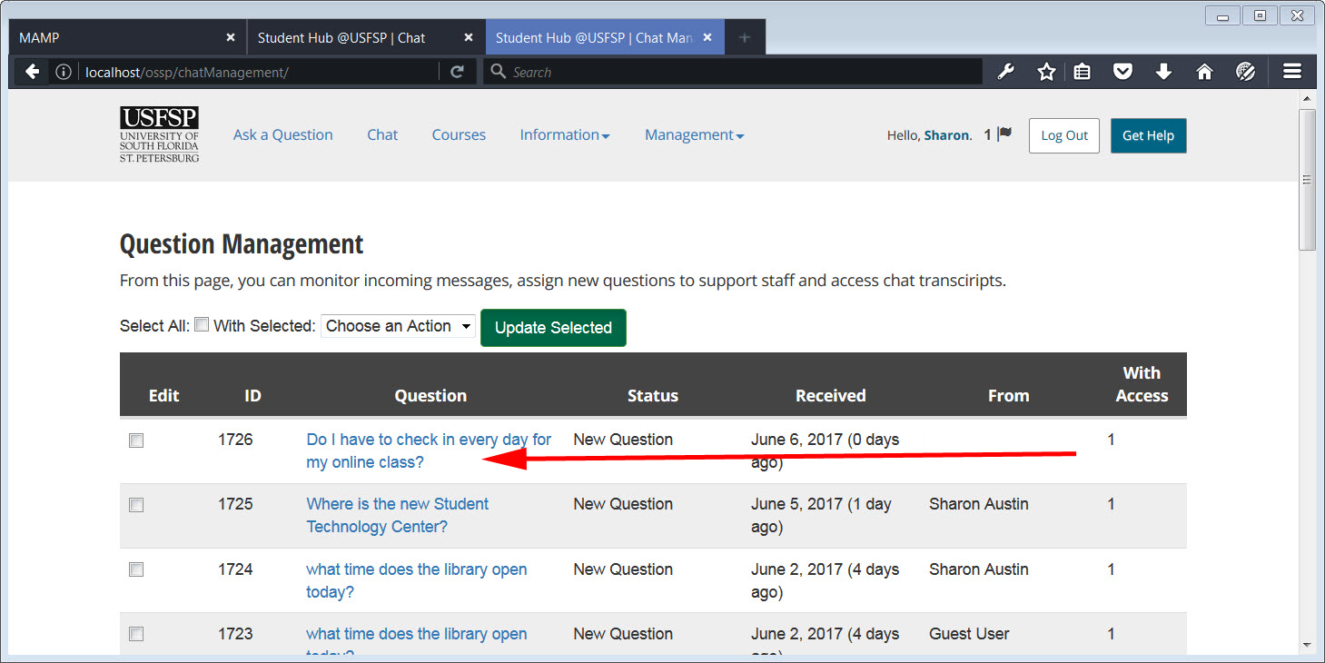

##### [ VII - 3 ] Connecting: Figure 4.

##### User “Sharon,” who has administrative privileges, pulls up the list of questions that have come in, and checks to see that they have all been either answered, or routed to someone who can answer the question. Here, the question that was just asked anonymously, “Do I have to check in every day for my online class,” appears automatically in the Question Management List. The administrator sees that the status is a new question, and has not yet been addressed.

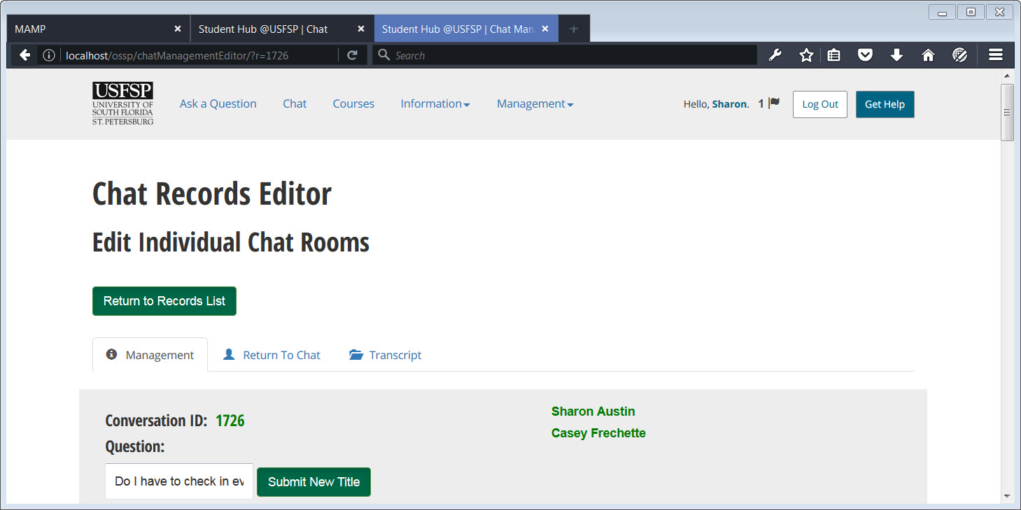

##### [ VII - 3 ] Connecting: Figure 5.

##### The administrator assigns this question to a particular department in the university. In this particular department, which is an artificial department created just for testing purposes, there are three — real — people assigned: Dr. Casey Frechette, Mr. Berrie Watson, and Ms. Sharon Austin. Note that only two of the three people appear on the list. This is because users Dr. Casey Frechette and Ms. Sharon Austin have had additional flags added to their names so that they automatically receive messages about incoming messages, but Mr. Berrie Watson has not yet been flagged for automatic notification, even though he is a member of the group. In this real-life example, the test group did not flag Mr. Berrie Watson for automatic notification because he had real-life work priorities to attend to, and we did not want to disturb him with the constant ping of messages. Put another way, the platform enables very granular control of access to messages, even anonymous ones.

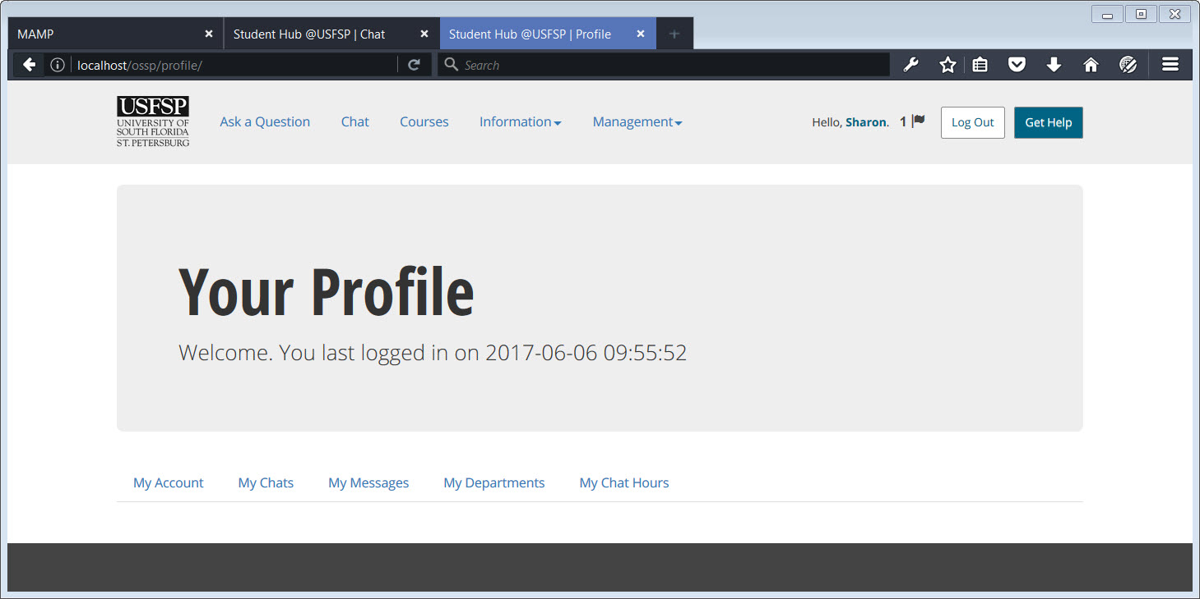

##### [ VII - 3 ] Connecting: Figure 6.

##### In this example, Sharon Austin, as one of the two people who have been flagged to receive automatic notifications, navigates to her personal profile page. (The notification could be sent by SMS text messaging, email notification, or both. In this particular instance, an audible ping from her cell phone alerted her that a new question had been assigned to her). In her personal profile page, user Sharon Austin finds a message notification flag next to her name, located in the upper right hand corner of the screen. This serves as a backup for those who choose not to be notified by SMS text-messaging or by email. (Details of the personal choice for notification are described in another section).

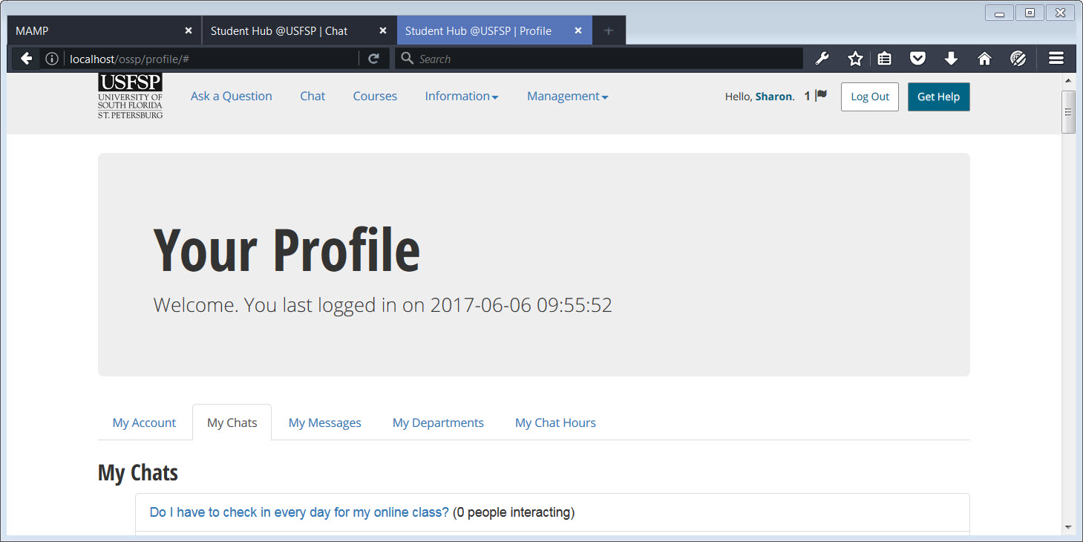

##### [ VII - 3 ] Connecting: Figure 7.

User “Sharon” clicks on the “My Chats” tab, to see the chats have been assigned to her (and also, to Dr. Frechette). As both individuals are authorized to respond to the question, both Sharon Austin and Dr. Casey Frechette may “see” the question, but only one of the two need to answer it. Each authorized responder is in effect, a backup for the other one. User Sharon Austin sees the general question, “Do I have to check in every day for my online class?” from an anonymous user, and that zero people are interacting.

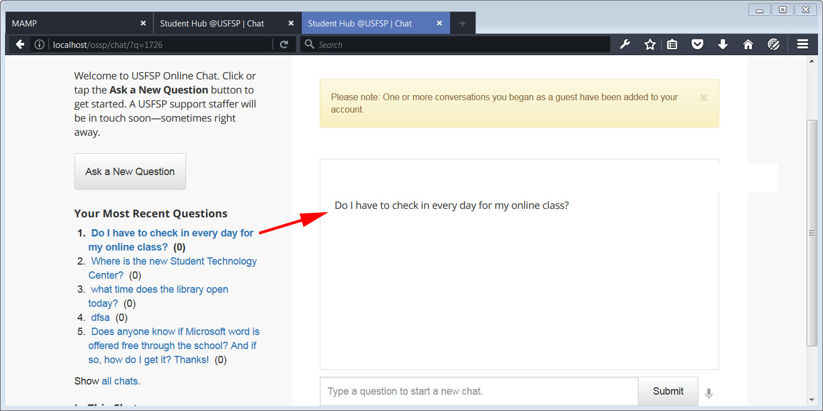

##### [ VII - 3 ] Connecting: Figure 8.

##### The authorized support person, in this case Sharon Austin, goes to the chat room and selects the chat in question from the list of questions on the left. She brings up a particular chat among many simply by clicking on it. Notice that on the left, the “zero” means that no one has interacted with the question yet.

##### . 6June2017OnlineChallenges_9A.jpg

##### [VII - 3 ] Connecting: Figure 9.

The anonymous user, on the other side, sees the name of the person trying to help him. If we continue with the scenario, the student would, in theory, identify a particular class, and the authorized router, in this case Sharon Austin, would be able to route the question to the appropriate faculty member or department.

It should be noted that the questions themselves can, and are, archived after stripping them of identifying metadata, to preserve student privacy. The sanitized questions are then reviewed again. If the question comes up frequently, or is of significance, it becomes a resource as a Frequently Asked Question.

##### To summarize: The mechanism by which the concern that students are unprepared for online learning is a chat platform, developed in-house, that not only connects students with the help they need via chat, or email, but automatically alerts authorized personnel that a question has come in. Further, the questions are archived, and if found to be a common question, or an important one, are converted to an additional resource as an FAQ. An additional point is that this process serves as a resource not only for the students, but for the staff who support them. For example, if there are many questions about technology support, for example, the Student Success Center or the Student Technology Center, then the resources can be indexed by keyword to assist staff who are answering student questions.

*Addressing the Digital Native*

Matt Weber, in a Harvard EdCast, asks, “In our digital world, where anyone with a little know-how can post unverified stories online and frame them as fact, when solid web design can make an advertisement seem like an article, and the question of what is and what is not "fake news" seems to come up on a daily basis, how do young people—"digital natives"—vet all the information in front of them?” (Weber, 2017). As we started to investigate “how” students interact with screens for the Online Student Support Portal, we realized we may have been operating on some presumptions.

##### According to an article in the Policy and Publications section of the ECDL (European Computer Driving Licence) website, “This idea of digital natives is a dangerous fallacy that risks leaving young people without the competences they need for the workplace, and risks leaving businesses without the skilled employees they need.” (ECDL, n.d.). While millennials may have had access to digital platforms from birth, “access doesn’t automatically equal competency” (Glazer, 2016). We soon realized that perhaps, we expected that the students would actually learn how to search on campus. But in an article from the Chronicle of Higher Education, “Confronting the Myth of the Digital Native,” the author found that, “Campus efforts to educate students about their digital presence, if they happen at all, exist as one-off, library-sponsored workshops or course addenda. They usually emphasize enhanced privacy settings on social-media accounts and scary case studies of career-ending YouTube videos.” (O’Neil, 2014).

Put in plain English: When students need help, they go to Google. They may not know how to search to get the answers they need in seeking academic help. So, a Google-like Search feature was built, to look and act like Google, but under the hood the code was directing students to the help they needed.

##### Students *do* use library databases – though they often start in Google. Regardless of the advanced-search capabilities of the database they were querying, “Students generally treated all search boxes as the equivalent of a Google search box, and searched ‘Google-style,’ using the ‘any word anywhere’ keyword as a default,” they wrote. Out of the 30 students Duke and Asher observed doing research, 27 failed to narrow their search criteria at all when doing so would have turned up more helpful returns.

Once students start using the portal’s Google-like search utility, they either are directed to the information they need, or if the answer proves to be unsatisfactory, are offered a place to browse for answers or start a chat. That we address the myth of the Digital Native by removing the intimidation factor as much as possible; we do that by making it look and feel as much like Google as is possible.

In higher education, access to libraries — and more importantly, librarians, is critical. According to Steve Kolowich, in the article, “What Students Don’t Know” A two-year anthropological study of student research habits shows that students are in dire need of help from librarians, but are loath to ask for it.(Kolowich, 2011). Nelson Poynter Memorial Library recently held focus groups in which students, faculty, and staff were interviewed multiple questions concerning, among other things, library communications and collaboration. As it relates to this topic, several points arose from the summary of the focus groups.

Regarding Collaboration:

“Librarians are no longer on the front lines, don’t get people coming directly to them, so rely on circ to direct students to them (staff).”

“It’s hard for people not on the front lines to know where to direct/refer people. (staff)”

Regarding Information Literacy:

“We need to know how to ask for what we need (student).”

Regarding Marketing:

“Don’t know how to use a chat with a librarian (student).”

“Create a more obvious presence that help is available (student).”

The portal addresses these problems multiple ways:

*Regarding Collaboration:*

The ability to archive chats until experts may view them has already been documented elsewhere in this report. However, there are some additional features developed specifically for this Online Student Support Portal that has particular relevance to collaboration.

First: The chat provides a keyword list so a staff member, unfamiliar with the detailed list of which librarian answers which question, is able to route the question to the appropriate librarian, or group of librarians. Many chat technologies embody a technology that enables one staff member to forward a question to another staff member. This is a technological bridge. However, the technology alone is not enough. A “bridge” to connect the different kinds of expertise, by concept, is also needed. This is where the keyword index comes in. It allows staff members who are not expert in an area look up keywords to find the right expert. This is “bridge” feature to the portal that is not available on commercial, off-the-shelf chat technologies.

Second: Targeted, context-sensitive chat widgets. The chat widget will programmatically understand by the context of the page that it is on that a student is seeking help on a library question. The librarian will receive the question. In other words, it is context-sensitive. This is another “bridge” feature on the portal that helps bring the right librarian the right question. Taking the example of the Library Guides for Nelson Poynter Memorial Library, we could illustrate context-sensitivity.

As an example, a “context-sensitive” chat widget could be embedded on this page for the Liaison Librarian, Gary Austin. The context in this particular case would be for the Subject Specialties that concern Business.

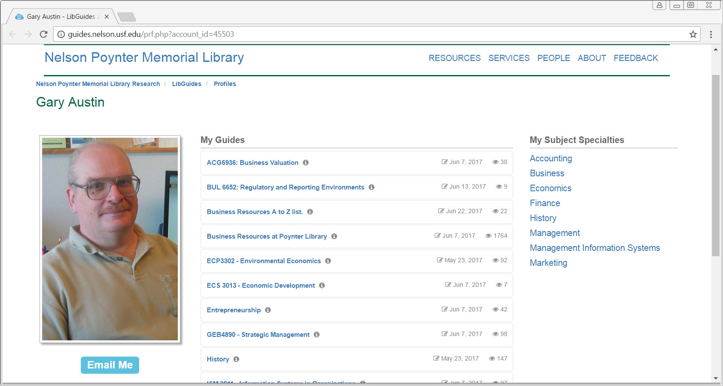

##### [ VII - 3 ] Example of a Recommended Context-Specific Location for Chat: Figure 1.

Gary Austin would be able to install a chat widget on this page, or any other page that he would be responsible for, as a librarian. The chat widget would be able to show specifically whether Gary Austin is available for chat. This, in turn, would depend upon the hours set for his individual chat widget on his profile page. Individual, context-sensitive chat widgets are available through the Online Student Support Platform; if such widgets were embedded in pages such as the one above, it would create a more obvious presence that help is available. (The request to create a more obvious presence that help is available was a comment from a student from one of the Library focus groups held in the first part of 2017). In the screenshots below, we show how that would be done in the Online Student Support Portal.

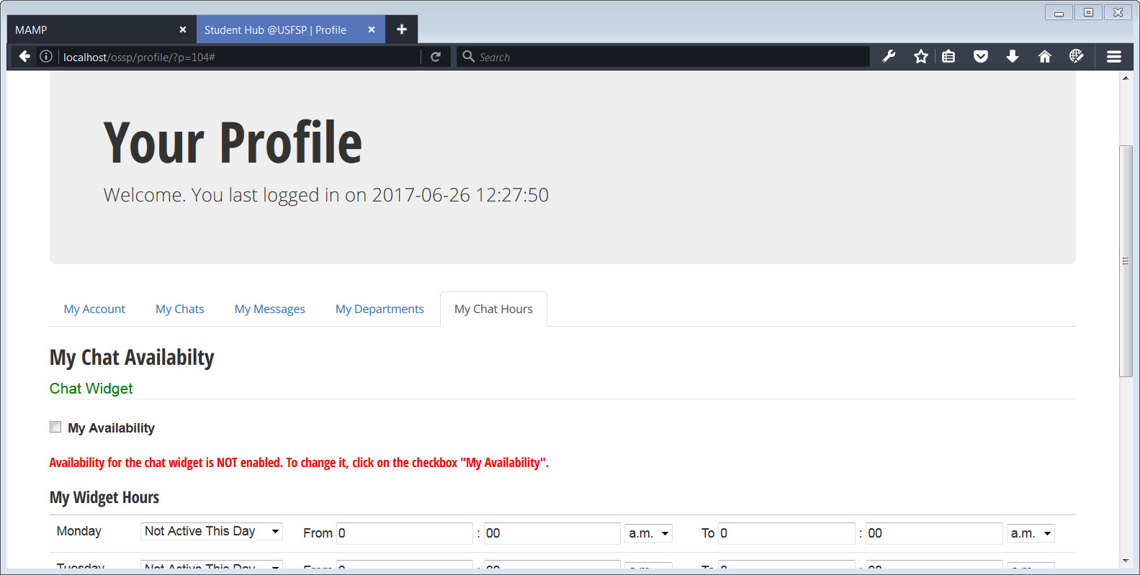

##### [ VII - 3 ] Individual Chat Availability: Figure 1.

In the screenshot above, we see that Gary Austin has not yet set his personal chat to show availability. He is able to set chat *hours* of availability, however, without making the chat itself available. This is so that he may set hours in advance. Once he checks the “My Availability” checkbox, the chat widget, that we may assume could be embedded on the specific LibGuide page for which he is responsible, would signal that he is available for chat. The hours set would be unique to him, and not to any other librarian. We’re using the library as an example, but this chat capability would be available to all departments at USFSP, for example, the Journalism Department.

There’s an additional, important point to be made: tracking by context is enabled. In other words, the architecture of the portal is set up to see “which” chat widgets on “which” pages are being used, and when. It also has the capability to track which device is being used to access the particular chat widget, and during which hours. The question itself is not tracked. There is no association between the question asked, and the technology by which the question is asked, to preserve student privacy. But the analytic information available from such tracking on the context-sensitive, personalized widgets is absolutely invaluable.

*Regarding Information Literacy:*

Students simply need to be able to connect with help. The library already embraces five different methods of connecting with students; chat, email, phone, appointment, and walk-in. The portal allows this to happen campus-wide, and to connect students to diverse groups that may share answers. For example when a student asks the question, “How do I do research for my business courses” , the answer, as it has been conceived for this portal, is to route the question to BOTH Gary Austin (The Library Liaison for the Business College ) and an authorized person at the Kate Tiedemann College of Business. Right now, delivery of content is in silos. If a department has a chat feature, the chat question does not cross departmental boundaries. The Online Student Support Portal, envisioned to be a fully integrated system, addresses this problem. As mentioned earlier, if such widgets were embedded in pages more broadly on campus, it would create a more obvious presence that help is available to the student. This matters to the student, and would help enforce the concept that the university is committed to student success.

*Regarding Marketing:*

One comment from a student was that they did not know how to use a chat with a librarian. This is understandable, as chat technology is not commonly used across campus. Right now, only a few departments on campus, such as Nelson Poynter Memorial Library and the Journalism department, use chat. If the chat widgets were used across the board, then they would gain familiarity with students. Part of the “don’t know how” is simply, that students are unfamiliar with it. Embedding chat widgets everywhere, instead of on only a handful of locations, should help create a more obvious presence that help is available.

The important point to remember is, that it is not simply the fact of embedding “a lot” of chat widgets, everywhere, that will help, although we do believe that is very valuable in its own right. By embedding chat widgets broadly, we ease the burden placed on the student in the position of finding the “special” places that only the chat widgets may be found. We certainly support the broad implementation of chat widgets! That said, we believe that it is by embedding *context-sensitive* chat widgets, that tie to targeted offices of support, that will make an even greater difference. The very presence of a particular chat widget on a particular page already “helps” the student in asking a question, because the support person on the other side of the chat will understand that the context of the question came from a particular page.

#### 4. Some students are unprepared for college.

##### The transition from high school to college challenges many incoming students.

*To address connecting students with the people who can help them fit in with college culture: Connect students to appropriate support staff and community assets in a more robust and targeted manner, technologically speaking. In terms of addressing a young person’s outreach for help, the portal was designed to be able to address questions asked anonymously.*

*To help young students embrace the college culture outside the walls of the classroom: Incorporate community connections, technologically speaking.*

More information on portal initiatives to address this item:

Many of the initiatives that address the concerns for item 3 above also address item 4. The difference is that for concern 4, the focus is on social and community connections. This initiative dovetails with USFSP Regional Chancellor Sophia Wisniewska’s Core Values outlined in the VISION 20/20 Strategic Plan is the *Commitment To Community*. “USF St. Petersburg connects seamlessly to St. Petersburg and the surrounding region. Our students enroll in the city as well as USFSP, bringing to the city the exuberance that only a residential campus culture can provide. Our community-based partners and mentors multiply opportunities for students and challenge faculty and administrators to recognize new areas for innovation and exploration. Together we shine.”(Wisniewska, 2014).

The value of community involvement can not be underestimated. “Developers and managers [do not] always remember every single detail on every single project; full-fledged community governance not [only] enables the users to share content, but also serves as [a] valuable knowledge base which can be continuously improved upon by [its] members through editing, rating, and review activities.” (Kayhan et al., 2013).

How is a student made aware of community connections? There are many great initiatives already in place at USFSP; all are certainly to be applauded for their success. Here, we address a contribution that may be made to the success of integrating the community via the Online Student Support Portal platform. We believe we have found a way to capture the community involvement and assets, and structure them in such a way as to surface them as results in student searches, as this is how students tend to find information. Thus, we focus on the search mechanism, develop data structures that capture links to the community, and enable the search mechanism to bring these community links forward to the student as search results.

At Illinois Wesleyan University, “The majority of students — of all levels — exhibited significant difficulties that ranged across nearly every aspect of the search process,” according to researchers there. They tended to overuse Google and misuse scholarly databases. They preferred simple database searches to other methods of discovery, but generally exhibited “a lack of understanding of search logic” that often foiled their attempts to find good sources. (Kolowich, 2011). It has already been noted earlier in this paper that we address the myth of the digital native in constructing a Google-like search. The portal also incorporates context-sensitive help menus on each of the major components. For example, on the page for Geolocation, a student can find additional information by clicking the Help Menu:

##### 

##### ContextSpecificHelp.jpg

##### [ VII - 4 ] Context-Sensitive Help: Figure 1.

Addressing the fourth concern really meant addressing the non-academic challenges faced by students outside the walls of the classroom, on campus, of course, but also, online. This is a concern not only for administrators, but for the students themselves. Beetham noted: *‘At key points in the student journey – pre-induction, on placements and years abroad, between academic years, and on graduation – their relationship with the institution is a virtual one. Digital services are critical to establishing and maintaining a sense of belonging across these spaces. And service providers have to find a balance between branding their offer clearly, and blending with students' own preferred services.’ (Beetham et al 2013).* And, in 2014, made this observation: *‘A related concern students have is being pushed too fast towards the public spaces of the open web, in the name of borderless classrooms or third space learning. They understand that this is somewhere they need to develop a presence, but they also see university as safe space where they can play and fail, try out new ways of expressing themselves and new identities. This could be seen as part of a more general need for affiliation and belonging, which is increasingly played out in digital as well as physical spaces.’ (Beetham 2014).*

In addition to developing a search mechanism that pairs with community data, the team also developed public-facing pages that consolidated useful information, with no search required. In short, to address the fourth concern, we try to support the supporters. We accommodate the “informal” support system of friends, family, and community by providing the assets they need and a technological path to connect through.

Publishing daily office hours is valuable to any who work, and must break away from work, to take care of student matters, such as parenting. Parents need to coordinate time off from work to support their child, so a campus-wide hours availability page would be invaluable to them. This is exactly one such feature on the portal. In the example below, one may see that the day of the week this was taken was a Wednesday, and that all offices on campus have their Wednesday hours highlighted. The hours are dynamically generated from the data entered by the stakeholders themselves.

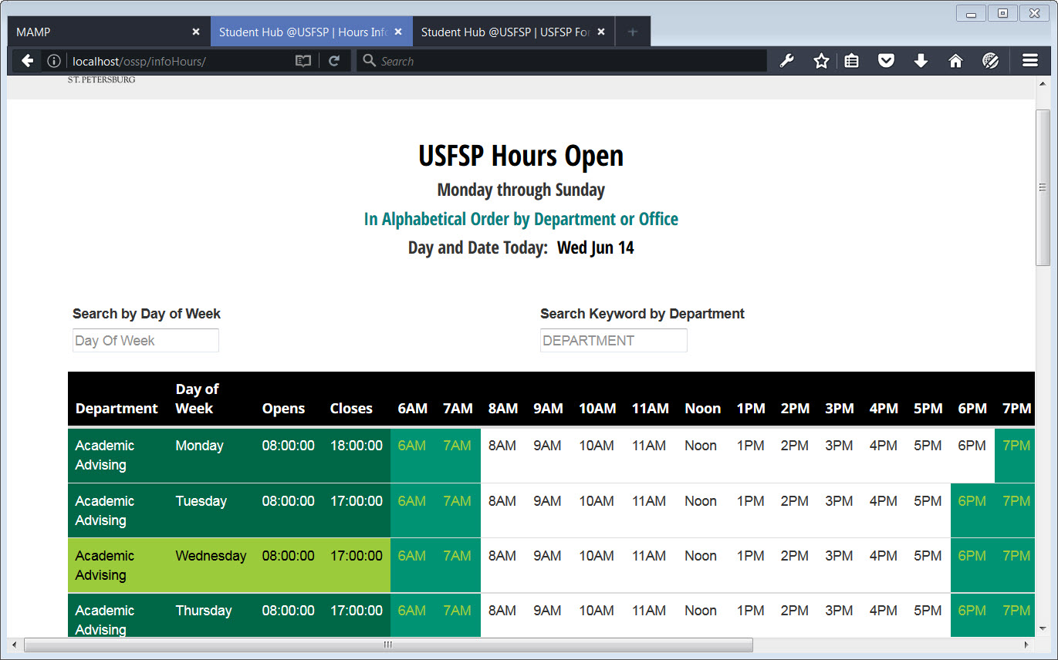

[ Section VII - 4 ] Campus-Wide Hours of Availability: Figure 1.

However, “hours availability” is not just about departments, it is about individual people. In addition to the campus-wide office hours page shown above, the portal chat also has the ability to reflect availability. This was mentioned as a way to connect students to academic help for concern 3, and we expand on its application for concern 4, to connect students to help above and beyond academic concerns.

Faculty office hours are particularly valuable. Dr. Maryellen Weimer noted, “Although we hold office hours as a way of supporting students, they benefit us as well. That time together helps strengthen our connections with students. We learn of student concerns—about assignments, course content, and their progress in the major. Perhaps those benefits deserve a mention.” (Weimer, 2015). In short, office hours are valuable to all in education—students and their support system alike. This capability could extend to departments as well as individual faculty or staff members. There is an ability to program the widget so that hours could be displayed on the widget, if administrators so choose. Each individual department could have its own chat widget, and have an indicator as to who was available, and who was offline at the time.

Earlier, we were introduced to the concept of individual widgets that allowed office hours and availability to be set. Below, we see a screenshot of a “next step” that a faculty, staff member, or department representative would take to set their personal hours of availability.

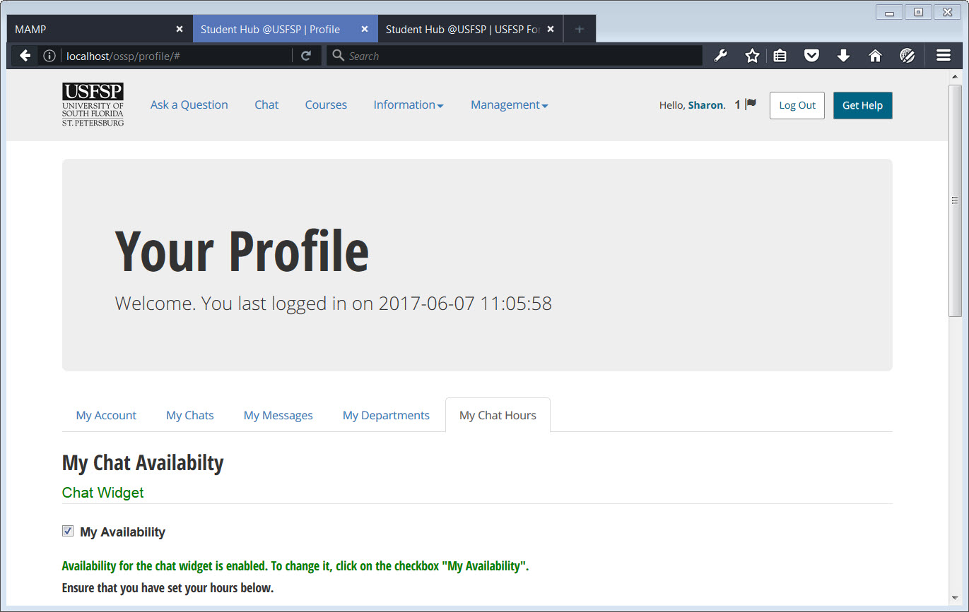

##### [ VII - 4 ] Chat Availability: Figure 1.

In the example above, user “Sharon” has set her personal widget to display that she is available on chat.

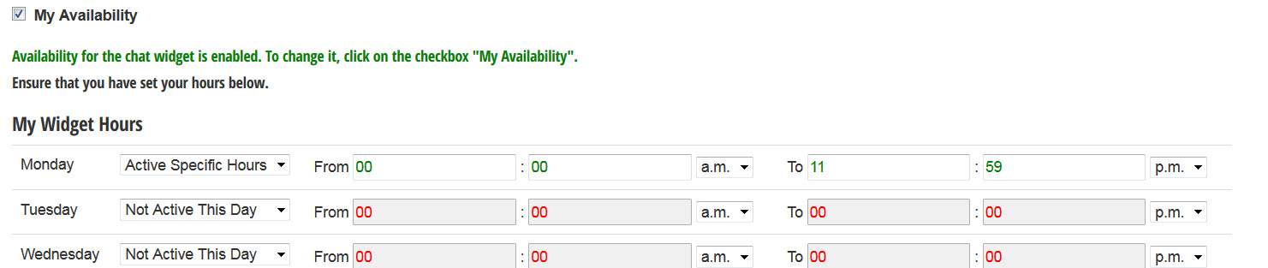

##### [ VII - 4 ] Chat Availability: Figure 2.

Above is a screenshot of the manner in which widget hours may be set on an individual basis, in advance.

As mentioned, the Online Student Support Portal created paths for assets that may not be under the formal administration of USFSP, such as community assets. It also allows for fluctuation of status. Organizations come and go as funding comes and goes, but what often happens is that the expertise stays in-house, albeit under a different name. This platform has ways to adjust to the fluctuating status, keeping the asset but changing “how” the information is communicated.

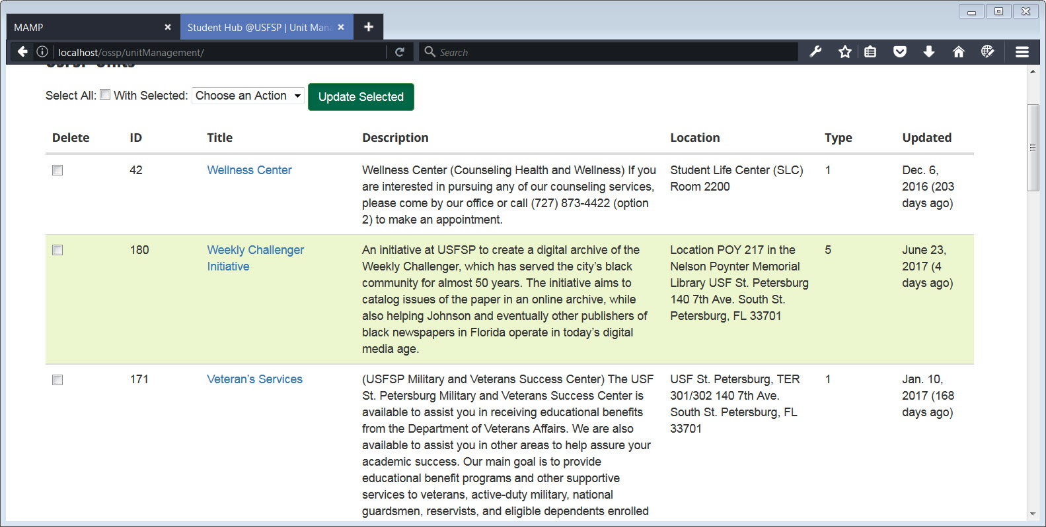

##### [ VII - 4 ] Organizational Status: Figure 1.

In the above screenshot, you may see three institutional units listed: The Wellness Center, The Weekly Challenger Initiative, and Veteran’s Services. It so happens that funding for the Weekly Challenger was vetoed by Governor Rick Scott in June 2017. When this summary was written, it was unknown whether other funding would be available to continue the initiative. The work done by the staff still remains. Note that there are two “kinds” of units in the list; two of them have the number “one” associated with them as a unit type, and the Weekly Challenger Initiative has been designated as a unit type number “five.” When a campus directory is built dynamically from the lists, administration may set which units get displayed on the directory based on the “type” of unit they are. In the case of the Weekly Challenger Initiative, because funding has been cut (at least for now), the unit was assigned a type that would not display on certain public-facing directories, nor would it display on the office hours page. However, the connections remain. The work is still there, and members from the community can still communicate with USFSP staff — including via the chat mechanism. This allows work to continue between the USFSP staff and the community they are involved in. It’s just a matter of how the group is displayed in directories. It allows for granular control of display. When funding became available again, we simply changed the unit type from “Special Resources” (Organizational Type Five) back to “Academic Department or Unit” (Organizational Type One).

Now, fortunately, we know that funds for the Weekly Challenger continue from other sources. So, the example that precedes is meant to illustrate what happens to organizational information when its status changes.

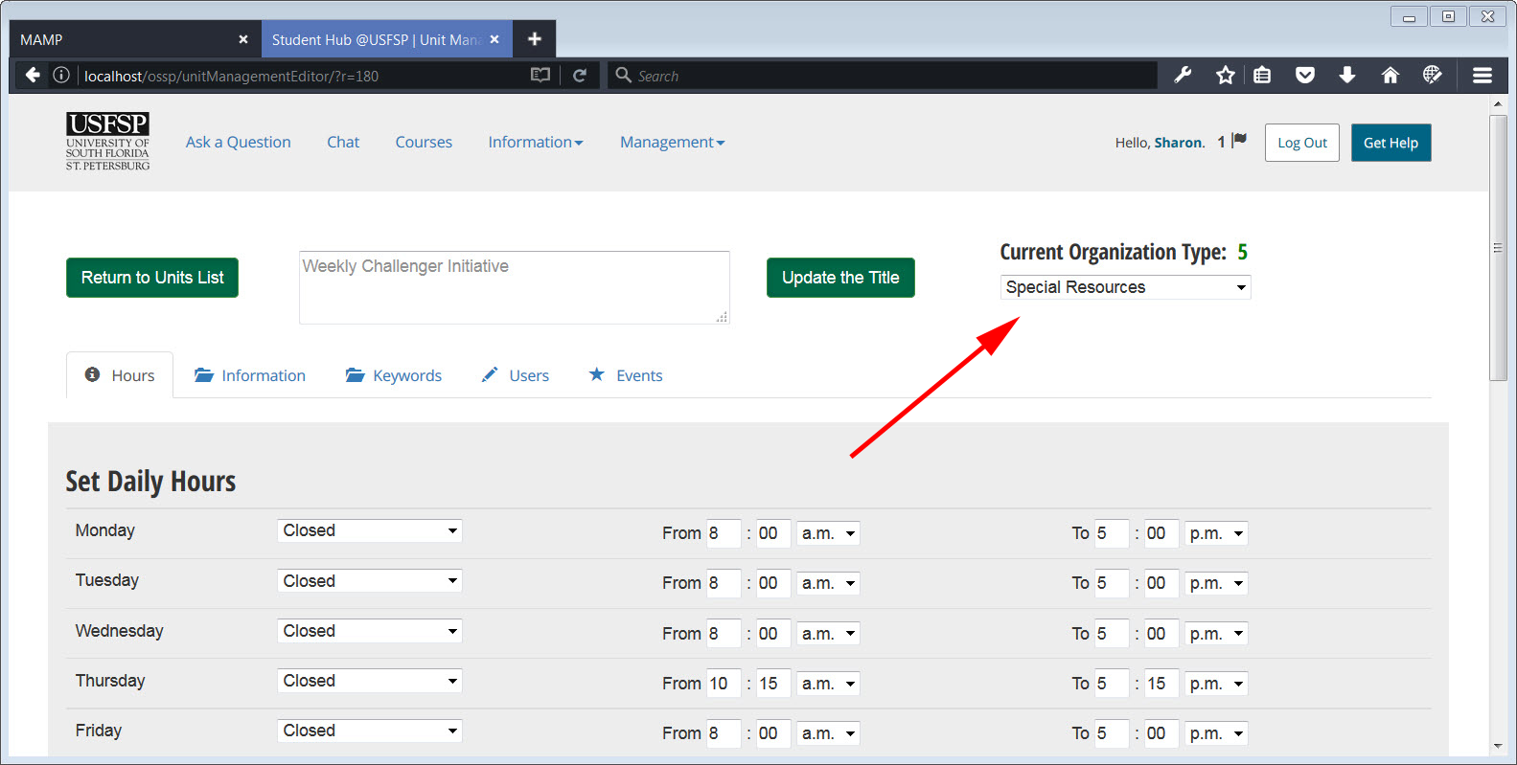

##### [ VII - 4 ] Organizational Status: Figure 2.

When it came to organizational hierarchy, the portal was designed to accommodate the fluctuations of academic funding, by finding a way to preserve the network channels established by faculty and staff, no matter what the status of funding is. Relationships take a long time to build, and they should not disappear when funding does. Notice that office hours are still available to be changed. For the purposes of this demonstration, the organization has been categorized as a “type 5” organization, and therefore, the office hours would not display on the “campus hours” page. That said, the individual chat widget is separate, and would still be able to set and display office hours on any special web page set aside for that purpose. Community connections based on earlier work still have a way to thrive, no matter the status of the organizational group.

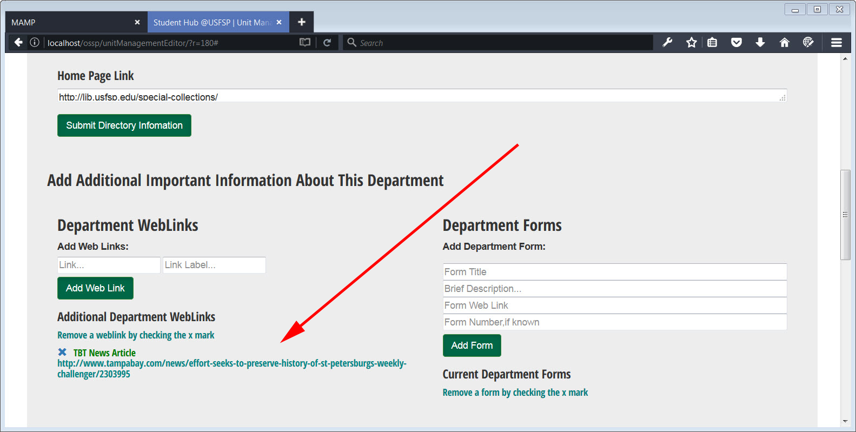

##### [ VII - 4 ] Organizational Status: Figure 3.

The screenshot above shows how content is saved in an organizational unit that has temporarily been assigned a category type of “5.” All content is still saved. It’s just displayed differently.

The very fact that content is displayed differently helps students, staff, and community understand the context of this particular group in USFSP’s organizational hierarchy. Final decisions on “what” to display “where” and “when” would need to be determined by administration, but the point is that the portal architecture allows granular display of content depending upon the nature of the organization. It’s is important to remember, that even though the information may not be displayed on a website, the portal architecture can, if adminstration so desires, to allow the contact information for community connections to surface even if there is not a web page for it. The portal was designed to allow multiple ways to connect with the community. And it is community involvement that helps our students in so many ways.

“Community” can mean a virtual community as well as a physical one. All of us benefit from USFSP’s OLITS “Monday Minute” videos. In the screenshots below, we will see Kaya van Beynen provide instruction on how to do search for children’s literature, and we will see see Karla Kmetz-Morris providing instruction on how to add alternative text to Word and PowerPoint. The very valuable information in these videos and others belong to all who want to be more inclusive; this means not only the virtual community of educators, but of *any* business or office that uses Word and PowerPoint.

The portal has the ability to program such results into searches. It’s important that the results come up in searches because, as we now understand, that is how students come to find information. Although the capability exists to do this, the capability has not yet been implemented in the portal. We would want to clear this with administrators before implementing the feature. However, should this be allowed to go forward, it would be one way of demonstrating this university’s deep commitment to the community.

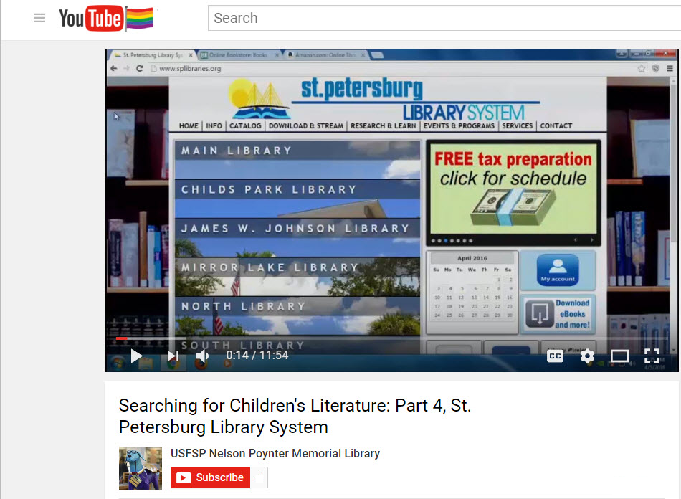

##### [ VII - 4 ] Virtual Community: Figure 1.

In the screenshot above, we see a frame from a video, produced by USFSP’s Nelson Poynter Memorial Library, on to search for children’s literature. Notice that a community library is featured in this video; the community library is a very valuable community asset. Featuring a community asset in USFSP’s video is one way of showing our commitment to community. The set of videos highlighted in this example is but one of many assets that, although created for Education students at USFSP, are in effect, an asset for all in the community. There are quite a few people in the community who have children, so it’s easy to see the broad reach this set of videos, produced by the library, could have for all! The value of this is not to be under-estimated; videos such as these make our institution relevant to the everyday lives of the people of our community.

In the next example, we see another video produced which has broad applications for anyone in the community who uses Word or PowerPoint, and wishes to ensure that the content is available to those with disabilities.

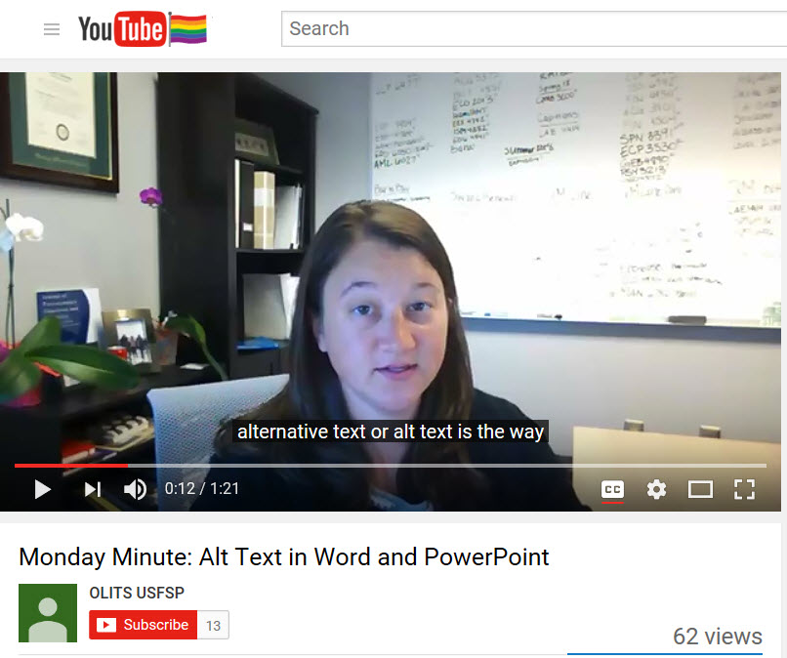

##### [ VII - 4 ] Virtual Community: Figure 2.

In the screenshot above, we see very valuable information on how to add alternative text to Word and PowerPoint by Karla Kmetz Morris, Manager of Instructional Design Services, for Online Learning and Instructional Technology Services (OLITS). This video is another community asset for all.

So, how would the Online Student Support Portal incorporate such video assets from the Nelson Poynter Memorial Library, and Online Learning and Instructional Technology Services, into generating results for student searches? Current configuration of the portal has an interface that allows stakeholders to input the links themselves. Because the stakeholders themselves are associated with certain departments, so too, would be the association of video assets in the Online Student Support Portal architecture.

Let’s use the example of adding a video asset as part of Online Learning and Instructional Technology Services (OLITS). Below, you see a generic interface for adding information about a department. In the particular example below, we have signed in as an authorized user of OLITS, so you are seeing an OLITS screen below.

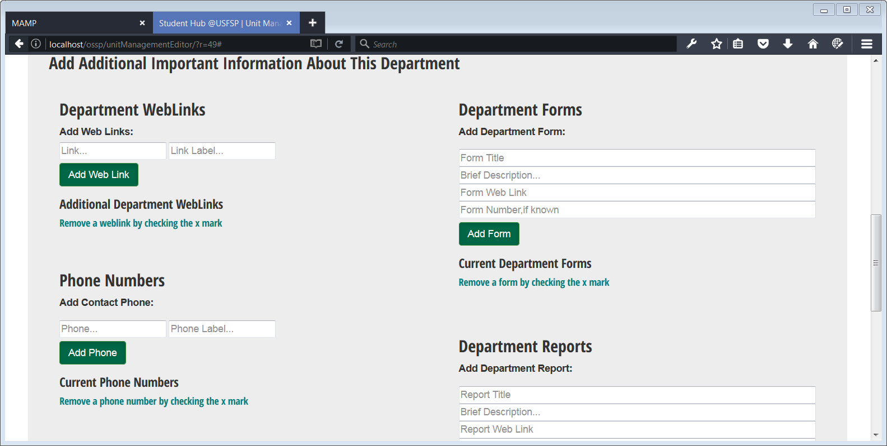

##### [ VII - 4 ] Attaching Video Resources to a Unique Department: Figure 1.

In this case, we want to add the OLITS YouTube Channel to Department Weblinks (You may see the area in the upper left hand corner of the screenshot). We won’t be adding EACH of the videos produced by OLITS, only a reference to their YouTube Channel. It is not the purpose of the portal platform to become a repository; the purpose is to surface information that is buried in silos among departments. The portal platform will understand that this particular link belongs to OLITS, and not another department. The videos created by OLITS will not be put in the same “bucket” as the videos created by Nelson Poynter Memorial Library, even though they are both videos on the YouTube channel. This will enable much more targeted (and therefore convenient) searches for users. This is important, because we understand that it is by searches that students find information.

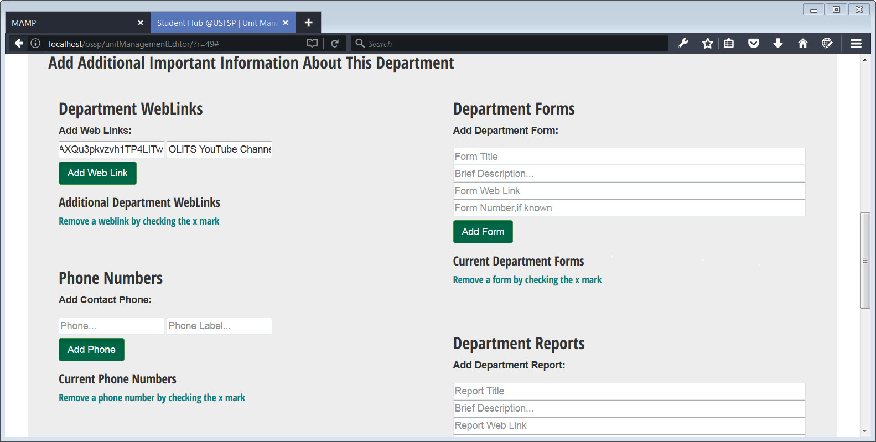

##### [ VII - 4 ] Attaching Video Resources to a Unique Department: Figure 2.

In the screenshot above, the generic YouTube Channel link has been entered in the Department Information Page for OLITS.

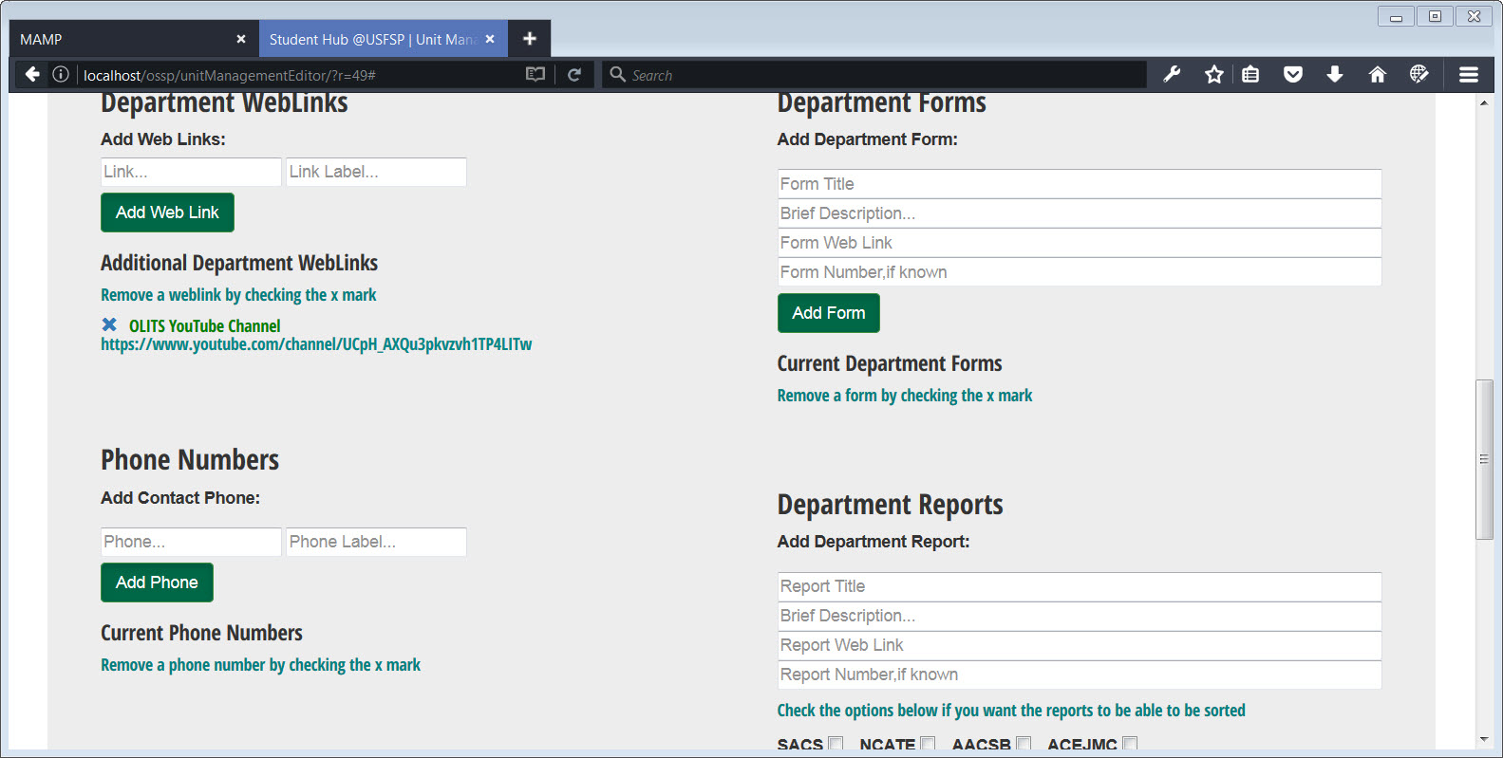

##### [ VII - 4 ] Attaching Video Resources to a Unique Department: Figure 3.

The YouTube Channel for OLITS has been added to the information associated specifically with OLITS.

Currently, the interface captures data associated with different departments at USFSP. A next step would be to add programming that captures this information to feed the artificial intelligence so that it may return a targeted reply when a student asks, for example, “Where are the OLITS videos”? This has already been done for department descriptions and locations; tests on this have been successful. However, administrative approval should be set before building a mechanism by which searches may bring up “informal” contacts of the community that are involved with USFSP. The code libraries to accomplish this have already been developed in-house by Dr. Frechette, and are reusable for this purpose. However, the process should be reviewed by administrators before implementing it.

It is not the purpose of the portal to serve as a repository of content. The purpose of the portal is to serve as a repository of *connections* between people, and if administration deems it appropriate, to surface these connections out of silos. We believe this may be one of the data points, “More out of silos to a shared vision,” as described in the “Key Shifts,” (i.e. Shifting from a culture of….to a new progressive thinking culture) for Strategic Goal #2: Student Success and Culture.

The case of the local community involved with Weekly Challenger Newspaper may serve as an example on how community connections may be preserved, and surfaced into search results (if administration were to approve it). Newspaper editor Cleveland Johnson founded the paper in 1967 as a way to tell the story of the black community in St. Petersburg. In an interview with Bay News 9 reporter Cait McVey, Lyn Johnson, his daughter, said of her father, “That was his goal. To highlight the good in the black community” (McVey, 2016). The initiative to preserve the issues of the Weekly Challenger was undertaken by USFSP. This isn’t just about archiving old editions of the newspaper, it was about preserving community history, and maintaining personal community connections.

Community connections help our students navigate through first-time college experience, so we want to make sure that we keep the personal connections, no matter what else is happening administratively. Of course, email accomplishes that. But keeping connections via email only don’t give these connections a way to surface to the student through searches, or special web pages. This platform allows us to surface the community connections through targeted searches (if approved by the administration).

So, how would the Online Student Support Portal incorporate such assets into student searches? There’s a different path for these connections than what was described for the video channels produced at USFSP. This is because the portal takes advantage of and ability to capture and route two-way communication, very specifically between stakeholders at USFSP, and members of the local community. That connection is already in place via email, but as was mentioned earlier, but we want to take that connection out of silos.

The portal architecture has a capability whereby “departments” or units that have special status or are unofficial may be set up; in the current configuration of the portal, such departments would not display on any official site at USFSP. Yet, content associated with such departments is preserved. In this example case, some of the content would be the community connections. It is the stakeholders themselves who input the connections with the community.

In our example, and for the purposes of a demonstration, the Weekly Challenger Initiative has been temporarily assigned a category 5, “Special Resources.” The final determination of the category would be made by administrators, of course. In this demonstration case, we are in the process of adding users to the group. Two members have already been added, and now we will add a third.

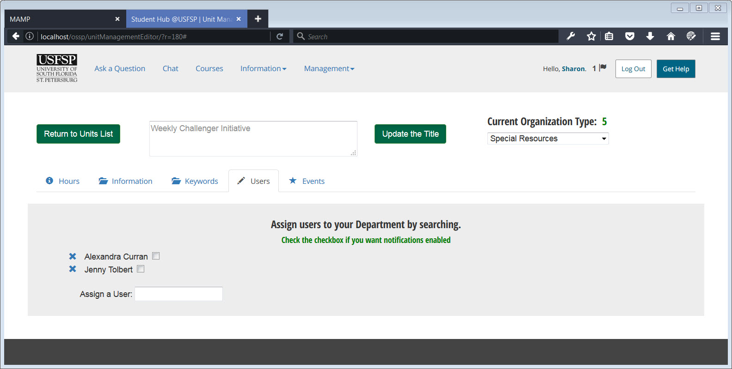

##### [ VII - 4 ] Granular Groups: Figure 1.

We want to add another user to the people who work with Special Collections and Archives, so we start to enter some text for the word, “David” into the search box for “Assign a User.” Notice that after entering only three letters, a feature similar to “Google-suggest” takes over and starts bringing up suggestions. The “Google-suggest” feature was developed in-house as part of a platform accessibility initiative to help students with motor skills disabilities; this feature brings the content to the user instead of forcing the user to find the content. But it applies broadly across the platform for *all* users because of its convenience, and to students in particular because of their tendency to use search mechanisms to find information.

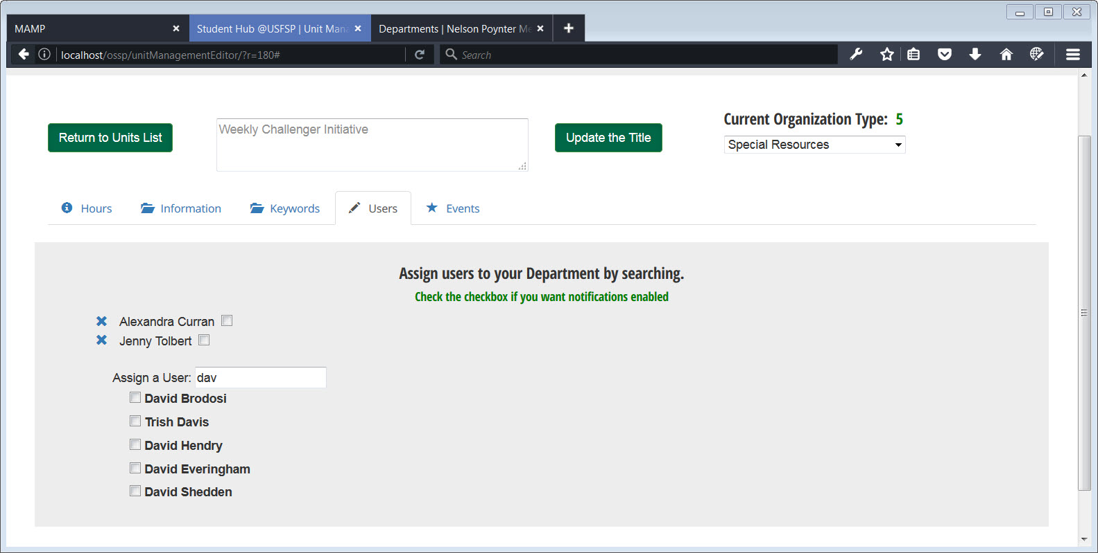

##### [ VII - 4 ] Granular Groups: Figure 2.

When we start typing in a few letters, we get “Google-suggest” style results that contain the letters, “D,” “A,” and “V.”

#### WeeklyChallengerE.jpg

##### [ VII - 4 ] Granular Groups: Figure 3.

In this particular case, we add, “David Shedden” by simply clicking on the checkbox. He is immediately added to this group.

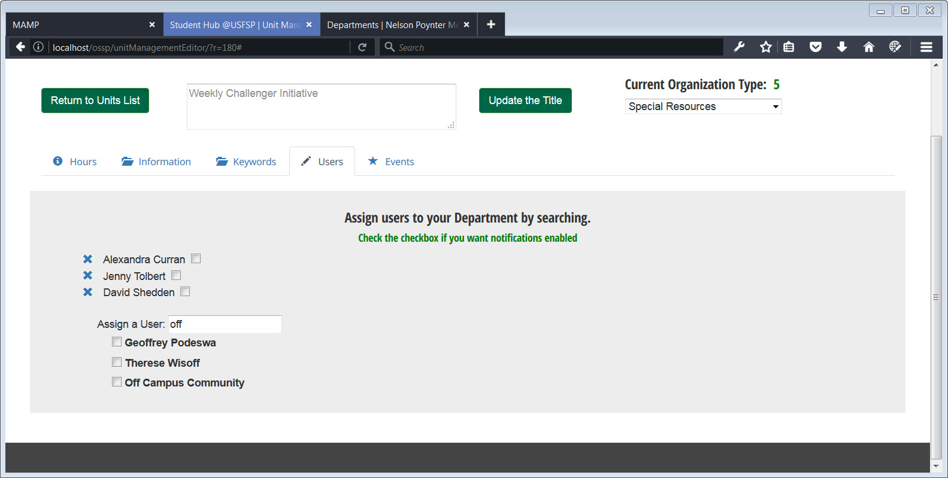

##### [ VII - 4 ] Granular Groups: Figure 3.

We may also add members from the community, as is shown with this test email case. Real community members may be added, such as Lyn Johnson, the daughter of Cleveland Johnson, the founder of the *Weekly Challenger*, should she choose to be. One must first clear it with administrators, of course, but the community may absolutely be involved, and communications lines set between students and community. It may be seen that the very architecture of the platform aligns with the university’s Core Values, “Commitment To Community.” It truly aids in allowing USF St. Petersburg to connect seamlessly to St. Petersburg and the surrounding region.

So what happens if a stakeholder changes the organizational type from a 5 to a 1? Nothing at all happens to the content. Changing the status from a category 5 to a category 1 simply allows the content to be displayed publicly, according to standards determined by administration. Here is the very important point about this: Changing status only changes the *display* of content. It does not change the content itself, nor does it create content or destroy content. It does not create web pages or destroy web pages. There is no webmaster to go through. The portal architecture allows the stakeholders to control the display of content, simply by changing the option on the drop-down list. This has a great advantage over processes that rely on creating or destroying web pages, as it removes the risk of leaving “dead links” on web pages.

Another type of “group” set up within the portal is for partners, such as those with the Pasco-Hernando State College. Both the College of Education and the College of Business have a presence there. A screenshot below illustrates their presence in the Online Student Support Portal. Other partnerships may be included, such as the Strategic Partners referenced in VISION 20/20, USFSP’s Strategic Plan.

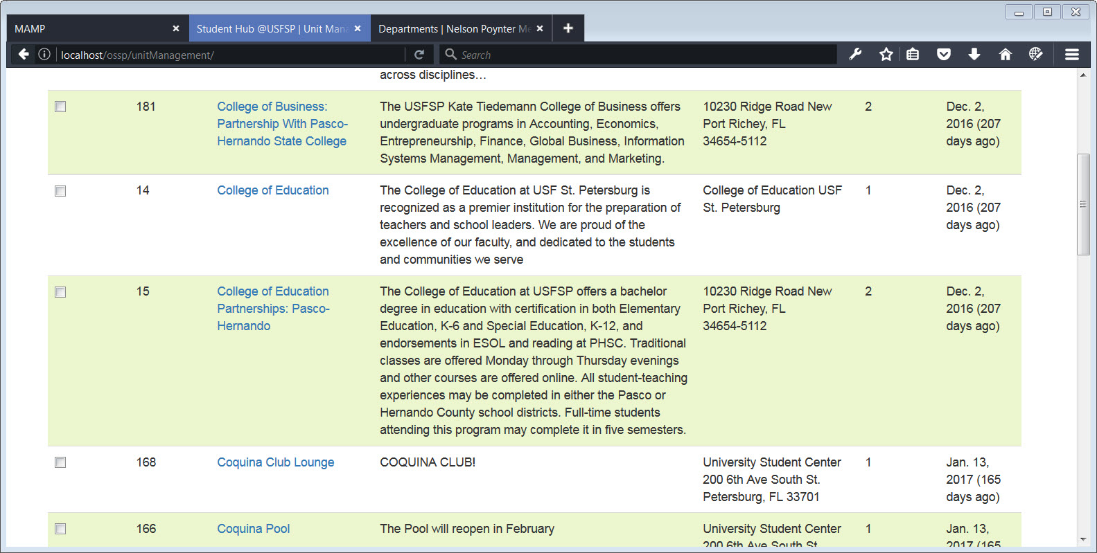

#### 

##### [ VII - 4 ] Partnerships: Figure 1.

In summary, the platform was designed to incorporate community, and partners, with the all at USFSP. By finding ways to preserve the connections between partners, the online and local area communities, and students, we feel we can help make headway in helping students overcome challenges in transitioning from high school to college. It takes a village to raise a child.

#### 5. Failure to provide timely, comprehensive support to a growing online student body may interfere with our alignment with SACS requirements.

##### *As the portion of instruction delivered online increases, so does the importance of providing adequate support services.*

##### *How this was addressed in the Online Student Support Portal:*

##### *Create special interfaces to allow stakeholders to tag reports necessary to SACS, and create a special, public-facing page, dynamically populated by the stakeholders themselves. This dynamically-populated page allows auditors to search for reports relevant to SACS and other important institutions.*

More information on portal initiatives to address this item:

University reports, such as SACS accreditation or CLERY reports, are at times required to be produced upon request with very little notice. It is not only the report itself and “where” it is that is important, it is also important to know “who” owns the report, or is responsible for its publication. The portal platform supplies an easy way to do this.

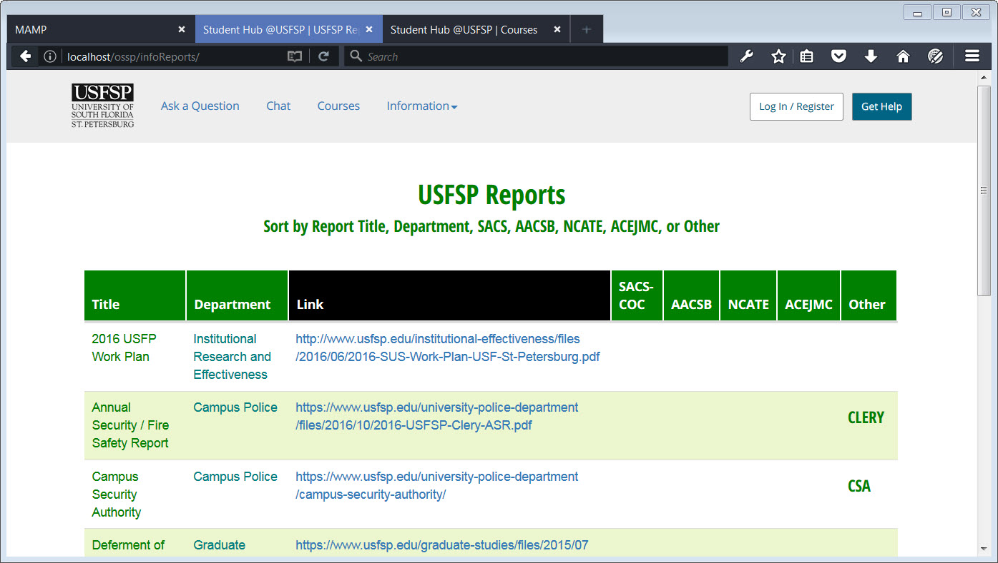

[ VII - 5 ] Centralized Location for USFSP Reports: Figure 1.

USFSP Reports Page. The content of this page is public-facing, and dynamically displays content maintained by the stakeholders.

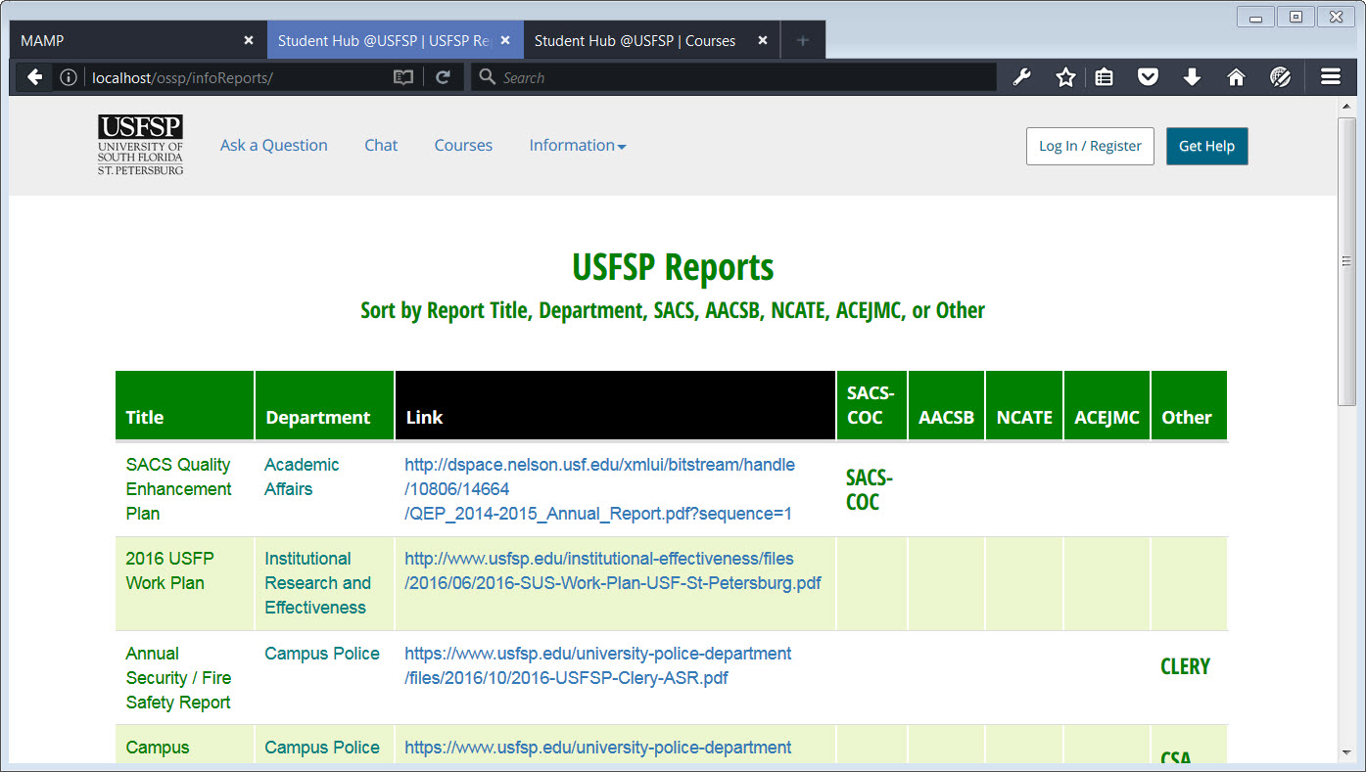

[ VII - 5 ] Centralized Location for USFSP Reports: Figure 2.

The USFSP Reports page allows sorting. In this example, the example of a document sorted via the SACS-COC column is displayed. This allows a convenient method to collect relevant documents, no matter the location or ownership of the document.

This may seem like a small thing, but it is true that it is time-consuming to track reports. In days in which staff are heavily-tasked and over-burdened, this small feature adds a measure by which report tracking and monitoring may be done in a timely manner. The ability to centralize reports by the organization to whom they are accountable facilitates transparency, which is of course, of critical importance for a public institution.

How are diverse reports from diverse departments collected and consolidated into one place? Through the departmental interface.

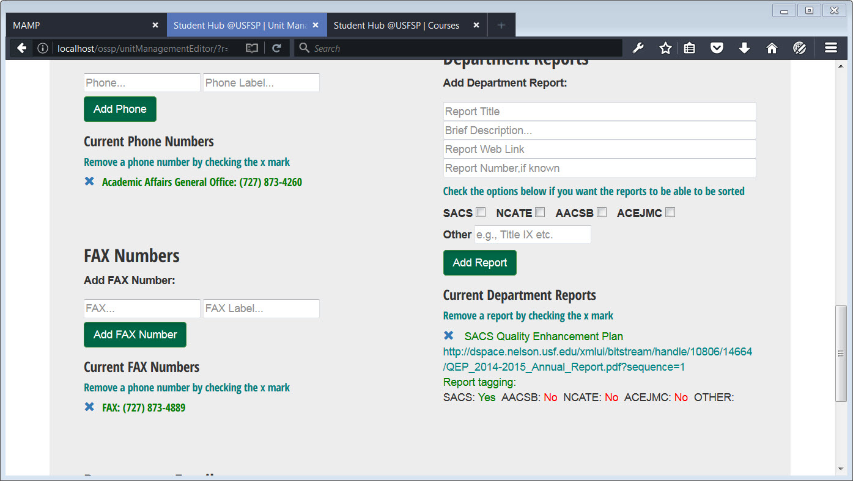

[ VII - 5 ] Centralized Location for USFSP Reports: Figure 3.

The content of the USFSP Reports Page is generated by stakeholder input. In the screenshot above, you may see where the current department reports are entered and tagged by the stakeholder. The stakeholder has to do nothing more than to enter the title of the report, its link, and check the box to which it applies. The Online Student Support Platform will automatically associate the department to the report, and update the centralized location for important reports.

#### 6. Existing support systems serve students to varying degrees, depending on the device from which they are accessed and the student’s needs.

##### Some information is difficult to access on mobile devices or without the use of downloadable plugins. Some students require access to specialized software, depending on their major.

##### *How this was addressed in the Online Student Support Portal:*

##### *To address the difficulty of accessing the content on mobile devices, the platform was developed as a mobile-first one. If a web site is available on mobile platforms, it will be available anywhere.*

*To address the issue of downloadable software/plugins: An Accessibility Initiative baked into the portal, was designed by Dr. Casey Frechette in concert with USFSP student Robert Beasey. This special feature, unique to USFSP, allows students with certain disabilities to access easy-to-see features and enter voice commands without the purchase of expensive software such as Zoom Text, or Dragon Naturally Speaking.*

*To ensure the support system was able to serve the students in as many ways as possible, multi-modal functionality was built into the system.*

Additional Information.

As much as possible, the Online Student Support Portal was designed to remove the need for “special” equipment or software as much as possible. The more universally the platform could serve student needs, the better. The obvious first approach was to remove any need to download an “app.” The portal will function on mobile devices as well as a desktop. Because of the team’s commitment to accessibility, we felt we could build-in certain other features that would help many of our students with disabilities. We can’t do it all, but we felt we could make some real headway in reducing a need for specialized software for some of the more common problems. This aligns with our university’s core values,”Student-Centered Success” and “Inclusion of Differences” of course. But we believe the ability to deliver more independence to our students, where possible, matters greatly to their pride, and this is not something to be taken lightly.

In a study on functional communication training using assistive devices, V. Mark Durand noted:

It has been hypothesized that factors such as stimulus satiation or choice may account for this rate of responding by many individuals in these studies (Durand, 1990). Other research suggests that choice, under certain circumstances, may in itself have a reinforcing effect (Fisher, Thompson, Piazza, Crosland, & Gotjen, 1997; Hanley et al., 1997). (Durand et al., 1999). Additional research by Dewsbury, et al noted “..control of the technology becomes imperative in enhancing the sense of independence due to self-determination and personal liberties (Dewsbury, et al., 2003).

Most would agree on instinct that the greater the sense of independence and self-determination, the better. Beyond the simple human issue of the need for self-worth, does a sense of independence and self-determination aid student success? According to the American Psychological Association, yes. “An enormous amount of research shows the importance of self-determination (i.e., autonomy) for students in elementary school through college for enhancing learning and improving important post-school outcomes.” (APA, n.d.). Consequently, the design of the portal platform took every advantage possible to embed, where possible, an ability to work independent of the need for special software or hardware to be added.

Cost and access to the Internet are one of the factors that Lin Muilenburg and Zane Berge noted as a barriers to online learning (Muilenburg, Berge, 2007). A platform designed mobile-first removes much of the cost by allow students to work from their phones, and to be able to access important content from devices which are low cost — and just as importantly — from locations that do not necessarily deliver high-bandwidth. For this reason, the USFSP Online Student Support portal was built mobile-first, using a framework that enabled tapping on mobile would work just as well as clicking on a button. Another way to reduce costs is to remove the requirement for special software, where possible.

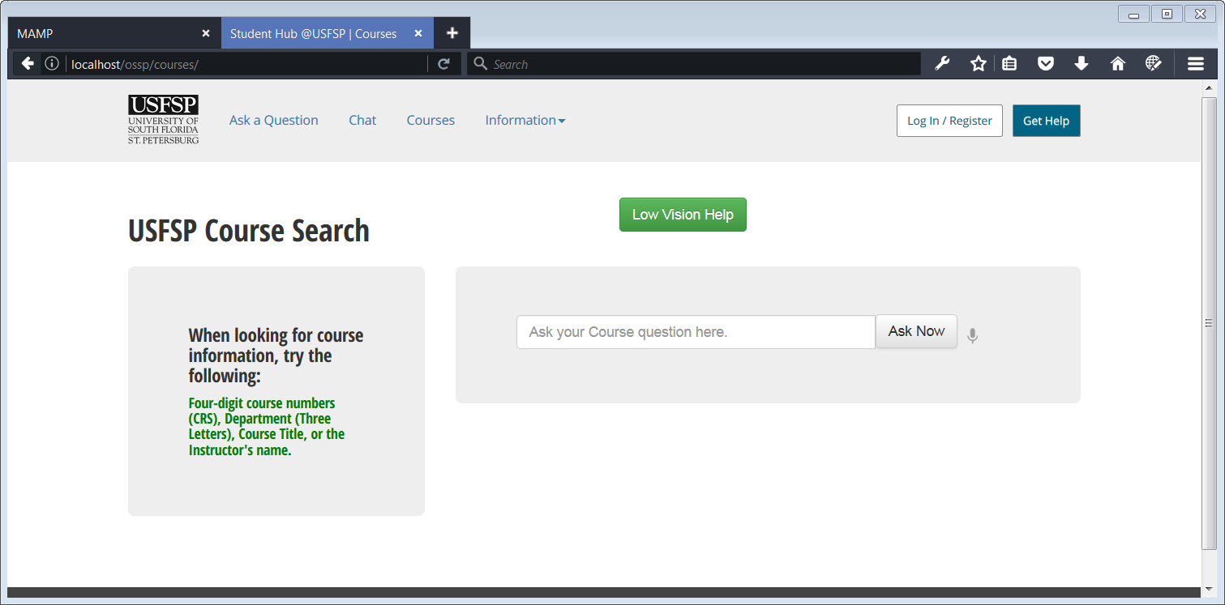

##### [ VII - 6 ] Figure 1.

##### Low-Vision Help baked into the Online Student Support Portal. The important point about this initiative is that the student may access it on any common device.

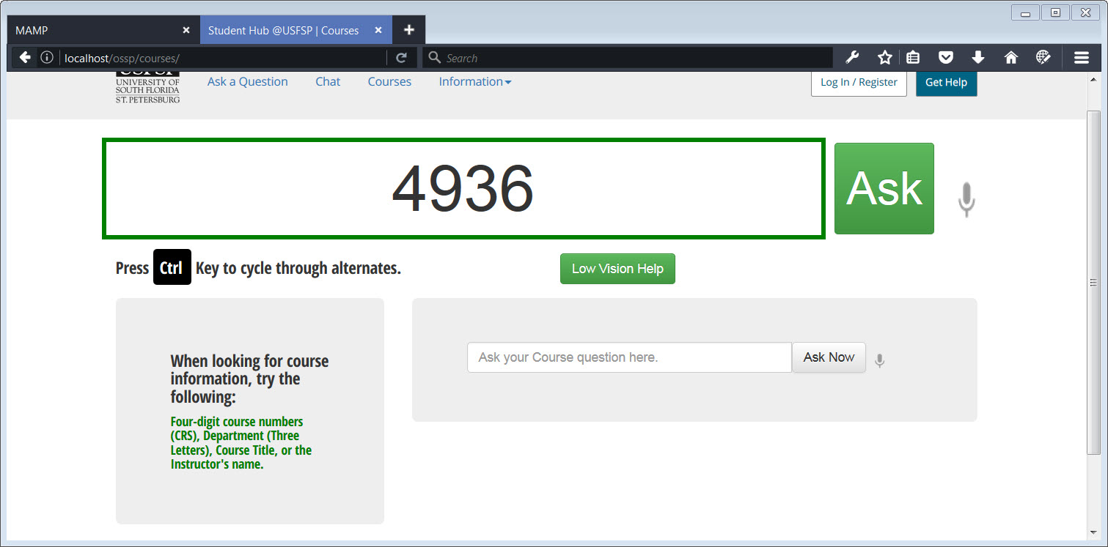

##### [ Section VII - 6 ] Figure 2.

##### Low-Vision Help baked into the Online Student Support Portal. This allows students with low vision to access large-size text without having to pay for Zoom Text software, or come to campus to use it. Here, the student enters the numbers, “4936” and presses the “Ask” button.

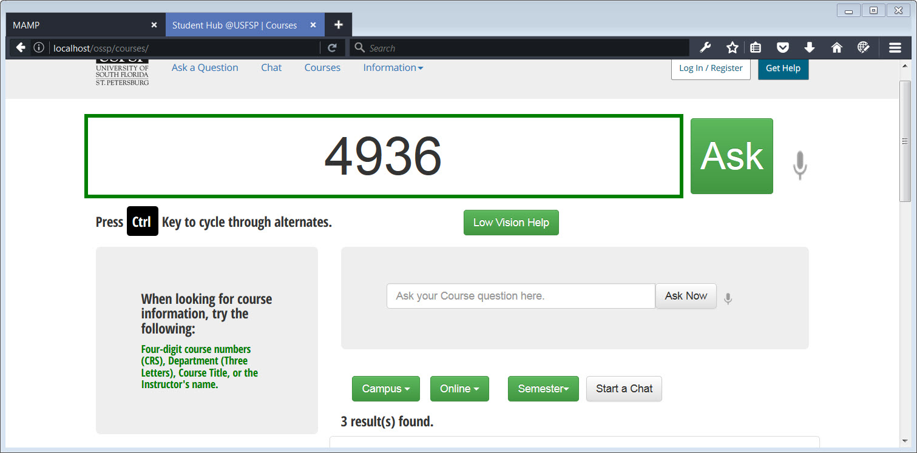

##### [ Section VII - 6 ] Figure 3.

##### The student has simply typed in three numbers, 4936, and pressed the “Ask” button. He receives three results.

#### 7.Seeking support presents a variety of privacy concerns, especially when students receive specific, personalized feedback.

##### Legal protections apply to certain information students might seek or share.

##### How this was addressed in the Online Student Support Portal:

##### Structure chat so that important conversations may be directed to appropriate, authorized help, and also, archive important anonymous conversations.

In the article, “The Question Exists, but You Don’t Exist With It”: Strategic Anonymity in the Social Lives of Adolescents,” the authors note that “Across these themes, we find that users strategically employ anonymity to achieve their social goals. Use of the site was often deeply embedded in offline social structures, such that the platform was used to circumvent rigid norms around socialization (who can talk to whom) and information-seeking (who can ask what), enforced in educational institutions and elsewhere. We conclude that the strategic use of selective anonymity has the potential to scaffold social processes through which adolescents work toward critical developmental goals.” (Ellison et al, 2016).

Of particular interest to us in the above statement were the terms, “selective anonymity.” As it applies to the platform, we use anonymity to remove barriers to allow students to seek help, but if the student requires the support of the resources of the university, the anonymous option retreats (except in event of emergency).

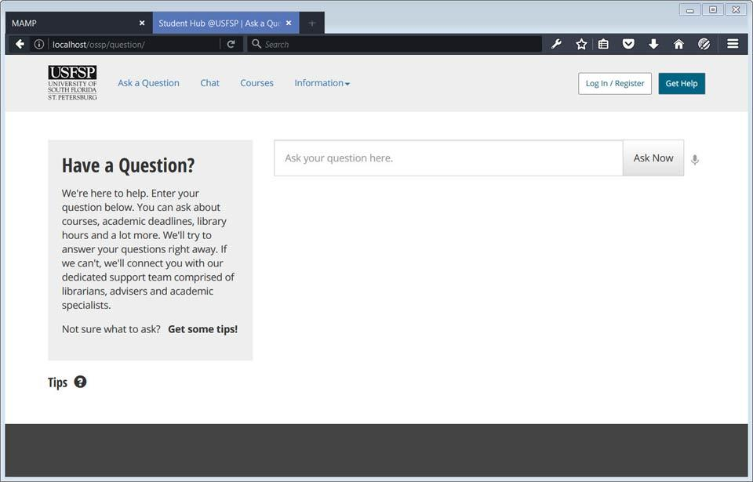

##### [ VII - 7 ] Privacy: Figure - 1

##### The landing page presents a large area where one may ask questions anonymously, and without logging in. The platform will attempt to provide an answer automatically from the databases without any interaction with the student, at first. If an answer cannot be provided, one may browse for an answer or start a chat. To receive an answer personally, one must create an account, but it’s not necessary. The question gets reviewed whether a student creates an account, or not, and is consequently screened to be included in the Recent Questions/Dropdown menu.

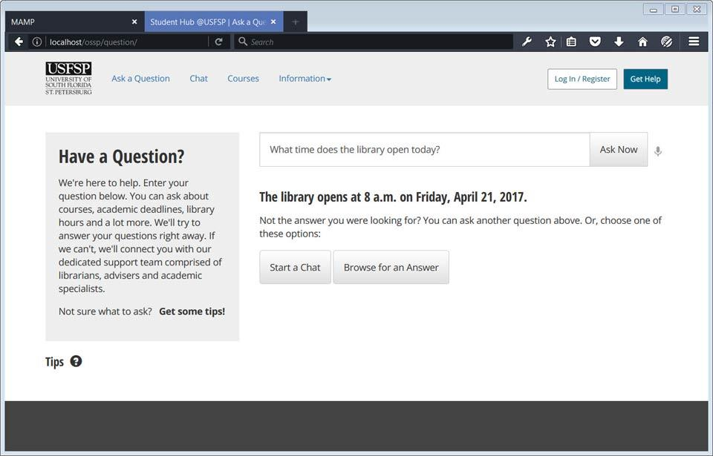

##### [ VII - 7 ] Privacy: Figure - 2

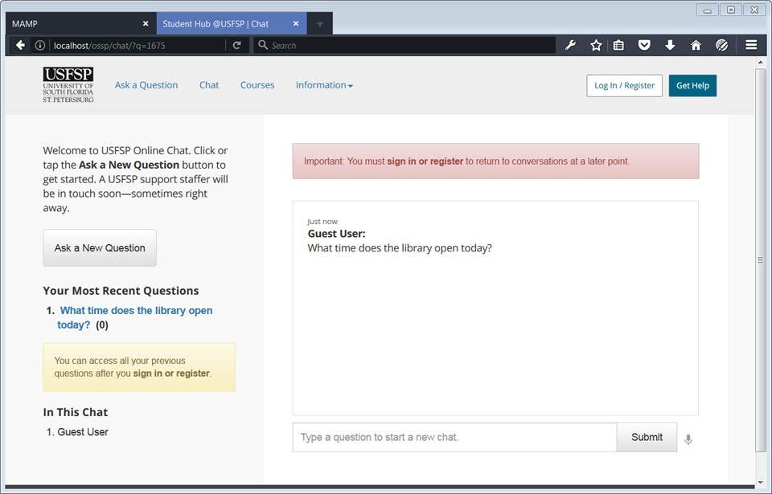

##### [ VII - 7 ] Privacy: Figure - 3

##### 

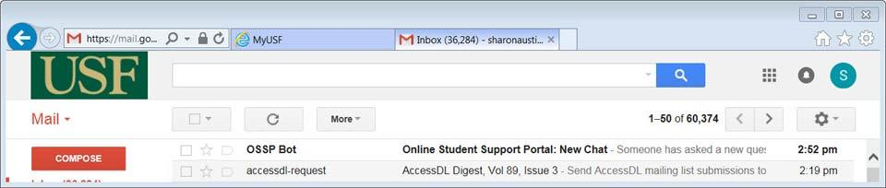

##### [ VII - 7 ] Privacy: Figure - 4

##### An authorized person is notified of the chat. These notifications may come by email and/or by SMS text messaging, depending upon how they have been set up in the staff member’s personal notification preferences.

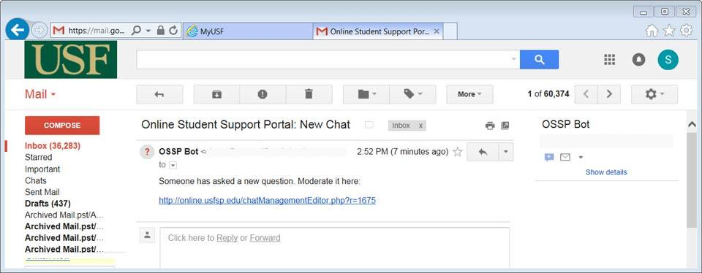

##### [ VII - 7 ] Privacy: Figure - 5

##### The email provides a link directly to the individual question. A staff member will not have to wade through extensive lists to respond to the question directly. Note that this question may have been asked anonymously.

#### 8. Students sometimes struggle to connect with professors and advisors to address online learning support needs.

##### Difficulty in receiving one-on-one assistance may impact the quality of support students receive.

##### *How this was addressed in the Online Student Support Portal:*

##### *The initiatives that addressed the concerns described in items 1, 3, and 4 addressed many of the concerns connecting students to help. The specialized components of this item, item 8, offer a convenient, centralized location for the professor to receive notifications, questions from the students, or signal that he is available for conversation.*

More information on portal initiatives to address this item:

The platform allows for multiple methods by which to contact a professor, and consolidates all the notifications into one, convenient location by which a professor may check notifications. In particular, the professor may be notified of chats that have been assigned to him, of personal messages that have come his way.

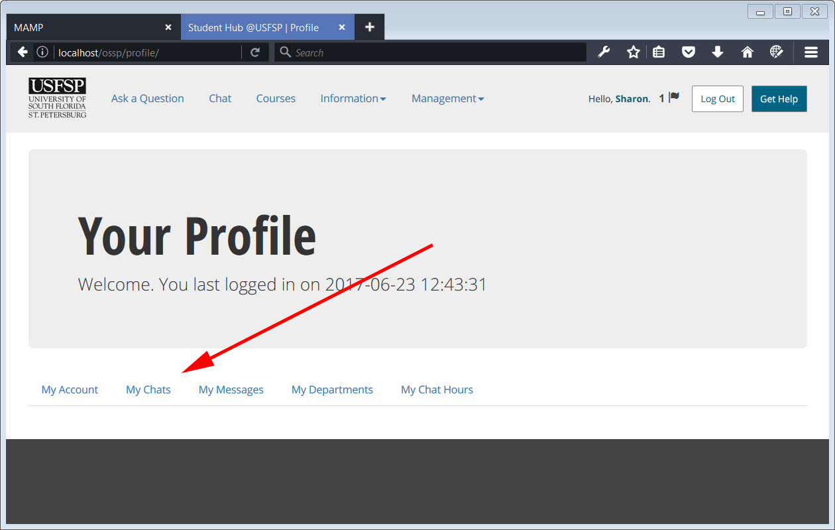

[ VII - 8 ] Figure 1

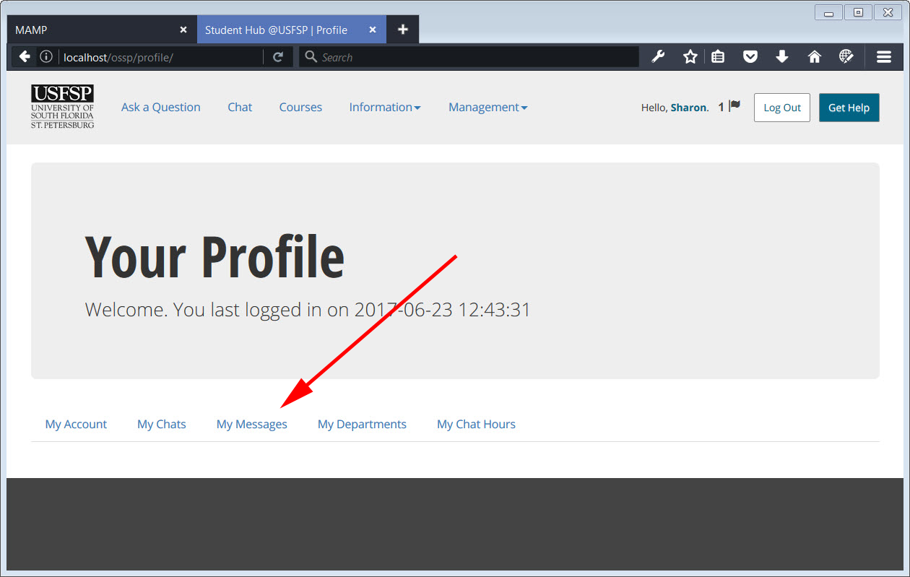

[ VII - 8 ] Figure 2

In the above screenshots, it may be seen that chats directed to the professor are delivered directly to him, as well as, any messages. The chats and messages may come directly from the students, or indirectly, as in the case of a router or advisor being placed in the same chat “room” to discuss a problem. These chats and alerts would be present in the personal profile page even if the professor elected not to be notified via email or SMS messaging; it’s just a quiet way of allowing the professor to check for notifications on his schedule, on his own terms, should he choose to.

It also serves as a kind of safety net to ensure that questions, chats, and notifications still find their way to the professor, should there be phone problems or connection problems.

For more details on the nature of the chat and SMS notifications, please see sections VII-3 and VII-4 for details.

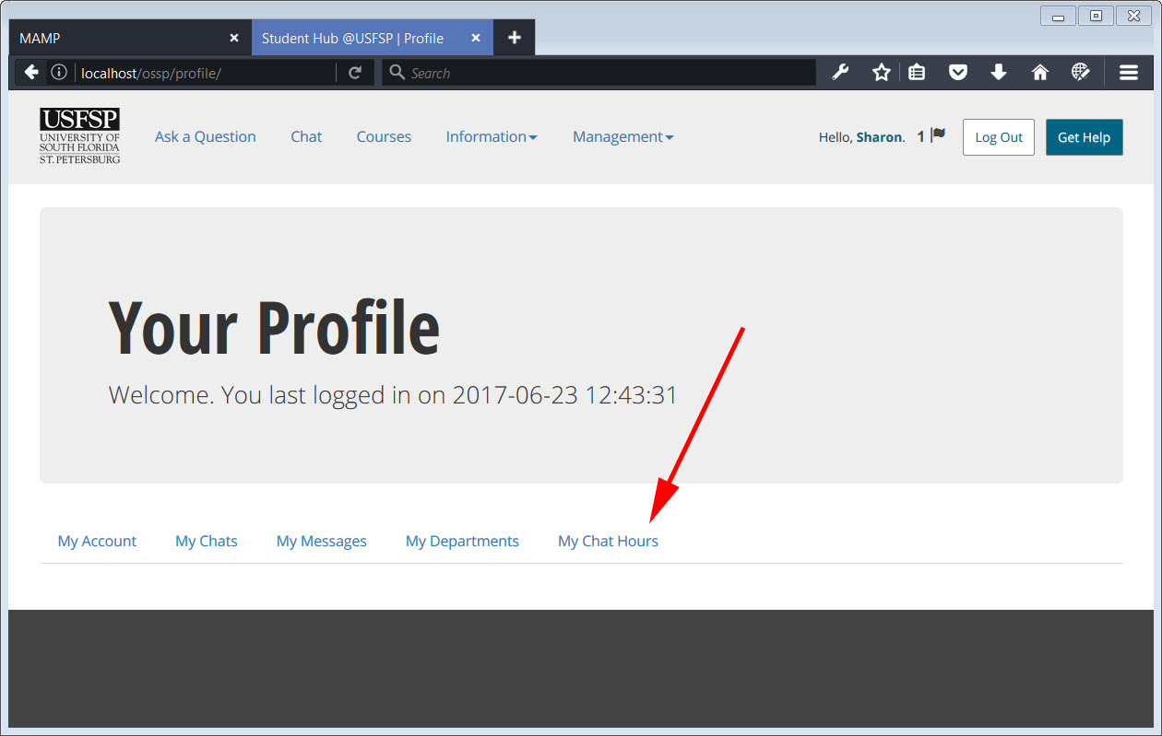

[ VII - 8 ] Figure 3

Additionally, the professor may employ a personal widget, should he choose, and make his and his hours of availability known via widget. The widget is able to be customized to display only on his personal staff page on the USFSP website, if he were to so choose, or on a departmental website, if the department so chose to do so. Additionally, future versions may be set up directly in Canvas, or other learning management systems (LMS’s).

For more details on how individual chat hours would be set up in the widget, please see section VII- 3.

#### 9. Accessibility for students with disabilities is still a challenge.

##### Various systems and software packages provide a wide range of support and access to students with disabilities.

##### *How this was addressed in the Online Student Support Portal:*

##### *A student with multiple disabilities was part and parcel to the process of designing and building the portal, and his input was integral in designing the User Interface. Standard accessibility practices were employed, but also, because the student was alongside at all points of the design process, new, one-of-a-kind accessibility initiatives were created — one of which is absolutely unique to USFSP.*

##### *Additionally, because the search function plays an extremely large role to those with disabilities, a specialized search function was developed to work specifically with USFSP databases, enabling a very targeted, context-sensitive search result. It is a simple but powerful initiative that allows students with disabilities to find information on a timely basis on par with those who do not have disabilities. This allowed us to substantially meet the definition of “accessible” as defined by the Office of Civil Rights and the U.S. Department of Education regarding inaccessible IT.*

Details and Background for the design decisions to address this concern.

According to Shuang, most information is presented in a textual format, but textual display may not always be the best solution. He noted that users may have difficulties in reading and comprehending complex texts, and that users of handheld devices cannot read much text information on a small screen. A recommendation was to use multimodal interfaces, as multimodal interfaces provide a logical solution by delivering information through multiple sensory modalities. (Shuang, X. et al 2008). We had noted the same issues, and found that they were amplified for those with disabilities.

To address this, we employed a multi-pronged approach. First, a section of the interface was set aside to allow for very large text, easily visible. Next, this particular part of the interface incorporated a special feature for those with weak motor skills, enabling a user to cycle through alternate letters should one be entered accidently. Finally, the voice component was developed in parallel, so that the interface could function in a manner similar to Dragon Naturally Speaking, but free, without charge, and without need to train the software.

In effect, this platform supports self-determination. Pride should not be underestimated as a force in the well-being of any student — or anybody, for that matter. It’s known that there are students on campus, eligible for assistance through the USFSP Disabilities office, who will not self-identify as having a disability. This platform allows students to do more for themselves, reducing the amount of time they need to ask someone for help; put simply, it helps students achieve self-determination. As noted earlier, this is important. A good description of self-determination is as follows: “Self-determination is a concept familiar to special educators and encompasses decision making, goal setting, self-awareness, self-advocacy, and self-monitoring” (Lombardi et al, 2016). However, it should be noted that although efforts to provide a setting that enables self-determination was done to help foster successful outcomes for students with disabilities, the implications apply to *all* students. The American Psychological Association noted the practical application of self-determination theory: “Researchers have developed and evaluated instructional interventions and supports to encourage self-determination for all students, with many of these programs designed for use by students with disabilities.” (APA, n.d.).

And, it helps with finances. By providing a platform that can allow students to use voice input when their hands do not work well, they are spared the tremendous expense of software such as Dragon Naturally Speaking, which although was not designed as assistive technology, is used by many as such. Dragon Naturally Speaking is not cheap, and purchasing it is not a casual expense, particularly for students, and even more so for students with disabilities, who suffer significant financial burdens because of their disabilities. According to research done by the authors of the paper, “College students with disabilities; Common on campus, uncommon in the literature,” the following was noted: Twenty-three of the interviewed students and 358 of the surveyed students reported a physical disability. A high proportion (41%) of students indicated they needed adaptations to access computers (Gelbar et al, 2105).

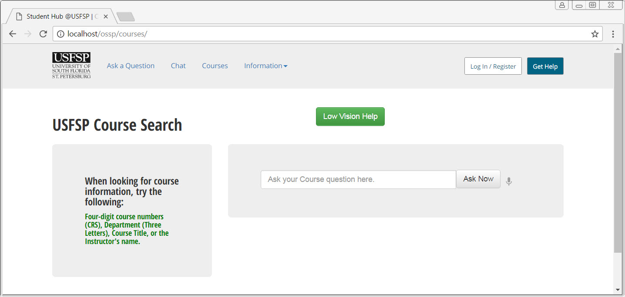

##### [ VII- 9 ] Figure - 1

##### Prototype of embedded Accessibility Initiative

The above screenshot shows the default setting for the Courses page. The final version of the user interface will be determined after user testing, so the snapshot here probably will not resemble the final version. Whatever the final version, it is important that the button is prominent, and easily discovered by users. The screenshot above is of a platform that is fully functional. All components for search work on this page, both the accessibility initiative, and the “standard” the component for those with normal vision. In both the accessibility initiative and in the standard version, users have the option of entering their search either by typing in text, or by speaking their search term into a microphone.

There are actually multiple initiatives rolled up into one on this page. First, the ability to use voice input rather than using hands, for those with poor motor skills, second an option to use a large-font text for those with poor vision, and, third, in the special accessibility initiative component of the portal, a feature that provides a convenient way to correct a mis-typed letter by choosing options. We’ll breakdown the examples one-by-one.

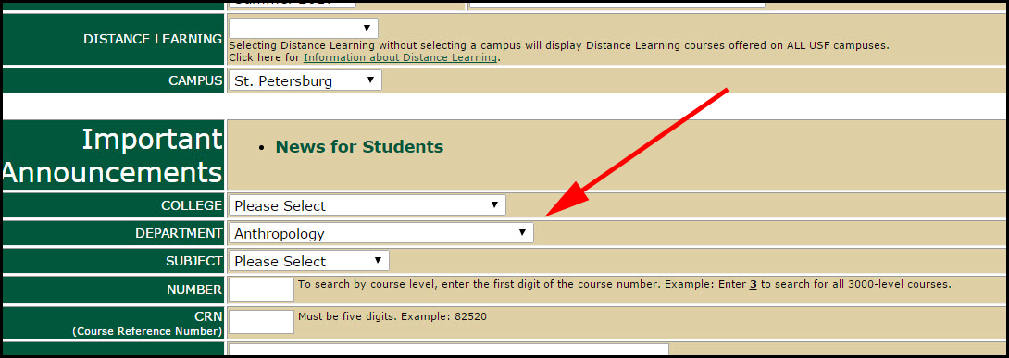

##### [ VII - 9] Figure - 2

##### 

##### Searching For Anthropology courses

Previously, the manner in which a student searched for Anthropology courses was to go to the appropriate OASIS page, and select the appropriate department (among many other steps). To someone who relied on Dragon NaturallySpeaking, even this simple act was problematic. Trying to grab control of a drop-down menu, and then navigate with Dragon Naturally Speaking was difficult and time-consuming, even to experienced users. Such searches were complicated by the fact that once a student was able to make a selection, the nature of Dragon Naturally Speaking software would be such that if a student moved down the page to refine the search, earlier choices would be “lost.”

Our answer to the problem, as we mentioned earlier, was to bring the content to the student, rather than have the student go find the content. This was applicable to all students, not just those with disabilities. But, for students with disabilities, this is a major benefit. In the case of those who rely on Dragon NaturallySpeaking, we had to incorporate voice recognition technology into the platform.

The next screenshots show the prototype of how voice recognition technology was incorporated into the Accessibility Initiative. In the first example, we demonstrate the prototype voice input component that allows one to search by voice. In this screenshot of the functional prototype, we may see that the ability to enter a search via voice has been activated, as the microphone has turned red. (We intend to fine tune this further, as a color-blind person may not be able to detect a change in color). The ability to use voice to search is a boon to those who have motor skills problems with their hands. We’ll be looking for Anthropology Courses, using a subject code of ANT. We do not make the student spell out the whole word, “Anthropology” (although that is an option if the student so desires to search in that manner).

##### CourseLowVisionScreen2.jpg

##### [VII- 9] Figure - 3

##### The user has activated the voice component, as seen by the microphone turning a red color. The user speaks the letters, “a,” “n,” and “t.” Behind the scenes, the code developed in-house automatically changes the lowercase letters to uppercase letters to match OASIS formatting for SUBJECT code. The user does not see this happen, but it enables a targeted, USFSP-specific search on appropriate data. It’s a small detail, but again, this small feature looms large to those who do not have full use of their hands, and for whom pressing a “Shift” key simultaneously to pressing another key presents a challenge.

##### CourseLowVisionScreen3.jpg

##### [ VII - 9 ] Figure - 4

##### 

##### Using voice input returns results.

##### Eight results for Anthropology courses offered in the current semester are returned. These results were generated from a voice query only. The platform understands that, because a user was searching on the “Courses” page, that three letters of the alphabet are meant to be taken as course codes. The search is context-sensitive.

##### CourseLowVisionScreen4.jpg

##### [ VII-9 ] Figure - 5

##### 

##### 

##### Using large-text options

##### The user clicks the low-vision button, and the special accessibility-initiative section of the portal appears. As in the earlier example, courses may be entered by hand in the text box, but in this example, we will enter only through voice command. We’ll again be looking for Anthropology Courses, using a subject code of ANT.

##### 

##### CourseLowVisionScreen5.jpg

##### [ VII-9 ] Figure - 5

##### 

##### Using large-text options with voice

##### As in the earlier example, the user has activated the voice component, and has spoken the letters, “a” “n” “t.” In the context of the courses page, the software understands that the user is asking for a three-letter SUBJECT code. From here, the user clicks the “Ask” button.

##### 

##### CourseLowVisionScreen6.jpg

##### [ VII - 9 ] Figure - 6

##### 

##### Results of using large-text options with voice

##### As in the earlier example, eight results are obtained with speed and ease on par with what a student without disabilities might encounter. We believe this is significant because it allows us to meet the definition of “accessible” as defined by the Office of Civil Rights and the U.S. Department of Education regarding inaccessible IT — that a student with disabilities must be able to access the same information ‘’... *with substantially equivalent ease of use.’’*

##### mis-type1.jpg

##### [ VII - 9 ] Figure - 7

##### Additional features for those with poor motor skills

##### An additional accessibility feature was built into the interface to assist those who have poor motor skills, or just plain shaky hands. If a user accidently types in a wrong letter, he has the option of pressing the Ctrl key (there are two on the keyboard, and both of them work) to cycle through optional letters that are in the immediate proximity of the one he typed in. In this particular example, the user “wanted” to type in the letters, “a” “n” “t,” but missed and typed in “a” “n” “g” instead. On the keyboard, the letters that are in proximity to the letter “g” are, in order: t, y, h, b, v, f, and r. In this particular portion of the interface, the user may simply press the Ctrl (Control) key to cycle through each of the options, until he found the one he wanted.

##### 

##### mis-type2.jpg

##### [ VII - 9 ] Figure - 8

##### Results of cycle through alternative letters

##### The screenshot above shows that the user was able to cycle through the six optional letters in the immediate proximity of the letter he accidently typed, and arrived at the desired letter. From here, he would simply press the “Ask” button to search for courses.

##### 

*Although very considerable work was done to make the Online Student Support Portal accessible, at this writing, more work is needed to check for screen-reader functionality on the platform. This is something that will not be able to be done in a meaningful manner until the final user interface is set.*

##### 

##### 

#### 10. Students need easy access to information we are legally obliged to supply, including Title IX and CLERY documentation.

##### We must supply easy, direct access to basic information about the University and its support for students.

##### *How this was addressed in the Online Student Support Portal:*

##### *A public-facing page that is searchable by report type.*

##### *We also reviewed the design of the Online Student Support Portal in terms of our responsibility to provide resources online where they were otherwise available by coming to campus. We did take especial note one of the recent cases, for the United States District Court for the Southern District of Florida Juan Carlos Gil, Plaintiff v. Winn Dixie Stores, Inc., Defendant Civil Action No. 16-23020-Civ-Scola, Judge Scola noted that “Winn-Dixie’s website is heavily integrated with, and in many ways operates as a gateway to, Winn-Dixie’s physical store locations.”*

More information on portal initiatives to address this item:

##### We found that the university had already done an amazing job of making information that was legally obliged to supply readily accessible, and online. We felt that one significant contribution that the portal platform could add to the already great job done by the university was to employ the search mechanism developed in-house. Because students use the search function so heavily, we felt that the custom search mechanism would be a fit to help students get the information they need. As we have said before, this platform innovates by bringing the content to the student, rather than having the student go find the content.

##### It’s important to note that the Online Student Support Portal works as an integrated platform, however. For the search mechanism to work, stakeholders would have to input the reports. That said, control would be totally in the hands of the stakeholders. If a revision was necessary, it’s easy for them to make the revision and publish immediately. There’s no need to go through a webmaster. If change needs to happen immediately, then change happens immediately.

##### Please see section VII-5 for more details on “how” the reports would be input by the stakeholder.

As envisioned, by inputting a report into the Online Student Support Portal, two results are achieved, simultaneously: First, the report shows up on the consolidated reports page. Second, the report becomes part of the data that makes itself available to the artificial intelligence developed in-house. In effect, killing two birds with one stone. The portal has not yet been configured to do this, as we feel that to do this would require administrative authorization and coordination. More harm than good if some departments used the portal platform to load important documents, and others did not. Users would not have a consistent experience, and think they were doing something wrong if important reports came up only sporadically through searches. That said, Dr. Frechette has already developed a code suite that may be applied to this purpose, should the decision be made to move forward with this.

##### VIII MORE INFORMATION ON PORTAL FEATURES

#### 1. Overall.

##### Content should be available and accessible regardless of device.

##### Ways in which this was addressed: Develop the platform with a mobile-first platform, ensuring USFSP branding is in place, bringing forward USFSP-specific assets when search is used, and using accessibility as a strategy, not a tactic.

The platform was developed as a mobile-first one, and tries to take advantage of capabilities available on mobile devices to enhance the student experience. There is only one platform, not multiple. Specifically, the same technology that works on desktops works on mobile phones. There is not a special “app” version of the site. This is by design. The use of apps is on the decline. “it has almost been [a year since research showed](http://qz.com/253618/most-smartphone-users-download-zero-apps-per-month/) the average US smartphone doesn’t download even a single app per month.” (Benson, 2016). Nearly 1 in 4 people abandon mobile apps after only one use. (Perez, 2016). Consequently, the platform was built to incorporate “app” features directly into the platform. The platform will display one set of behaviors if viewed on a desktop, or will display a different set of behaviors if viewed on a phone.

One example is the inclusion of geolocation coordinates in a database to match the location of the buildings on campus, allowing students to plug in coordinates into their GPS devices or phones and navigate to campus. In the example below, the latitude and longitude of Nelson Poynter Memorial Library was entered into a custom data table. The intent is to be able to coordinate the graphics of a campus map with the coordinates of the location, so that students, family, and friends may take advantage of these coordinates for devices capable of geolocation. The advantage, of course, is that no privacy concerns are in place here — these are locations of public buildings, public facilities — but the data would provide great assistance to those who want to take advantage of it.

The platform was developed mobile-first, and is operable on mobile devices, but follow-up work is needed. Kearns noted that “While mobile increases worker agility and allows them to work remotely the pervasiveness and evolution of these devices creates a special threat because policies and controls for computers are not sufficiently broad to cover the new threats these devices pose” (Kearns, 2016).

The next feature that supports the ability to make content available and accessible regardless of device is the very high incorporation of the special search capability, developed in-house. To every point possible, it tries to deliver information via text response, rather than the download of files, such as Word documents or .pdf files. This is because often, unless a staff member knows how to make such documents accessible — *and has the time to do so —* such documents are often inadvertent barriers to screen readers.

To get a feel for the time that it takes to make such documents accessible, please see the very valuable instruction offered by Karla Kmetz in the OLITS video, “Monday Minute: Alt Text in Word and PowerPoint “ found at this url on YouTube:

[https://www.YouTube.com/watch?v=ReoT1LeZSlw](https://www.youtube.com/watch?v=ReoT1LeZSlw)

As far as accessibility is concerned, all other things being equal, anything that may be done to remove the need for special-handling of documents for accessibility, such as using a platform that delivers screen-readable html text, is preferable to a platform that houses documents which may or may not be accessible. There are times which the best option is *not* html text, but a .pdf file or other similar such format, and that is for anything involving legal matters. Such documents *should* be in a .pdf format, so that changes are not easy or casual. That said, it would be helpful to have an html “web” version available of the same document for screen-readers, and/or for those who are unable to afford computers with the ability to download such documents.

The are really two ways one may interpret the terms, “making content accessible.” There are the terms “making content accessible” as they imply, “accessibility” for those with screen readers and other assistive technology, and there are the terms “making content accessible” as they imply the ability for a device to access content. To this second interpretation, the platform should be able to deliver content no matter the device used. It’s difficult for those using phones as their access to the Internet to download files, so the more that the platform may deliver the content as text, instead of a downloadable file, the more mobile friendly the platform will be for the users. It is not the point of the platform to be a repository of documents.

Finally, a special feature that supports the ability to make content available and accessible regardless of device is the special, built-in accessibility initiative for the platform. Although this accessibility cannot help all people, it certainly can make a difference in the lives of many, saving them the expense of acquiring special software, that often must be paired with certain browsers or hardware packages. This one-of-a-kind initiative was developed in-house by Dr. Frechette, and is unique to USFSP.

#### 2. Dashboard.

##### A personal hub by which notifications and important messages are centralized.

##### Ways in which this was addressed: Developed a personal dashboard/profile page for users in which alerts, notifications are received, and by authorized users may control availability notification through widgets customized to fit on department pages.

The dashboard has the ability to set up communications and notifications to agencies *outside* of the university as well as *inside* of it, to be able to interact with the community. This aligns with the Vision 20/20 USF St. Petersburg Strategic Plan: *“Our goal is a vision for USFSP that focuses our resources to have a powerful impact in Pinellas County and beyond. We are eager to move forward and build on the vision of making USFSP one of the best public institutions in the region.”*

The dashboard exists solely as a means to connect students, and if so desired, community, to faculty and staff. It allows these communications to be shared by other faculty and staff, if desired, and it embodies an ability to find the proper authority to send the conversation to if staff or faculty believe the question or conversation should be routed elsewhere (through keywords). This is the part of the portal that allows faculty and staff to set up their personal notification preferences, to make it convenient on their terms to communicate with students, while ensuring that student questions do not fall through the cracks.

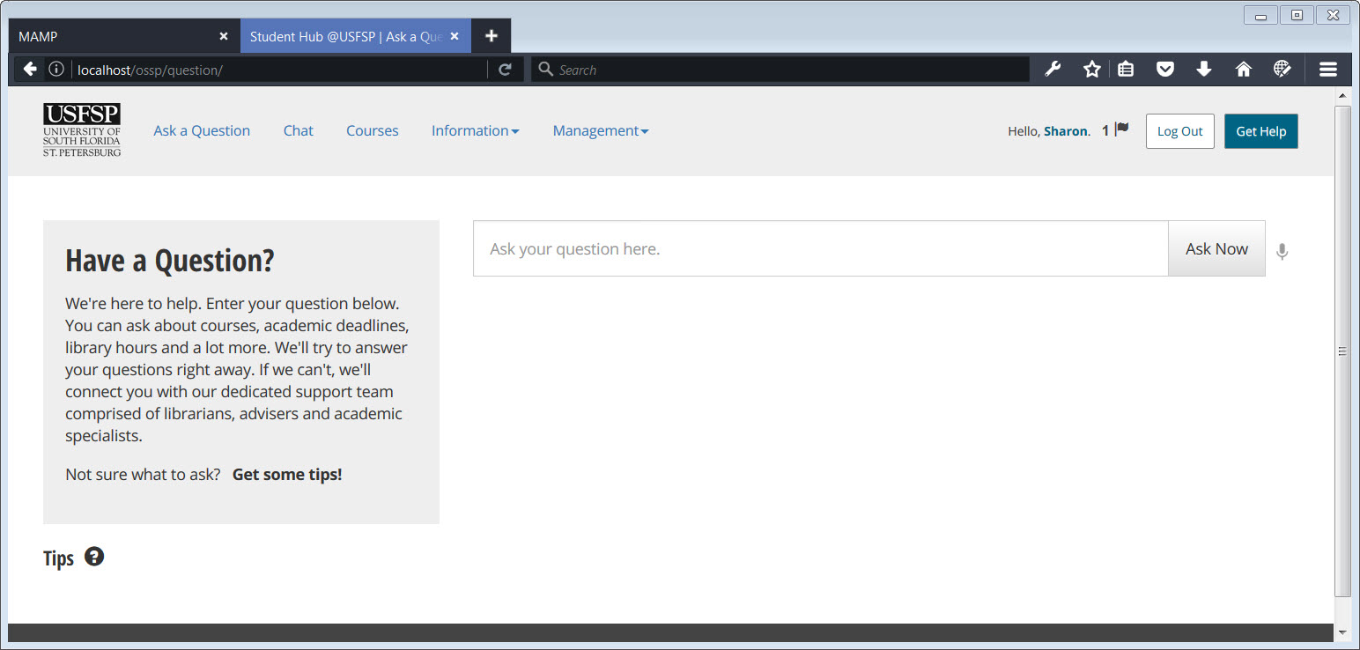

##### [ VIII - 2 ] Logged In: Figure - 1

In the screenshot above, you may see that user “Sharon” has logged in, and has a flag indicating that a message awaits.

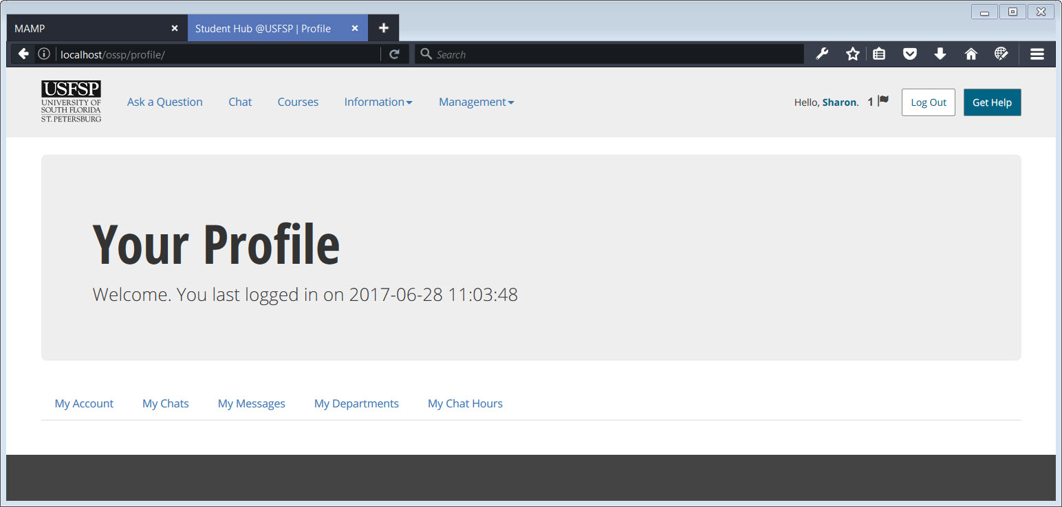

##### [ VIII - 2 ] Logged In: Figure - 2

##### Clicking on her name, user “Sharon” is taken to her profile page. Here, she is able to see that she last logged in on June 28, 2107. This profile is for setting notification preferences, and for managing conversations, and her hours of availability for conversations.

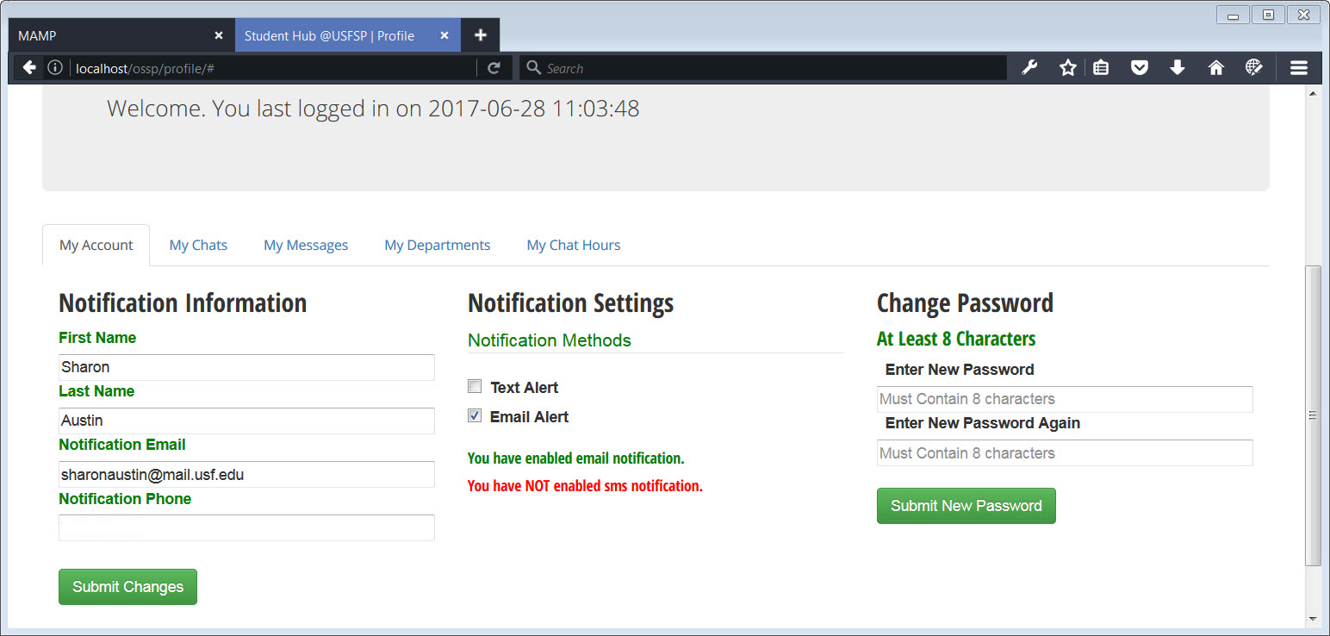

##### [ VIII - 2 ] Logged In: Figure - 3

Clicking the tab to “My Account” brings up the screen by which user “Sharon” sets her notification preferences. In this example, she has decided to be notified by email only, not by phone. Although it is not shown here, a cell phone number may be entered, but not activated for notification unless the notification box is checked. If neither the email or the phone notification box is checked, then the notifications of incoming chat messages are delivered through this portal interface.

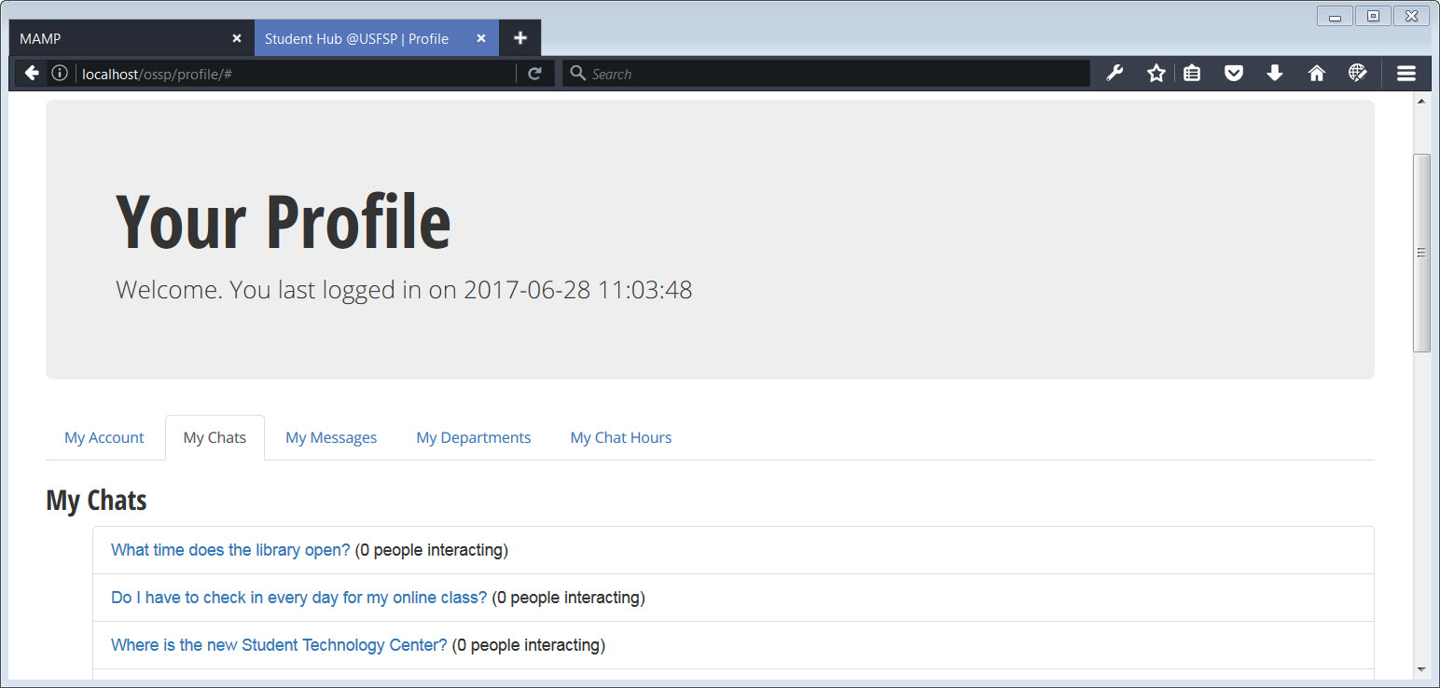

##### [ VIII - 2 ] Logged In: Figure - 4

In the above screenshot, we see that user “Sharon” has many chats assigned to her. She hasn’t answered any of the chats yet in this scenario. It’s a view of what a user sees if he or she has not activated either the email notification or the SMS notification capability of the portal; it is the “safety net” for student conversations should other notification methods fail, or be turned off.

The other point to note about these chats is that they may be shared with others on campus. If one expert needs to involved another in a student’s chat, multiple experts may share a chat room.

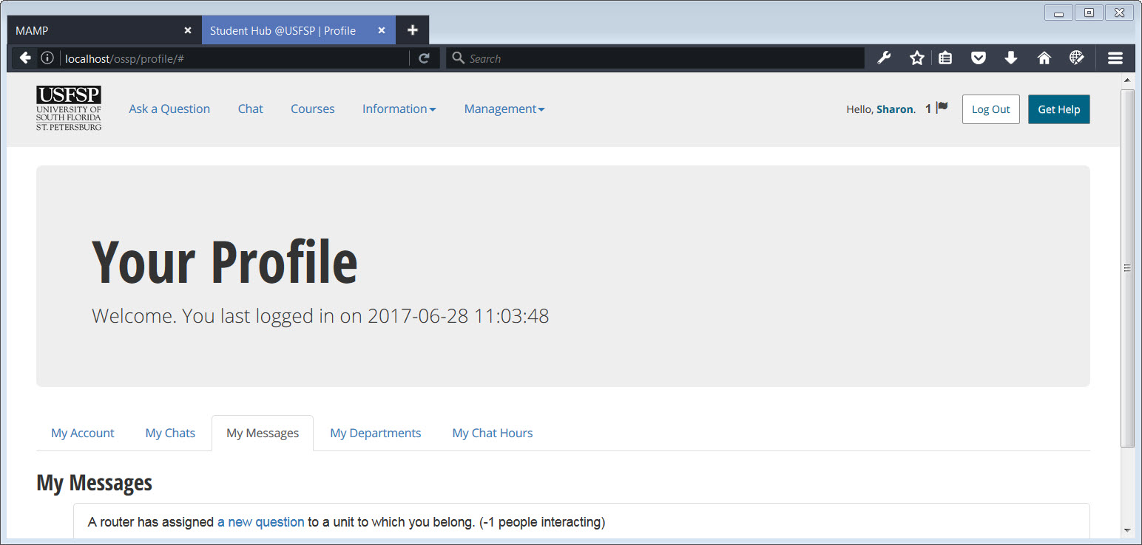

##### [ VIII - 2 ] Logged In: Figure - 5

In the screenshot above, we see that user “Sharon” has received a message that a new question has been routed to her.

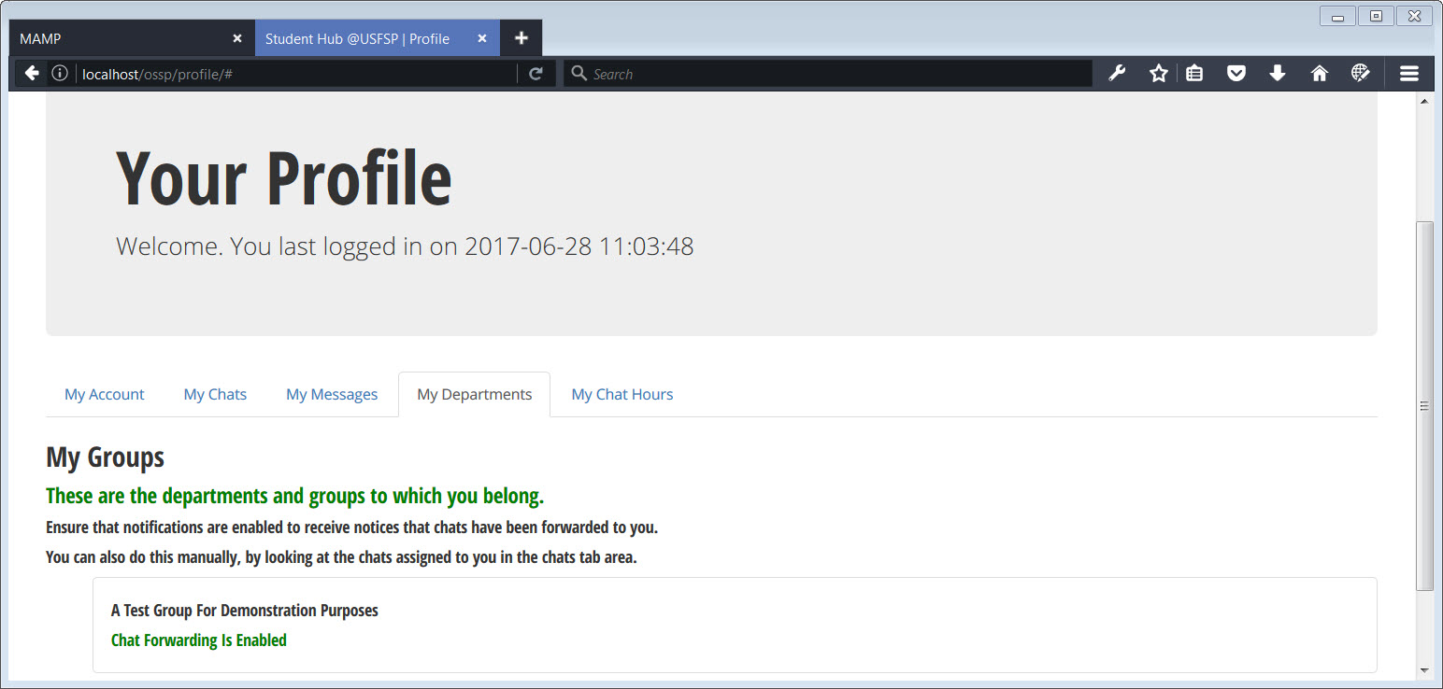

##### [ VIII - 2 ] Logged In: Figure - 6

Next, we see the departments to which user “Sharon” is assigned. She would have been assigned this department by a higher authority. In this particular case, user “Sharon” is assigned to a department called, “A Test Group for Demonstration Purposes.” By the fact that users are assigned to a certain department, communications paths are established by which certain users may talk with certain students. That said, there is the ability to break out of these paths by putting people from different organizations within USFSP into the same chat room — in other words, to break through silos to get the right set of people to help the student. Screenshots showing departmental assignments follow shortly.

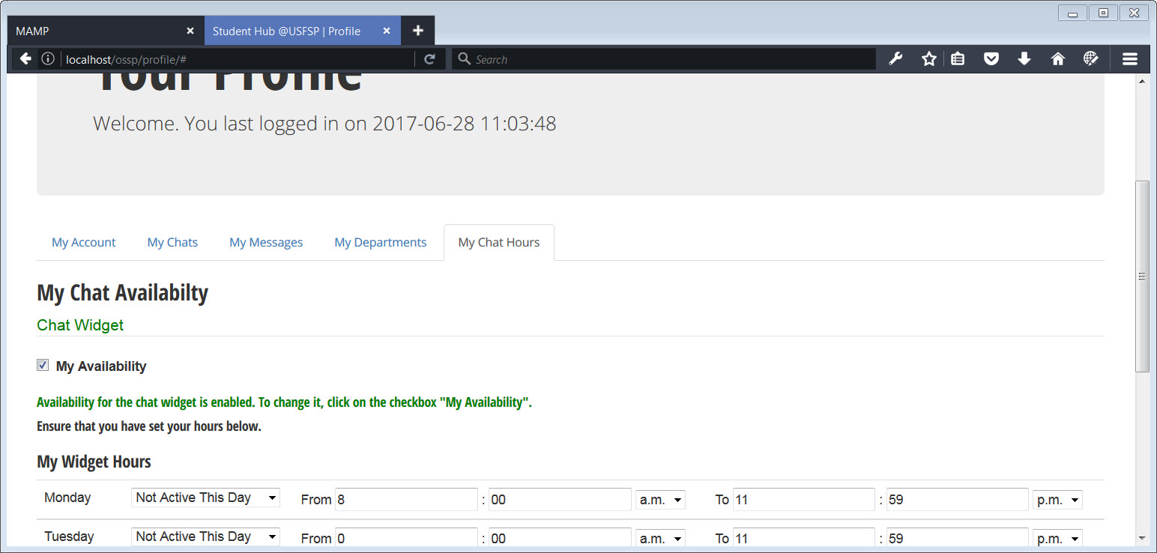

##### [ VIII - 2 ] Logged In: Figure - 7

Finally, the portal has the capability to set personal chat widget hours of availability. It also has the ability to set the hours ahead of time, but to prevent the widget from becoming available unless the checkbox is set to allow visibility.

We have mentioned briefly how the student chats actually find their way to the faculty or staff member. Much of this is accomplished through the broader setting of an individual into a particular group, as determined by administrators. It is through the control of the organizations that granular control of the paths to individual stakeholders is established. First, control is established by the “type” of organization it is. For example, standard offices such as Finance would be assigned a group type of one, whereas a partnership would be assigned a group type of two. It is USFSP administrators who would determine the nature of the group, and what that means in terms of public access to the information contained therein. The bottom line is, the contact information of the organization is preserved, whether it is displayed or not.

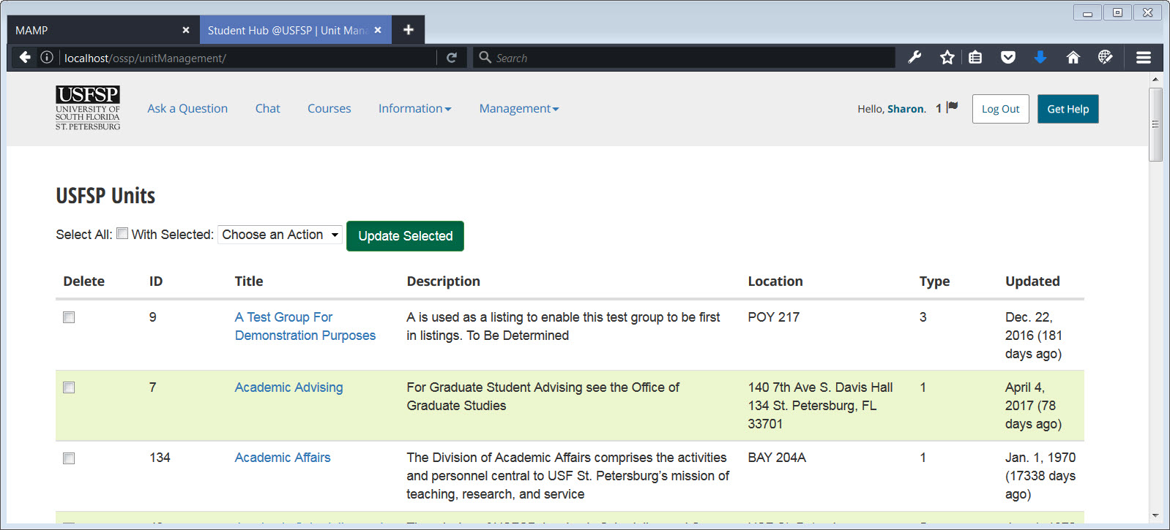

[ VIII - 2 ] Department Paths to User: Figure 1

In the screenshot above, we see multiple groups available by which to assign users. User “Sharon” is assigned to the group, “A Test Group For Demonstration Purposes” and conversations will be routed to her on a granular basis, based on the nature of the group (how it is typed), her role in the group, and the nature of the conversation. Even if user “Sharon” has turned off her notification preferences, she will still find that she has been routed chats from students via the “My Chats” tab and the “My Messages” tab in the Profile Interface. This is to provide a safety net for student communications. In addition, if she is temporarily added to another group, to share a conversation with experts in that group, the change would show up in the “My Departments” tab of the profile interface.

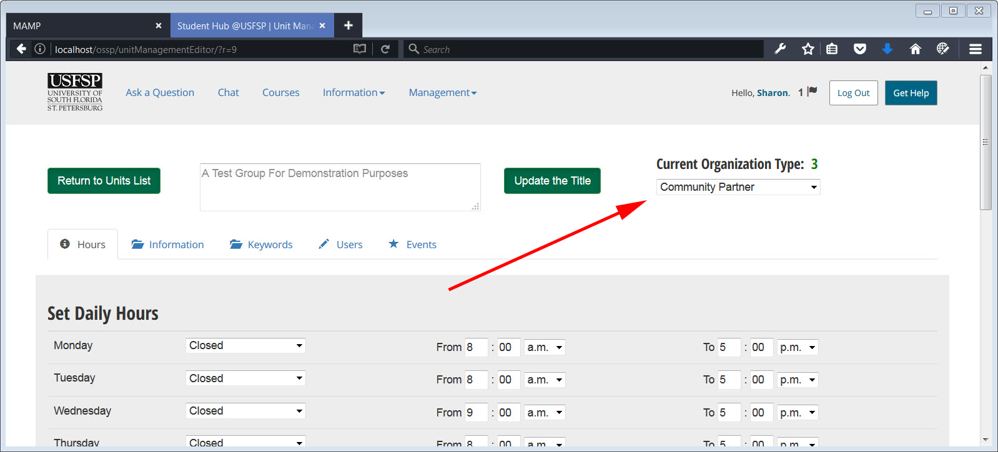

[ VIII - 2 ] Department Paths to User: Figure 2

Administrators may set up with community connections. These do not necessarily show up in formal USFSP “directories” but do enable quick communication channels with local community efforts.

#### 3. Search.

##### A customized search that brings forward USFSP-specific assets.

##### Students find most of their information through search mechanisms; consequently, it looms large in contributing to student success.

##### The search is a one-of-a-kind mechanism developed in-house by USFSP’s Dr. Frechette. It was developed specifically to allow stakeholders to input content important to their organization, and serve as information to feed the artificial intelligence that automatically answers student questions. In essence, the stakeholders themselves maintain the content. It is the stakeholders themselves who, through the special code of this platform, answer student questions.

How the content is maintained through the stakeholder input.

1. Through stakeholders.

Authorized stakeholders may make corrections, or add supplemental information to, the results provided search mechanism via their interface, and the results will be immediate.

Below are a series of screenshots illustrating the process.

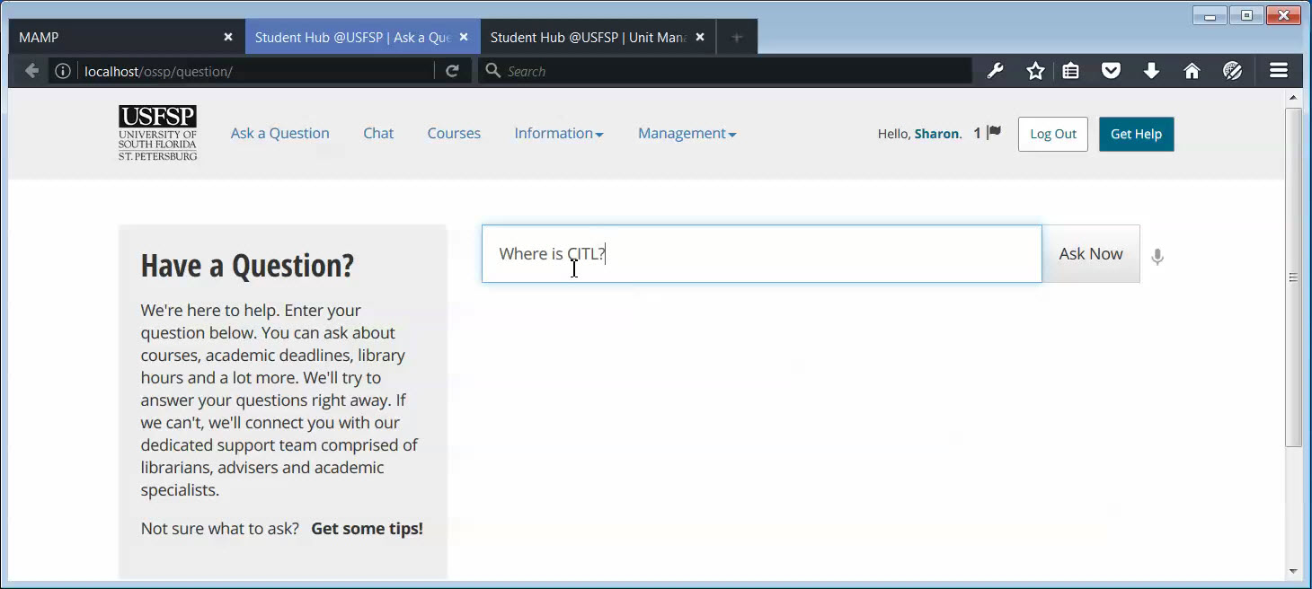

[ VIII - 3 ] Answers Informed by Stakeholders: Figure 1

Explanation of the figure above: A user asks the question, “Where is CITL?.” Notice that this is a question asked in a manner commonly used in searches, such as using acronyms, and using incomplete sentence structure.

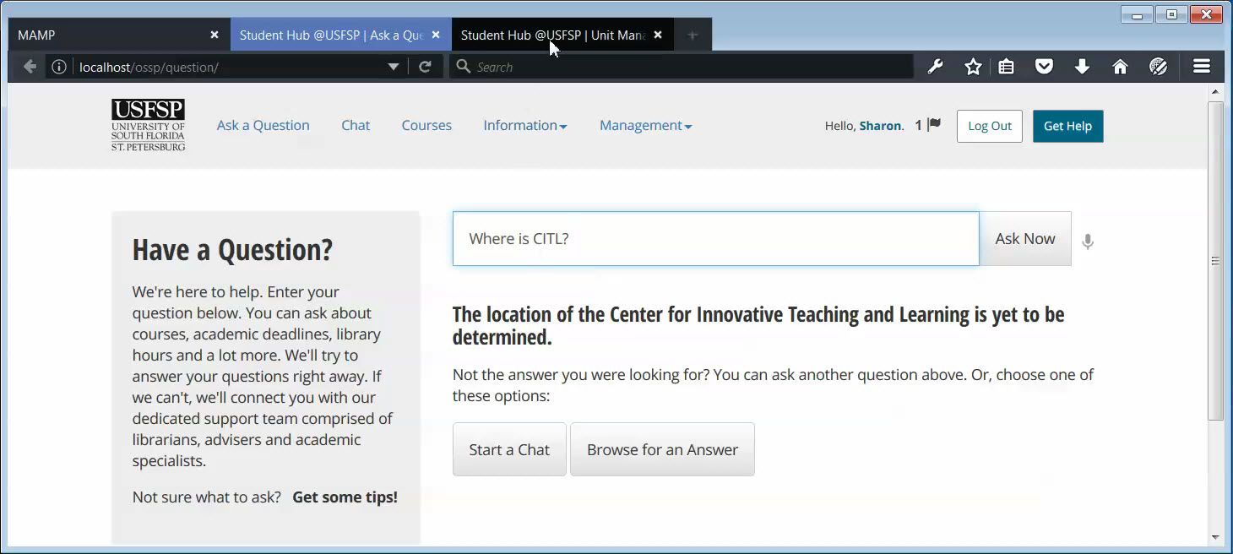

[ VIII - 3 ] Answers Informed by Stakeholders: Figure 2

The automated response understands that, in the specific context of CITL, the meaning is that the user is looking for the Center for Innovative Teaching and Learning specifically, at USFSP. How would a stakeholder update the information that is generated automatically through the portal’s special code?

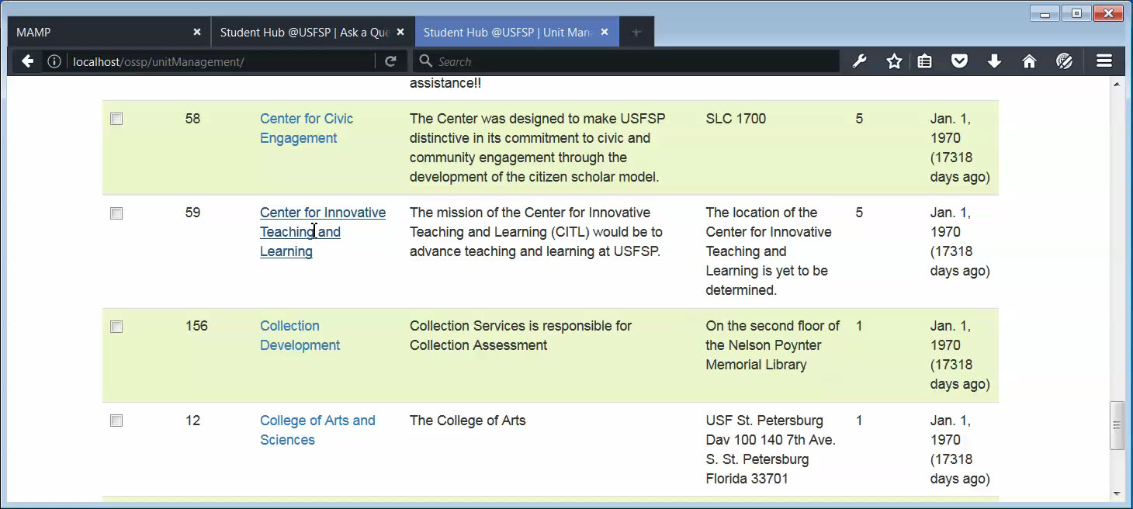

[ VIII - 3 ] Answers Informed by Stakeholders: Figure 3

to change the results given by the search utility, an authorized user, or super-user, acesses the page for correcting department information.

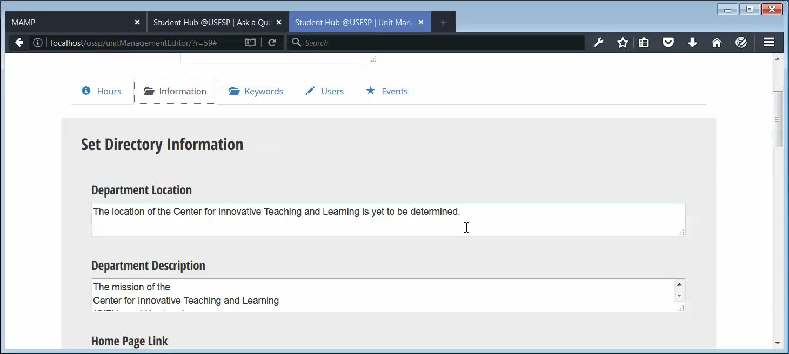

[ VIII - 3 ] Answers Informed by Stakeholders: Figure 4

The authorized user accesses the information box. Notice that this is the response generated in the search.

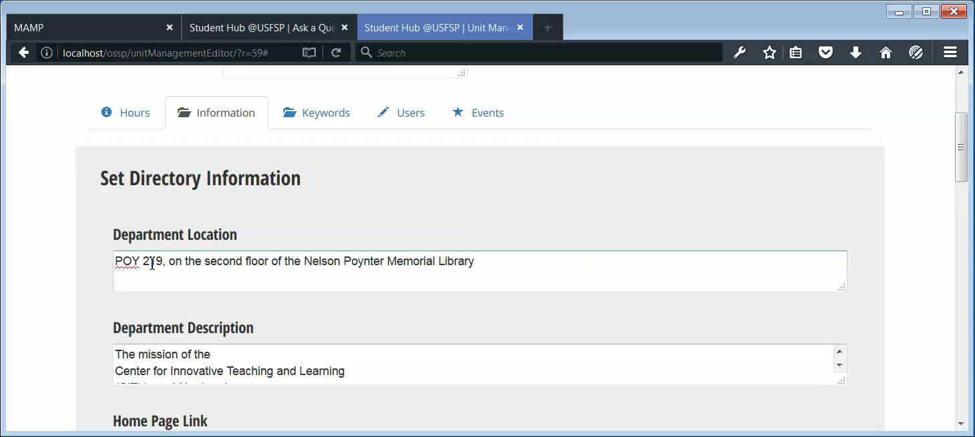

[ VIII - 3 ] Answers Informed by Stakeholders: Figure 5

The authorized user makes a correction to the information.

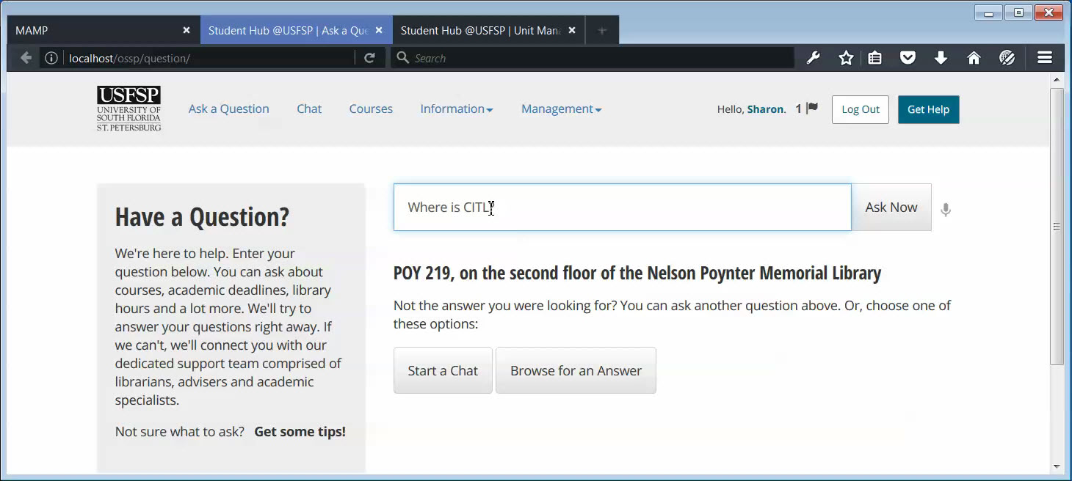

[ VIII - 3 ] Answers Informed by Stakeholders: Figure 6

The changes take effect immediately. The next time a user asks, “Where is CITL?” the result shows the newly updated information. No webmaster involvement is needed.

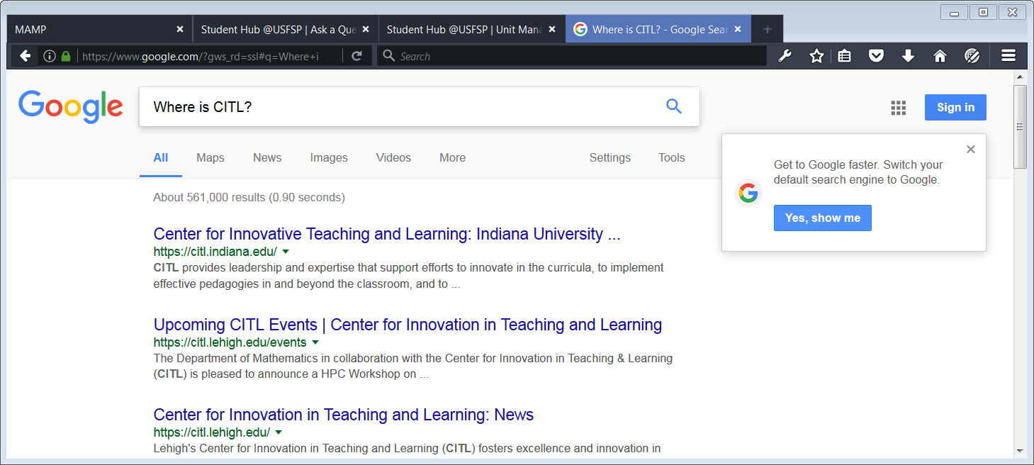

[ VIII - 3 ] Much More Targeted Than Google Search: Figure 1

Contrast the results from the same question asked in Google. The first set of results that come up are not relevant to USFSP.

4. Talk/Chat.

##### A customized chat feature developed in-house that integrated diverse service components.

##### *How this was addressed in the Online Student Support Portal: A chat system developed in-house provides real-time communications with designated support staff when they are available, and when they are not, provides a way to review the question for forwarding to an available staff member so that the question is not dropped. The in-house chat system was developed to be able to cross departmental silos and send multiple notifications when student questions required the response of more than one department.*

*What makes this chat different from off-the-shelf chat technology: integration with keywords, to enable the ability of a staff member to connect a student’s question to a proper and authoritative source. The keywords are established by the stakeholder themselves, and do not require a webmaster. The key point to remember is that more than simply departmental information is in silos, the “who” is responsible for “what” is also in information silos. The chat platform allows staff to search for keywords relevant to a student question, and route the chat accordingly.*

*This process directly aligns with the Vision 20/20 Strategic Plan Goals, Strategy no. 5.7: Design and enhance internal and external communication systems to support mission and goals*

Heretofore much of the chat functionality has been described, in section VII -3, how chats are initiated, and how these chats reach faculty and staff at the other end. These are for routine cases of chat with students. A student does not need to have a mail.usf.edu account to interact with the chat, nor does he even need to log in.

Special temporary id’s are associated with anonymous users, so that the students may ask anonymously, if they so desire. This was done partly for accessibility issues. It is not a casual effort to log in with assistive technology. We have even found that, in certain instances, password requirements, such as the requirement to include a number in the password, actually thwarts efforts to login with assistive technology.

However, there is the special case of a student using the chat anonymously to ask for personal help.

This could be a safety issue for students. In their article, “Understanding Social Media Disclosures of Sexual Abuse Through the Lenses of Support Seeking and Anonymity,” the authors found that “Support seeking in stigmatized contexts is useful when the discloser receives the desired response, but it also entails social risks. Thus, people do not always disclose or seek support when they need it. One such stigmatized context for support seeking is sexual abuse.” We wanted to make sure that if a student needed to ask for help anonymously, that the capability existed.

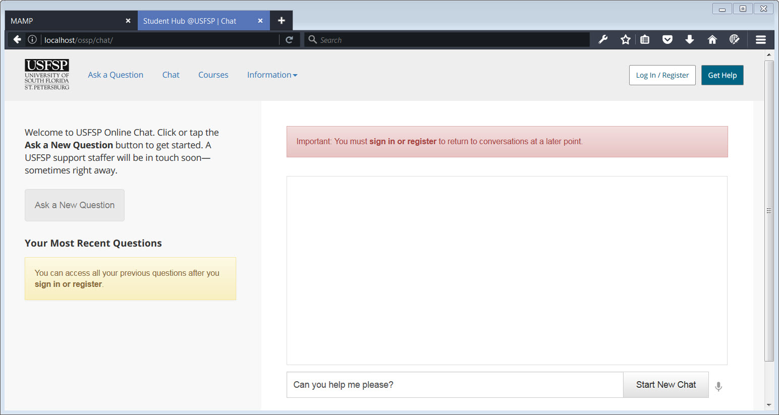

[ VIII - 4 ] Anonymous Chat: Figure 1

In the screenshot above, we see that someone has asked for help, anonymously. At the other end, is someone who is monitoring the chat. Normally, we would expect very generic questions, and these could be answered by some canned responses, or routing the question to someone who could answer the question. Notice, the red flag on top, in which it warns that if no one is available to handle the conversation immediately, then registration is required. A “throw-away” account is fine.

Note that, we have assumed that the student, in this case, has not availed themselves of the drop-down help menu. All the drop-down menus ask if it is an emergency, and if so, to contact 9-1-1. If for any reason, we can establish through the chat that an emergency is taking place, we would so instruct the student, through the chat mechanism, to call 9-1-1.

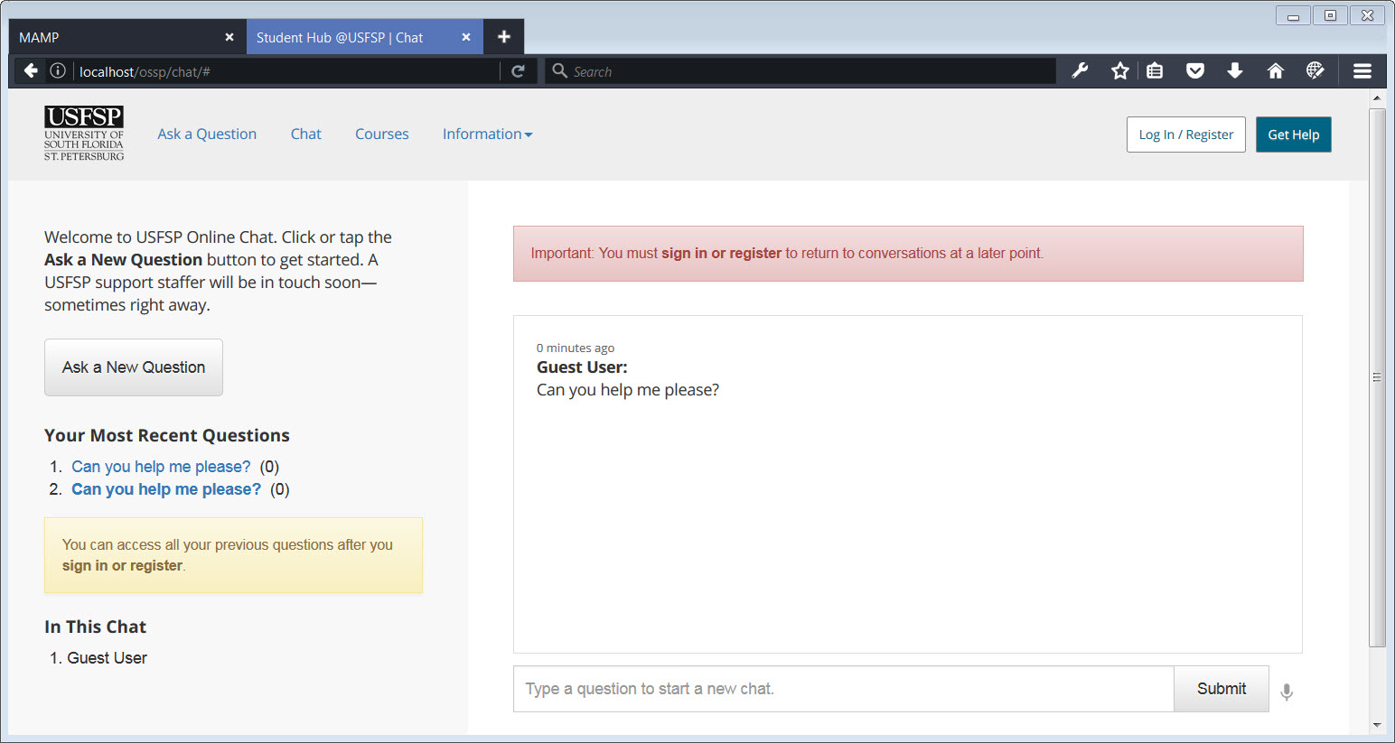

[ VIII - 4 ] Anonymous Chat: Figure 2

In this very hypothetical, imaginary case, the user was nervous and accidentally asked the question twice. Both are archived, as may be seen on the left side of the screen. The router at the other end would be able to investigate both anonymous questions, “Can you help me please?” and send the question for help.

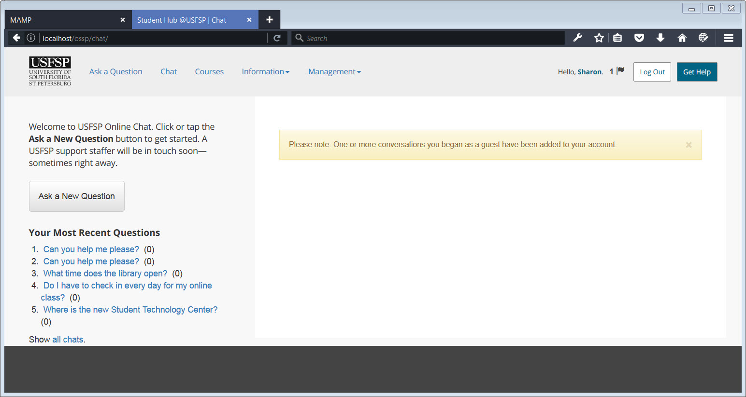

[ VIII - 4 ] Anonymous Chat: Figure 3

In the screenshot above, Sharon, who is monitoring chats, sees that one or more people have asked for help. Sharon, an administrator, sees that two chats asking the same question have appeared. In this very special case the administrator has a special role enabling her to see additional information, not shown here, including the user agent (browser), id (including temporary ids) and time stamp. Based on this information, she would be able to understand that this is probably one person asking for help twice, rather than two people asking for help in a different location. This is a rare scenario, but it was built in as a method to assist routers with ascertaining the nature of the request. It would help clarify, for example, whether a user might be experiencing an emergency that should be communicated to authorities.

Its custom tools and features are essential to the way the Online Student Support Portal works. It wouldn’t be possible to deliver the same experience over an existing platform such as Facebook or Twitter. Nonetheless, the Portal has been developed in such as a way that future connections to social media are possible. As one example, a module could be developed that connects a student’s Twitter account to her Portal account. Specifically, the student could receive alerts through Twitter when responses have been added to her chat questions.

In this way, the Portal can integrate with the social and mobile technologies students are already familiar with, including SMS and texting technologies. Research has shown that social media has a role in emergencies and a particular application for those with disabilities. Morris notes that “levels of use of social media in general are high for people with disabilities, as well as for the general population.” (Morris et al., 2014) We are not seeking to redefine that role — only to be ready for it should it come our way.

Conversations with a USFSP student with multiple disabilities who worked with us on the project reinforce the value of allowing easy access to the two-way, interactive, personalized communication tools built into the portal. We knew that the initiatives we described above would offer more than convenience. In some cases, they could even be a life-saver.

#### 5. Knowledgebase/FAQs.

##### A feature developed in-house that integrated authentic student questions into archived data.

Ways in which this was addressed: Provide answers to questions submitted by real students. These questions will come from directly from the input from the students, but sanitized of personal information to protect privacy.

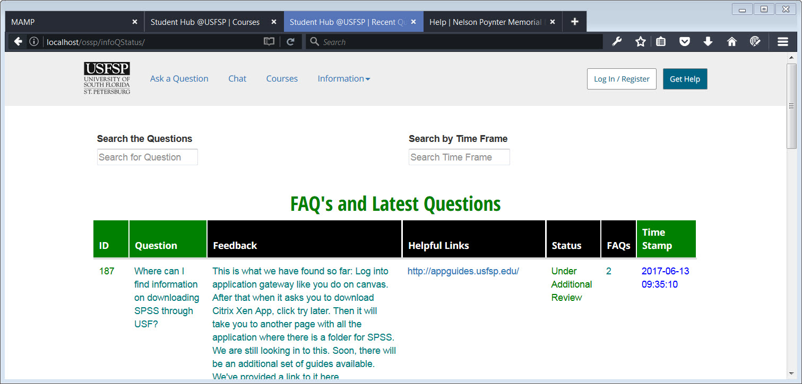

[ VIII - 5 ] FAQs: Figure 1

The drop-down menu, “Information” has a link by which students may explore FAQs. A student may check the status of a question. Here, in this example, we see that a question is still under review, and that more information may follow.

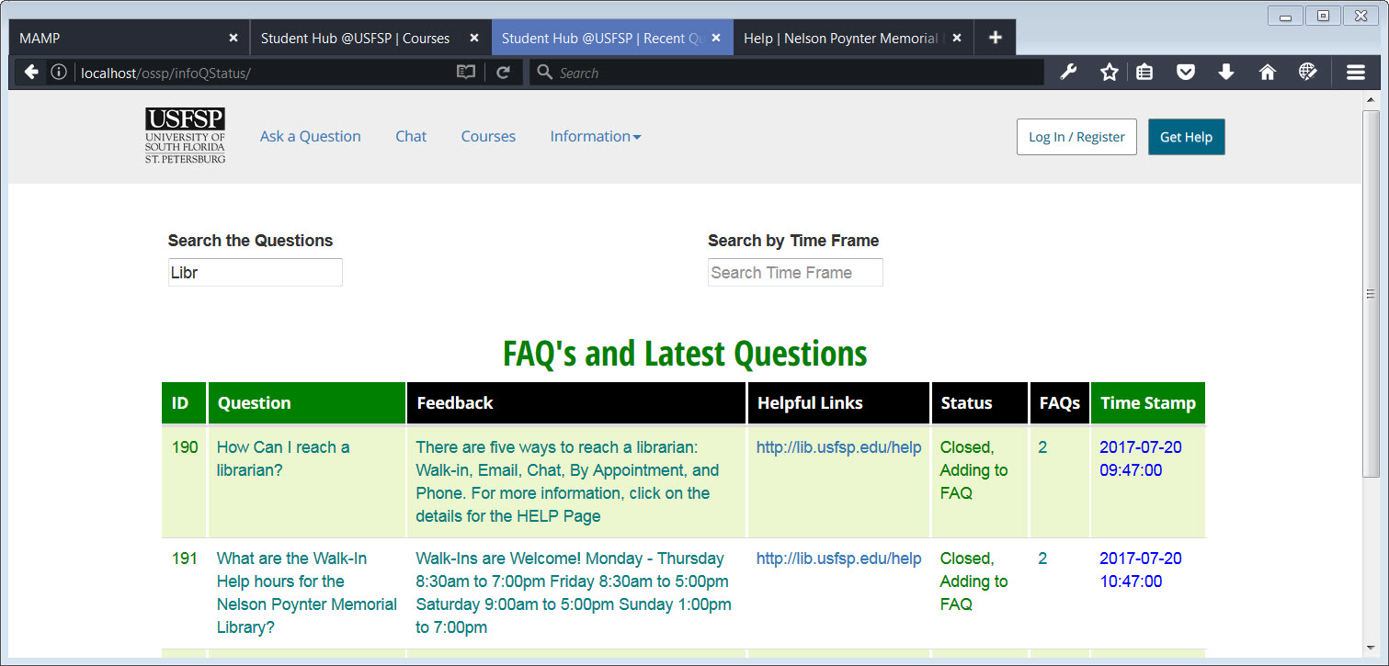

[ VIII - 5 ] FAQs: Figure 2

A student or casual observer may search the questions by a particular term. In this example, you may see that one has begun to enter the term “Library,” and the Questions that deal with the term “Library” start to come up even before one has spelled out the term completely.

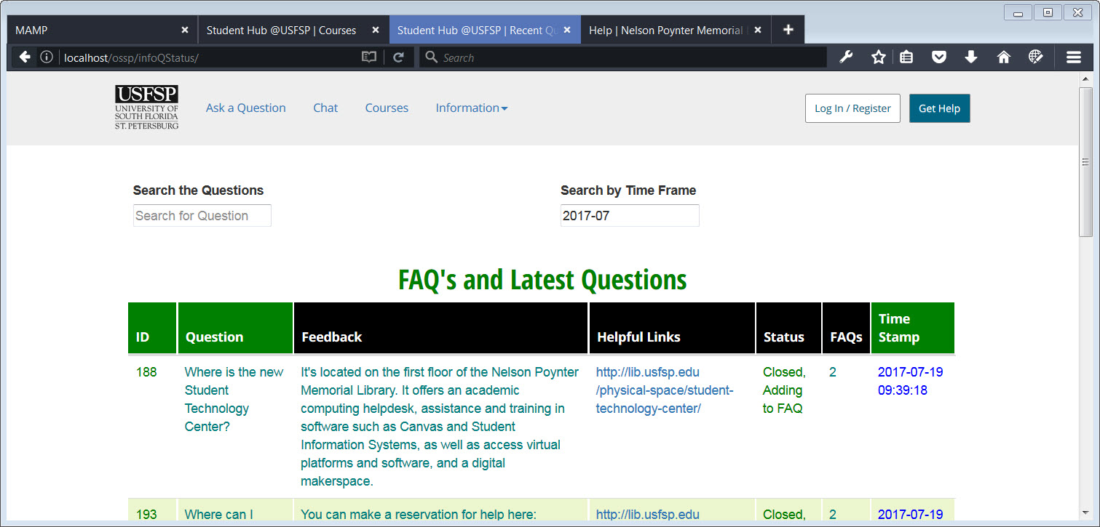

[ VIII - 5 ] FAQs: Figure 3

A student or casual observer may search the questions by a particular time frame. In this example, one has entered a search for all questions asked in July 2017.

NEXT STEPS

The Online Student Support Portal was built from the ground up, rather than from the top down. Functionality was built first, and overlaid with user interfaces last. To that end, most of the work that remains to be done with the portal is user testing, and finalizing the interfaces based on the results of the testing. More specifically, the following tasks need to be completed:

1. To ensure the stability and integrity of the databases, data sanitization must be added to all form fields across the application.
2. Conduct significant user testing, to include mobile testing, to finalize the interface.
3. Coordinate with marketing to add official USFSP colors and visuals.
4. Add WAI-ARIA for screen-readers. This should wait until the interface is finalized after user-testing, because content is generated dynamically which, in turn, affects how the content will be announced to screen-readers. Adding WAI-ARIA for screen-readers at the wrong point in time will do far more harm than good.
5. Follow-on, additional testing with screen-readers is necessary after the first and second steps above have been completed. For screen-reader testing to be meaningful, it can take place only after the user interface has been finalized.
6. Add data to certain tables for the artificial intelligence component of the portal. Currently, only enough data is in place to enable proof-of-concept demonstrations.
7. Modify the “roles” functionality from the simple one it is now to the much more sophisticated and powerful version that has been designed by Dr. Frechette.
8. Create an additional specialized interface for managers and staff, including

a. an interface to allow managers to assign roles to staff;

b. an interface to allow staff to add specialized terms to teach the artificial intelligence;

c. an interface to allow staff to enter special FAQs based on student questions;

d. an interface to allow staff to input coordinates for map function.

1. Coordinate with Information Technology, test for domain cross-functionality, to ensure that all URLs/URIs necessary for content delivery are white-listed.
2. Set up a toggle for the chat function to allow the download of a transcript for accessibility purposes.

CONCLUSION

We would like to thank many for the opportunity to develop this one-of-a-kind Online Student Support Portal. First and foremost, we are in deep gratitude to the deans of Nelson Poynter Memorial Library, Dean Carol Hixson and Dean Catherine Cardwell for their involvement and support; David Brodosi, Associate Director of Online Learning and Instructional Technology Services for the funding; ALL the librarians and ALL of the staff at Nelson Poynter Memorial Library — you are just awesome — and for the many new friends who came into our lives because of the project, with the shared commitment to students, their families, and the community. Thank you so much. It is all of you who made the journey a great one.

We firmly believe that we have created something very special here, something powerful that is simply not done elsewhere, and something that truly represents USFSP, and is totally unique to USFSP. This platform was built in-house, by USFSP faculty and staff. It truly has USFSP in its DNA.

NOTES

1. ["Resolution Agreement: South Carolina Technical College System, OCR Compliance Review No. 11-11-6002."](http://www2.ed.gov/about/offices/list/ocr/docs/investigations/11116002-b.pdf)

Definition of Accessible: “Accessible” means a person with a disability is afforded the opportunity to acquire the same information, engage in the same interactions, and enjoy the same services as a person without a disability in an equally effective and equally integrated manner, with substantially equivalent ease of use. The person with a disability must be able to obtain the information as fully, equally and independently as a person without a disability. Although this might not result in identical ease of use compared to that of persons without disabilities, it still must ensure equal opportunity to the educational benefits and opportunities afforded by the technology and equal treatment in the use of such technology.

2. Case 1:16-cv-23020-RNS Document 32 Entered on FLSD Docket 03/15/2017

United States District Court for the Southern District of Florida

Juan Carlos Gil, Plaintiff v. Winn Dixie Stores, Inc., Defendant

Civil Action No. 16-23020-Civ-Scola

http://www.adatitleiii.com/wp-content/uploads/sites/121/2017/04/16-cv-23020-32-Order-on-Dft-MTD-Mtn-Strike-\_Winn-Dixie.pdf

Accessed June 21, 2017

REFERENCES

American Psychological Association (APA); (n.d.) “Increasing Student Success Through Instruction in Self-Determination” http://www.apa.org/research/action/success.aspx Accessed June 29, 2017

Andalibi, Nazanin; Hamison, Oliver; De Choudhury, Munmun; Forte, Andrea; (May 2016)Understanding Social Media Disclosures of Sexual Abuse Through the Lenses of Support Seeking and Anonymity’ Proceedings of the 2016 CHI Conference on Human Factors in Computing Systems Pages 3906-3918

Beetham, Helen & White, David; (2013) Students’ experiences and expectations of the digital environment. Co-designed by Jisc, RLUK, RUGIT, SCONUL and UCISA

<http://repository.jisc.ac.uk/5572/1/JR0006_STUDENTS_EXPECTATIONS_EXEC_SUMMARY_v2.pdf>

Accessed June 1, 2017

Benson, Matthew; (June 15, 2016) “An end or an error: App downloads are on a dangerous decline in the USA” *Android Authority*

*http://www.androidauthority.com/end-era-app-downloads-decline-usa-698555/*

Accessed June 23, 2017

Brice, Alejandro; (2014) “Speech Perception in Bilingual Speakers: Ten Years of Research” *University of South Florida St. Petersburg. Digital USFSP Faculty Publications 2014*

http://digital.usfsp.edu/cgi/viewcontent.cgi?article=1395&context=fac\_publications

Accessed June 22, 2017

Button, Keith; (March 21, 2014) “10 mobile apps making campuses safer” EducationDIVE

http://www.educationdive.com/news/10-mobile-apps-making-campuses-safer/241575/

Accessed June 26, 2017

Crews,Tena; Bordonada, Tiffany; Wilkinson, Kelly; "Student Feedback on Quality Matters Standards for Online Course Design" *Educause Review* 5 June 2017

Davis, Christopher;Morris, Karla;(2015) Student Engagement:”The core model and inter-cohort analysis” *Information Systems Education Journal Volume 13, No. 3 May 2015 ISSN:1545-679X*

Duke, Lynda M., Ed.; Asher, Andrew D., Ed. (2012) College Libraries and Student Culture: What We Now Know : American Library Association, *50 East Huron Street, Chicago, IL 60611*

Durand, V.M. (1999). Functional communication training using assistive devices: Recruiting natural communities of reinforcement. Journal of Applied Behavior Analysis, 32, 247-267. doi: 10.1901/jaba.1999.32-247

##### ECDL (European Computer Driving Licence) (n.d.) Policy and Publications “The Fallacy of the 'Digital Native'” http://ecdl.org/policy-publications/digital-native-fallacy Accessed June 23, 2017

Ellison, Nicole; Blackwell, Lindsay; Lampe, Cliff; Trieu, Penny; “The Question Exists, but You Don’t Exist With It”: Strategic Anonymity in the Social Lives of Adolescents. SM+S (Social Media + Society) October-December 2016 1-13 sms.sagepub.com

http://journals.sagepub.com/doi/pdf/10.1177/2056305116670673

Accessed June 20, 2017

Fisher, W. W., Thompson, R. H., Piazza, C. C., Crosland, K., & Gotjen, D. (1997). On the relative reinforcing effects of choice and differential consequences. Journal of Applied Behavior Analysis, 30, 423–438.

Gelbar, N.W., Madaus, J.W., Lombardi, A., Faggella-Luby, M., & Dukes, L.L., III. (2015). College students with physical disabilities: Common on campus, uncommon in the literature. Physical Disabilities: Education & Related Services, 34(2), 14-31. doi: 10.14434/pders.v34i2.19224

Gil v. Winn Dixie. (United States District Court for the Southern District of Florida December, 2016).http://www.adatitleiii.com/wp-content/uploads/sites/121/2017/04/16-cv-23020-32-Order-on-Dft-MTD-Mtn-Strike-\_Winn-Dixie.pdf Accessed 21 June 2017

Glazer, Kip; (October 26, 2016). “The Digital Natives Myth” *Literacy Daily*

https://www.literacyworldwide.org/blog/literacy-daily/2016/10/26/the-digital-natives-myth

Accesed 23 June 2017

Goel, Vindu (June 29, 2014)” Facebook Tinkers With Users’ Emotions in News Feed Experiment, Stirring Outcry” The New York Times.

https://www.nytimes.com/2014/06/30/technology/facebook-tinkers-with-users-emotions-in-news-feed-experiment-stirring-outcry.html?\_r=0 Accessed June 2, 2017

Gunawardena, Charlotte N.; Jennings, Barbara; Ortegano-Layne, Ludmila C.; Frechette, Casey; Carabajal, Kayleigh; Lindemann, Ken; Mummert, Julia (Mar 2004) “Building an Online Wisdom Community: A Transformational Design Model” Journal of Computing in Higher Education, v15 n2 p40-62 Mar 2004

Gwizdka, J. (2010) “Using Stroop Task to Assess Cognitive Load” Proceedings of the 2010 European Conference on Cognitive Ergonomics (ECCE2010)

Hanley, G. P., Piazza, C. C., Fisher, W. W., Contrucci, S. A., & Maglieri, K. A. (1997). Evaluation of client preference for function-based treatment packages. Journal of Applied Behavior Analysis, 30, 459–473.

Hevner, A.; March, S; Park, J.; Ram, S. ;(2004) “Design Science in Information Systems Research” MIS Quarterly

HIGHER EDUCATION OPPORTUNITY ACT PUBLIC LAW 110-315-AUG. 14, 2008

Retrieved from<https://www.gpo.gov/fdsys/pkg/PLAW-110publ315/pdf/PLAW-110publ315.pdf>

February 13, 2017

Hord, Jennifer (n.d.) “How SMS works”

http://computer.howstuffworks.com/e-mail-messaging/sms1.htm

Accessed 2 June 2017

Kayhan, Varol Onur & Davis, Christopher J (2016). Situational privacy concerns and antecedent factors Journal of Computer Information Systems, 56 (3), 228-237. Doi: 10.1080/08874417.2016.1153913.

Accessed February 13, 2017

Varol O. Kayhan, Christopher J. Davis, Rosann Webb Collins, and Anol Bhattacherjee (Feb 13, 2013) [Verification of Knowledge Assets in Electronic Repositories: Expert- and Community-Governance](http://www.tandfonline.com/doi/abs/10.1080/10580530.2013.773812) [Information Systems Management](http://www.tandfonline.com/toc/uism20/30/2) Vol. 30 , Iss. 2,2013

Kearns, Grover (2016) “Countering Mobile Device Threats: A Mobile Device Security Model” Journal of Forensic and Investigative Accounting (JIFA) Volume 8: Issue 1, January-June, 2016

Khosrow-Pour, Mehdi Encyclopedia of Information Science and Technology, Second Edition IGI Global, Oct 31, 2008 - [Business & Economics](https://www.google.com/search?tbo=p&tbm=bks&q=subject:%22Business+%26+Economics%22&source=gbs_ge_summary_r&cad=0) - 5266 pages

Kirshner, Paul A & Karpinski, Aryn (2010) Facebook and academic performance. [Computers in Human Behavior](http://www.sciencedirect.com/science/journal/07475632) [Volume 26, Issue 6](http://www.sciencedirect.com/science/journal/07475632/26/6), November 2010, Pages 1237–1245

<http://www.sciencedirect.com/science/article/pii/S0747563210000646>

Accessed June 1, 2017

Kolowich, Steve (August 22, 2011) “What Students Don’t Know. - A two-year anthropological study of student research habits shows that students are in dire need of help from librarians, but are loath to ask for it.” Inside Higher Ed.

https://www.insidehighered.com/news/2011/08/22/erial\_study\_of\_student\_research\_habits\_at\_illinois\_university\_libraries\_reveals\_alarmingly\_poor\_information\_literacy\_and\_skills

Accessed June 19, 2017

Kramera, Adam; Guilloryb, Jamie; & Hancockb, Jeffery (n.d.) “Editorial Expression of Concern and Correction” Proceedings of the National Academy of Sciences of the United States of America pnas11129 correction10779

http://www.pnas.org/content/111/24/8788.full.pdf

Accessed 2 June 2017

Kvavik, R. B. (2005). Convenience, communications, and control: How students use technology. *Educating the net generation*, *1*, 7-1.

Accessed June 1, 2017

Lytle, Ryan (2013, January 14). 5 Tips to Succeed in an Online Course.

*https://www.usnews.com/education/online-education/articles/2013/01/14/5-tips-to-succeed-in-an-online-course*

Accessed June 6, 2017

Lombardi, A., Gelbar, N., Dukes, L. L., III, Kowitt, J., Wei, Y., Madaus, J., Lalor, A. R., & Faggella-Luby, M. (2016, June 23). Higher Education and Disability: A Systematic Review of Assessment Instruments Designed for Students, Faculty, and Staff. Journal of Diversity in Higher Education

Advance online publication. http://dx.doi.org/10.1037/dhe0000027

McNeil, Claire (Jan 31 2017). College campus crisis: mental health services *The Tampa Bay Times pp1A, 4A*

McNeil, Claire (Apr 2 2017). Science of Success: USF uses data to predict trouble courses and find and help struggling students *The Tampa Bay Times pp1A, 15A*

Neville, T. M., & Henry, D. B. (2009). Reference Classification — Is It Time to Make Some Changes?. Reference & User Services

Quarterly, 48(4), 372-383.

McVey, Cait (November 30, 2016). “Effort underway to preserve historic African American Newspaper” *Bay News 9 website*

http://www.baynews9.com/content/news/baynews9/on-the-town/article.html/content/news/articles/bn9/2016/11/30/effort\_underway\_to\_p.html

Accessed June 28, 2017

Milliron, Mark. (n.d.) “Making the Most of a Healthy Change in Education: The Emerging Student Success Platform.”

Muilenburg, Lin; Berge, Zane; "Student Barriers to Online Learning: A Factor Analytic Study" *Journal of Distance Education*, Vol. 26, No. 1, 2007: 29–48.

Murtagh, Rebecca (July 8 2014) *Mobile Now Exceeds PC: The Biggest Shift Since the Internet Began* Search Engine Watch Retreived from http://searchenginewatch.com/sew/opinion/2353616/mobile-now-exceeds-pc-the-biggest-shift-since-the-internet-began

Nelson Poytner Memorial Library (Producer). (January 30, 2017).Searching for Children's Literature: Part 4, St. Petersburg Library System[Video file]. Retrieved June 28, 2017, from https://www.YouTube.com/watch?v=iKF1txo0gI4

Office of Civil Rights Compliance Review: Resolution Agreement South Carolina Technical College System OCR Compliance Review No. 11-11-6002 Retrieved from https://www2.ed.gov/about/offices/list/ocr/docs/investigations/11116002-b.pdf

Accessed February 13, 2017

O’Neil, Megan (April 21, 2014) *“Confronting the Myth of the Digital Native*.” The Chronicle of Higher Education. Technology.

http://www.chronicle.com/article/Confronting-the-Myth-of-the/145949

Accessed June 23, 2017

Online Learning and Instructional Technology Services (Producer). (17 February 2017). *Monday Minute: Alt Text in Word and PowerPoint* [Video file]. Retrieved June 28, 2017, from https://www.YouTube.com/watch?v=ReoT1LeZSlw

Perez, Sarah; (May 31, 2016) “Nearly 1 in 4 people abandon mobile apps after only one use” TechCrunch https://techcrunch.com/2016/05/31/nearly-1-in-4-people-abandon-mobile-apps-after-only-one-use/ Accessed June 23, 2017

Rodriguez, L. M., Neighbors, C., Rinker, D. V., Lewis, M. A., Lazorwitz, B., Gonzales, R. G., & Larimer, M. E. (2015). Remote versus in-lab computer-delivered personalized normative feedback interventions for college student drinking. *Journal Of Consulting And Clinical Psychology*, *83*(3), 455-463. doi:10.1037/a0039030

Roper, Kristin Grabarek, Sobel, Karen (2016) Anonymity versus Perceived Patron Identity in Virtual Reference Transcripts Public Services Quarterly Volume 8, 2012 Issue 4 Pages 297-315 | Received 11 Aug 2011, Accepted 14 Nov 2011, Published online: 20 Nov 2012

Seo, H., Harn, R., Ebrahim, H., & Aldana, J. (2016). International students’ social media use and social adjustment. *First Monday, 21*(11). [http://firstmonday.org/ojs/index.php/fm/ article/view/6880/5646.](http://firstmonday.org/ojs/index.php/fm/%20article/view/6880/5646)

Accessed May 30, 2017

Shuang, X., Xiaowen Fang1, x., Brzezinski, J., & Chan, S. (2008). Development of a Dual-Modal Presentation of Texts for Small Screens. *International Journal Of Human-Computer Interaction*, *24*(8), 776-793.

SOUTHERN ASSOCIATION OF COLLEGES AND SCHOOLS (Edited Jan 2012, reformatted July 2014) *Distance and Correspondence Education Policy Statement*<http://www.sacscoc.org/pdf/DistanceCorrespondenceEducation.pdf>

Accessed January 28 2016

SOUTHERN ASSOCIATION OF COLLEGES AND SCHOOLS (April 2015) *Fifth Year Interim Report**<http://www.sacscoc.org/fifth%20year/Summary.The%20Fifth%20Year%20Interim%20Report.pdf>*

Accessed January 29 2016

SOUTHERN ASSOCIATION OF COLLEGES AND SCHOOLS(Approved: SACSCOC Executive Council: December 2011) *Guidelines for Addressing Distance and Correspondence Education A Guide for Evaluators Charged with Reviewing Distance and Correspondence Education*

<http://www.sacscoc.org/pdf/081705/Guidelines%20for%20Addressing%20Distance%20and%20Correspondence%20Education.pdf> Accessed January 28 2016

University of South Florida St. Petersburg, Vision 20/20 Strategic Plan Goals

[https://www.usfsp.edu/vision2020/boldgoals](https://www.usfsp.edu/vision2020/boldgoals/#toggle-id-5)

Accessed 14 June 2017

Van Beynen, Kaya; Swenson, Camielle (January 2016). Exploring Peer-to-Peer Library Content and Engagement on a Student-Run Facebook Group. *College and Research Libraries Volume 77 Number 1*

Van Beynen, Kaya; Swenson, Camielle; Champion, Virginia (May 2013). Self-Checkout Machine Assessment. University of South Florida St. Petersburg. Digital USFSP Faculty Publications 2013

http://digital.usfsp.edu/cgi/viewcontent.cgi?article=1985&context=fac\_publications

Accessed June 22, 2017

W3C *Web Content Accessibility and Mobile Web: Making a Website Accessible Both for People with Disabilities and for Mobile Devices (WCAG) 2.0* Retrieved from<http://www.w3.org/WAI/mobile/overlap.html> 17 December 2015

W3C *Relationship between Mobile Web Best Practices (MWBP) and Web Content Accessibility Guidelines (WCAG) 2.0* Retrieved from<http://www.w3.org/TR/mwbp-wcag/> 17 December 2015

W3C (2008, December 11) *Web Content Accessibility Guidelines (WCAG) 2.0* Retrieved from<http://www.w3.org/TR/WCAG20/> 16 December 2015

WCAG (2014, April7) *WCAG Technique for Dynamic Content (WCAG) 2.0* Retrieved from<https://www.w3.org/WAI/GL/wiki/WCAG_Techniques_for_dynamic_content> 17 February 2017

WebAim *Accessibility of AJAX Applications* Retrieved from<http://webaim.org/techniques/ajax/> 16 December 2015

WebAim *Accessibility of Rich Internet Applications* Retrieved from<http://webaim.org/techniques/aria/#dynamic> 16 December 2015

Weber, Matt; (January 12, 2017). “Harvard EdCast: The Digital Natives Myth” *Literacy Daily*

http://www.gse.harvard.edu/news/17/01/harvard-edcast-myth-digital-native

Accesed 23 June 2017

Weimer, Maryelen; (January 21, 2015) “Why Students Don’t Attend Office Hours” Faculty Focus - Higher Ed Teaching Strategies From MANGA Publications.

https://www.facultyfocus.com/articles/teaching-professor-blog/students-dont-attend-office-hours/

Accessed 14 June 2017

### Wisniewska, Sopphia; (2014) USF St. Petersburg Strategic Plan Vision 20/20: Engaging Students and the Community to Transform the World 2014 -2019 https://www.usfsp.edu/vision2020/files/2014/09/USFSP\_stratplan.pdf

Accessed June 23, 2017

### Wisniewska, Sophia T.; (2014) USF St. Petersburg Strategic Plan Vision 20/20: USFSP Core Values. https://www.usfsp.edu/vision2020/usfsp-core-values/

Accessed June 28, 2017

### Wisniewska, Sophia T.; (2014) USF St. Petersburg Strategic Plan Vision 20/20: USFSP Strategic Goal #2: Student Success and Culture https://www.usfsp.edu/vision2020/bold-goal-2-student-success-and-culture/

Accessed June 29, 2017